The March 19th TRC Board Meeting will be at
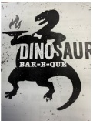

Dinosaurs BAR-B-QUE!
377 River St, Troy, NY 12180
With Beef Brisket, Half Chicken Split, &
Memphis Style Pulled Pork
Coleslaw, Macaroni & Cheese, & Honey Hush Cornbread
Dessert:
Caramel Topped Cheesecake f
Coffee, tea, and Soda are included.
Dinner will begin at 5:45 p.m.

