Trainer’s EDGE
(The Craft of Training)
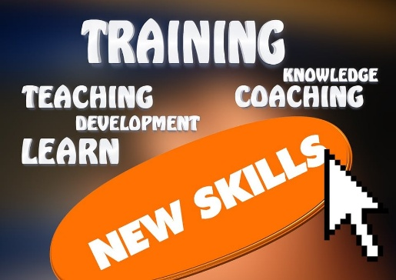
Staffing a Wood Badge, NYLT course or just looking to sharpen your teaching skills, come join us for this course.
When: Saturday March 28, 2026
Where: Twin Rivers Council Service Center - 253 Washington Ave. Ext. – Albany, N.Y. 12205

Time: 9a.m. – 2p.m.

Bring a bag lunch and materials to present a 5-minute presentation on a scouting subject of your choice.

Register at https://scoutingevent.com/364-99573

Complete The Science of Training Fundamentals online at www.scouting.org

Questions: Contact Cheryl Downing, Twin Rivers Council Training Chair at training@trcscouting.org or 518-925-7815.

