Scouting America
2025 Spooktacular
Land of the Monsters

October 24-26, 2025
Camp Carpenter
300 Blondin Road
Manchester, NH

Be prepared to have fun and camp with other scouts.

Theme: Monsters
Registration: Please register your unit online here (https://scoutingevent.com/).
Campsites: Each Pack that is camping overnight will be assigned a campsite. Your campsite assignment will be given to your leader at HQ during check-in upon arrival on Friday night. Please gather your unit and check in at HQ **before** going to your campsite. If arriving on Saturday, please check in at HQ **before** going to your campsite or attending any activities. Please also note that multiple units will be assigned to each campsite as necessary.
Parking: Parking is available along the main camp road. Parking attendants will direct you to an appropriate parking spot. Please try to carpool to save space in the parking lot. Only one vehicle will be allowed to bring equipment or a trailer to the campsite. Any trailers are allowed to remain on site, but ALL VEHICLES must return to the appropriate parking lots. No vehicles are allowed on the site. EXCEPT THE CHO. Please be sure to check in with a parking attendant before traveling the camp roads to your campsite. Campsite assignment will be distributed when you check-in at HQ.
Check-in: HQ is located at Manning Hall. Please send ONE leader to HQ to turn in your unit roster and health forms for all attendees (scouts, parents, leaders). Wristbands will be given to units. Please make sure everyone in your unit wears them. Please do NOT turn in any medication–keep that with your unit. Your unit will be given their campsite at check-in once all payments and forms are turned in.
Unit Roster: One leader will turn in a unit roster at check-in. This roster lists the names of all attendees for the event, as well as the contact information for the primary and secondary leaders within the unit. A blank roster is available at the end of this guide. Please fill this in and turn it in at check-in.
Medical Forms: Packs will turn in medical Part A & B forms upon arrival. Suggest that one leader turns in Med Forms at check-in, and please keep a copy with your group as well. Forms will be returned upon checkout. We will not have access to black pug. Any specific medical conditions must be communicated to the Camp Health Officer or District staff. Due to National Boy Scout regulations, a Camp Health Officer is required to be on-site all weekend.
First Aid: Each unit must have its own First Aid Kit for minor injuries. The Camp Health Officer is available all weekend to support any injuries. Any injury-related urgent care visits must be reported to the Camp Health Officer. BSA requires an incident report for injuries.
Water: Water jugs can be filled from the tap at the back of the Dining Hall.
Food: Each Pack is responsible for their own food. Meals will be cooked and eaten at the unit’s site.
Clothing: Due to warm days and cool nights, layering is recommended, and synthetic layers to help stay dry. Good footwear is required for walking and hiking around the camp. No crocs, sandals, or open-toed shoes! Wear a Halloween costume too! Rain gear is required if inclement weather is predicted.
Uniform: Please wear Class B uniforms for the weekend.
Fires: Fires must be contained to the campfire rings in your campsite. Due to NH guidelines, firewood cannot be brought into Camp Carpenter from an off-site source. Instructions on obtaining wood will be available at check-in, and dead wood from around your campsite is always available to burn.
Activities: The Scouting Memorabilia show will be located in the dining hall. All scouts are free to enter the show. On Saturday morning, Scouts who are interested will be able to work on the Collecting and Scouting Heritage Merit Badges. Please make sure the scout brings a blue card for each badge. If they are doing the collections, they need to bring their collection or pictures of it.
Guns and Archery: No devices shall be brought from home that can shoot arrows, bullets, BBs, or other projectiles.
Shelter: Each family needs to bring a suitable weatherproof tent for camping during the weekend. A dining fly is recommended in case of rain. Tents can be set up on the ground or on the campsite platforms. Hammocks are also allowed.
Youth Supervision: BSA guidelines require two fully trained BSA-registered leaders to always accompany youth. Cub Scouts that are camping overnight **must** be accompanied by a parent or guardian. Siblings are not allowed to promote the one-on-one relationship between parent and Cub. Cub Scouts are not allowed to wander off on their own away from their parents or from their unit. Failure to properly supervise youth according to these guidelines may mean you will be asked to leave the event.
Toilet: Latrines are available throughout the camp at the various campsites. In case of shortage, carry a roll with you.
Trash: This is a pack-in, pack-out event. Please take all the trash with you. No trash should be left out at camp. Please be sure all food waste is secured from wildlife.
For questions, please reach out to the Staff:
Tonya Pinet, Massabesic District, tonyapinet@gmail.com
Nick Greci, Wannalancit District, grecinp3@metrocast.net

Recommended Gear
Personal Gear - Day Trippers (Saturday Only)

- Day pack / Backpack
- Class B Uniform
- Weather gear: rain gear, bug repellent, sunscreen
- Mess kit
- Boots/hikers
- Notebook & Pen

- Cub Scout Handbook /
- Scouts BSA Handbook
- Water Bottle and Water
- (NO ADULT BEVERAGES!)
- Lunch & Snacks
- Trash bag (for personal trash)
- Halloween Costume! (NO GUNS PLEASE)

Personal Gear – Overnighters

- Day Trippers Gear (above)
- Tent
- Camping Chair
- Sleeping bags & Sleeping pads
- Change of Clothes
(stick to the synthetics!)
- Toiletries
- Flashlight

Pack Gear

- Pack Flag
- Unit Roster
- Med Forms for all attendees
- Pack First Aid Kit
- ALL MEALS FOR YOUR STAY
- Trash bag(s)

Weekend Schedule
Friday, October 18
5:30-8 PM | Check In
10:00 PM | Taps

Saturday, October 19

7:00-9:00 AM | Breakfast
9:00 AM | Opening Ceremony behind Manning Hall
 | Cubs can work on their advancement at their site.
12:00-1:00 PM | Lunch
1:00 PM - 5:00 PM | Site Decoration
5,00PM - 7:00 PM | Supper
7:00 PM - 8:30 PM | Monster Site Visits
10 PM | Taps
Sunday, October 20
7:00-9:00 AM Breakfast and Camp Breakdown
10:00 AM Closing Ceremony

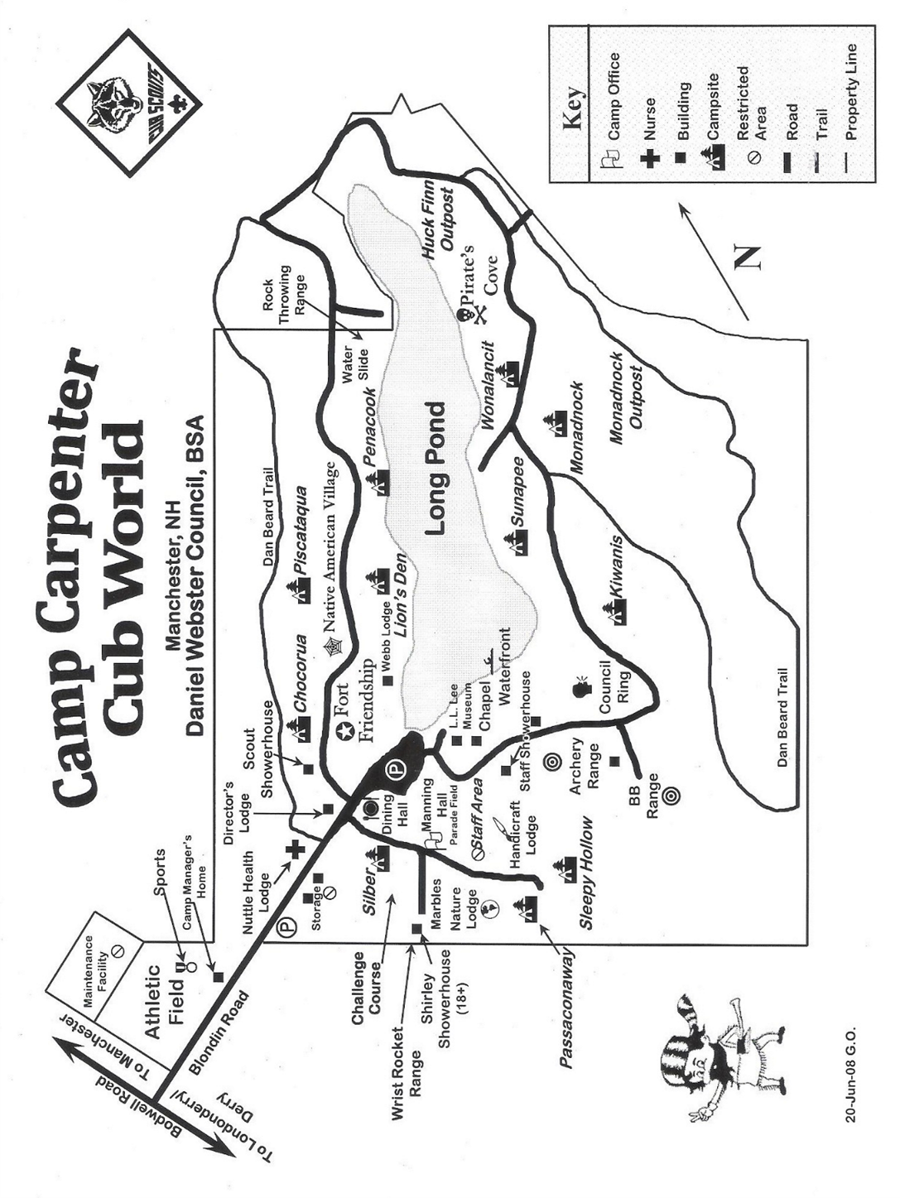
(Please turn in the completed roster at check-in)

Unit Roster
Pack Number
Primary Leader Name
Cell #
Secondary Leader Name
Cell #

Additional Leaders & Parents (use the back for more entries)
Each leader and parent requires a completed BSA Health Form (Parts A&B + ins card)
# | Name | Camping? (Y or N)

Scouts (use the back for more entries)
Each scout requires a completed BSA Health Form (Parts A&B + ins card)
# | Name | Camping? (Y or N)

