Graphic Design Pre-Work

Intro:

Hello Scouts and welcome to the Graphic Design Merit badge. This Course in the Merit Badge college will give you a better understanding of Graphic Design, its history, an overview of different methods of producing graphic arts, and finally a practical run through of Graphic Design from concept to finished piece.

Prerequisites for this Merit badge course:

* PC or MAC capable of running graphic design software.
* Internet access to download SW and upload designs
* Inkscape (an open-source graphic design software). You can download the software from this link: <https://inkscape.org/release/inkscape-1.3.2/>
* Inkscape Design Starting Template. You can download that from this link: <https://tinyurl.com/ycyn29yh>

Requirements:

* Designs need to fit inside of the 5” x 7” template (either portrait or landscape)
* Designs must be single color and should meet the guidelines below:

Examples/description of appropriate vector design:

Vector design definition:

Vector artwork is art that's made up of vector graphics. These graphics are points, lines, curves and shapes that are based on mathematical formulas. When you scale a vector image file, it isn't low resolution and there's no loss of quality, so it can be sized to however large or small you need it to be.



One of the main disadvantages of vector graphics is that they are limited in their ability to represent complex and realistic images, such as photographs. However, vector graphics are ideal for forms of printing, such as screen printing.

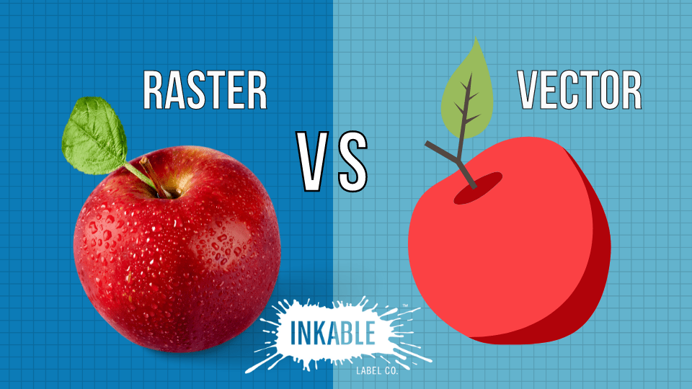

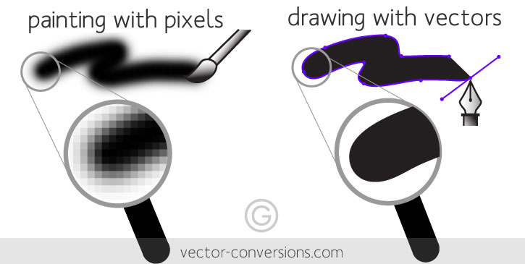 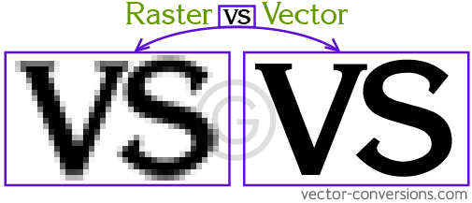-

Please no halftones, gradients or blends, small dots/stipple or fine or thin lines. As well as small/thin reverse shapes or lines (where the dark shape negative surrounds the positive shape/line) - see example below showing designs that are not recommended.

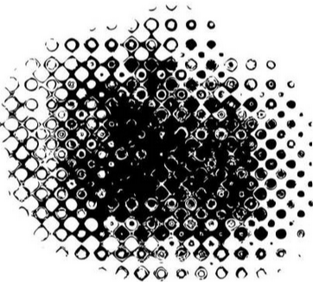 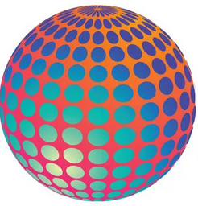 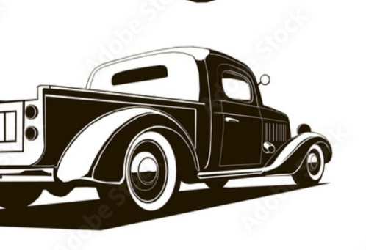

Within these parameters we request that scouts submit designs with opaque shapes and solid forms. Scouts are required to add text to their design in any way they wish as long as they follow the guidelines and parameters. Here are some examples:



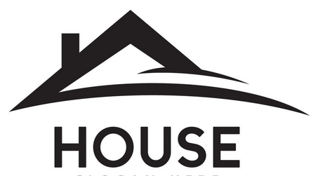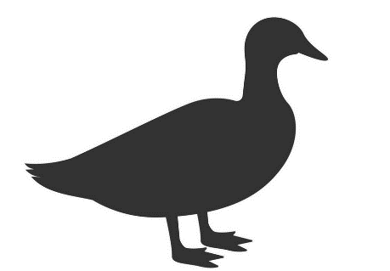

**DUCK**

**EDSEL Motors**

If we receive designs that are not within the vector parameters, we will do our best to 'Quick trace' the design so it's correct/print ready, or reach out to the scouts to correct the problem.

In the practical portion of the workshop Scouts will screenprint their and others designs onto paper, and perform post processing to cut up the layouts into individual designs.

If time is available scouts will be able to do ink/color changes and have their designs printed in different colors vs strictly black.

----DEADLINE for Designs is Sunday October 13th. ----

Name your Vector artwork with which class you are attending (morning or afternoon), first and last name and upload it to the following Link:

<https://drive.google.com/drive/folders/1yoLdKoEc0ZWXLhn_2JsjM29Eot6a9whG>

The file format we will use is .svg

A Scalable Vector Graphics (SVG) file is a type of image format that uses XML-based text to describe how the image should appear. Unlike pixel-based images, SVG files can be scaled to different sizes without losing quality, making them ideal for logos, icons, illustrations, and graphics on websites.

Filename example: MorningJonSmith.svg

- Have fun, be creative!

**Scouts can view the Graphic Arts workbook** [**here.**](http://usscouts.org/mb/worksheets/Graphic-arts.pdf)