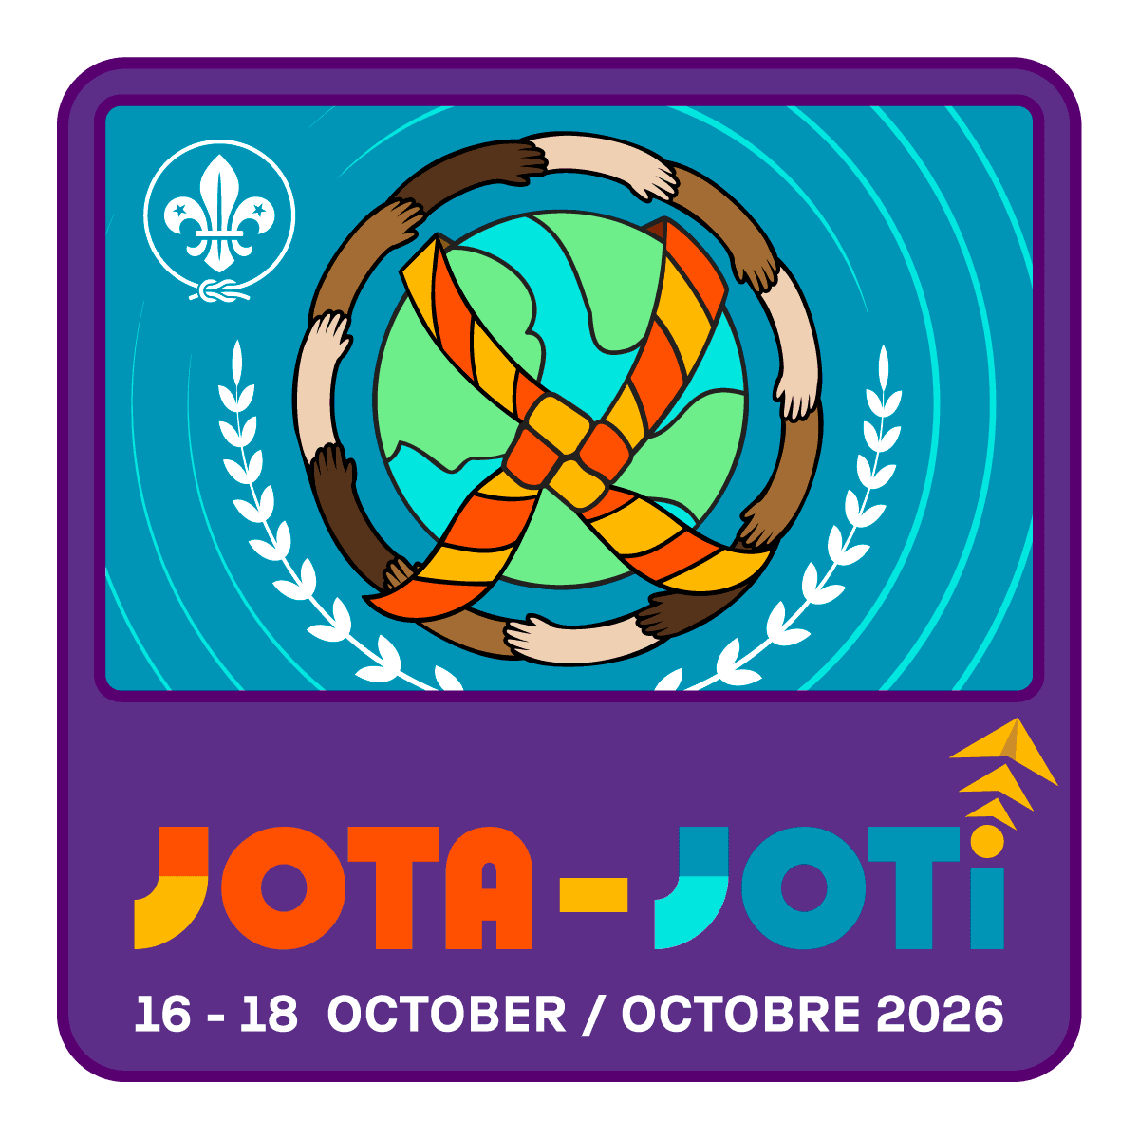
Join us for Jamboree-on-the-Air (JOTA)!

Scouts of all ages are invited to discover the fun of amateur radio — no experience required! Connect with Scouts from around the world, learn how radios work, and take part in hands-on activities that bring the adventure of Scouting to life.

If you’re newly licensed, this is your chance to get your radio programmed, practice making real contacts, and pick up tips from experienced operators. If you’re new to radio, come explore, listen in, and even try your first QSO (radio contact) with the guidance of friendly mentors.

Whether you’re curious about radio, working on advancement, or ready to put your new call sign to use, JOTA is the perfect place to start your journey!

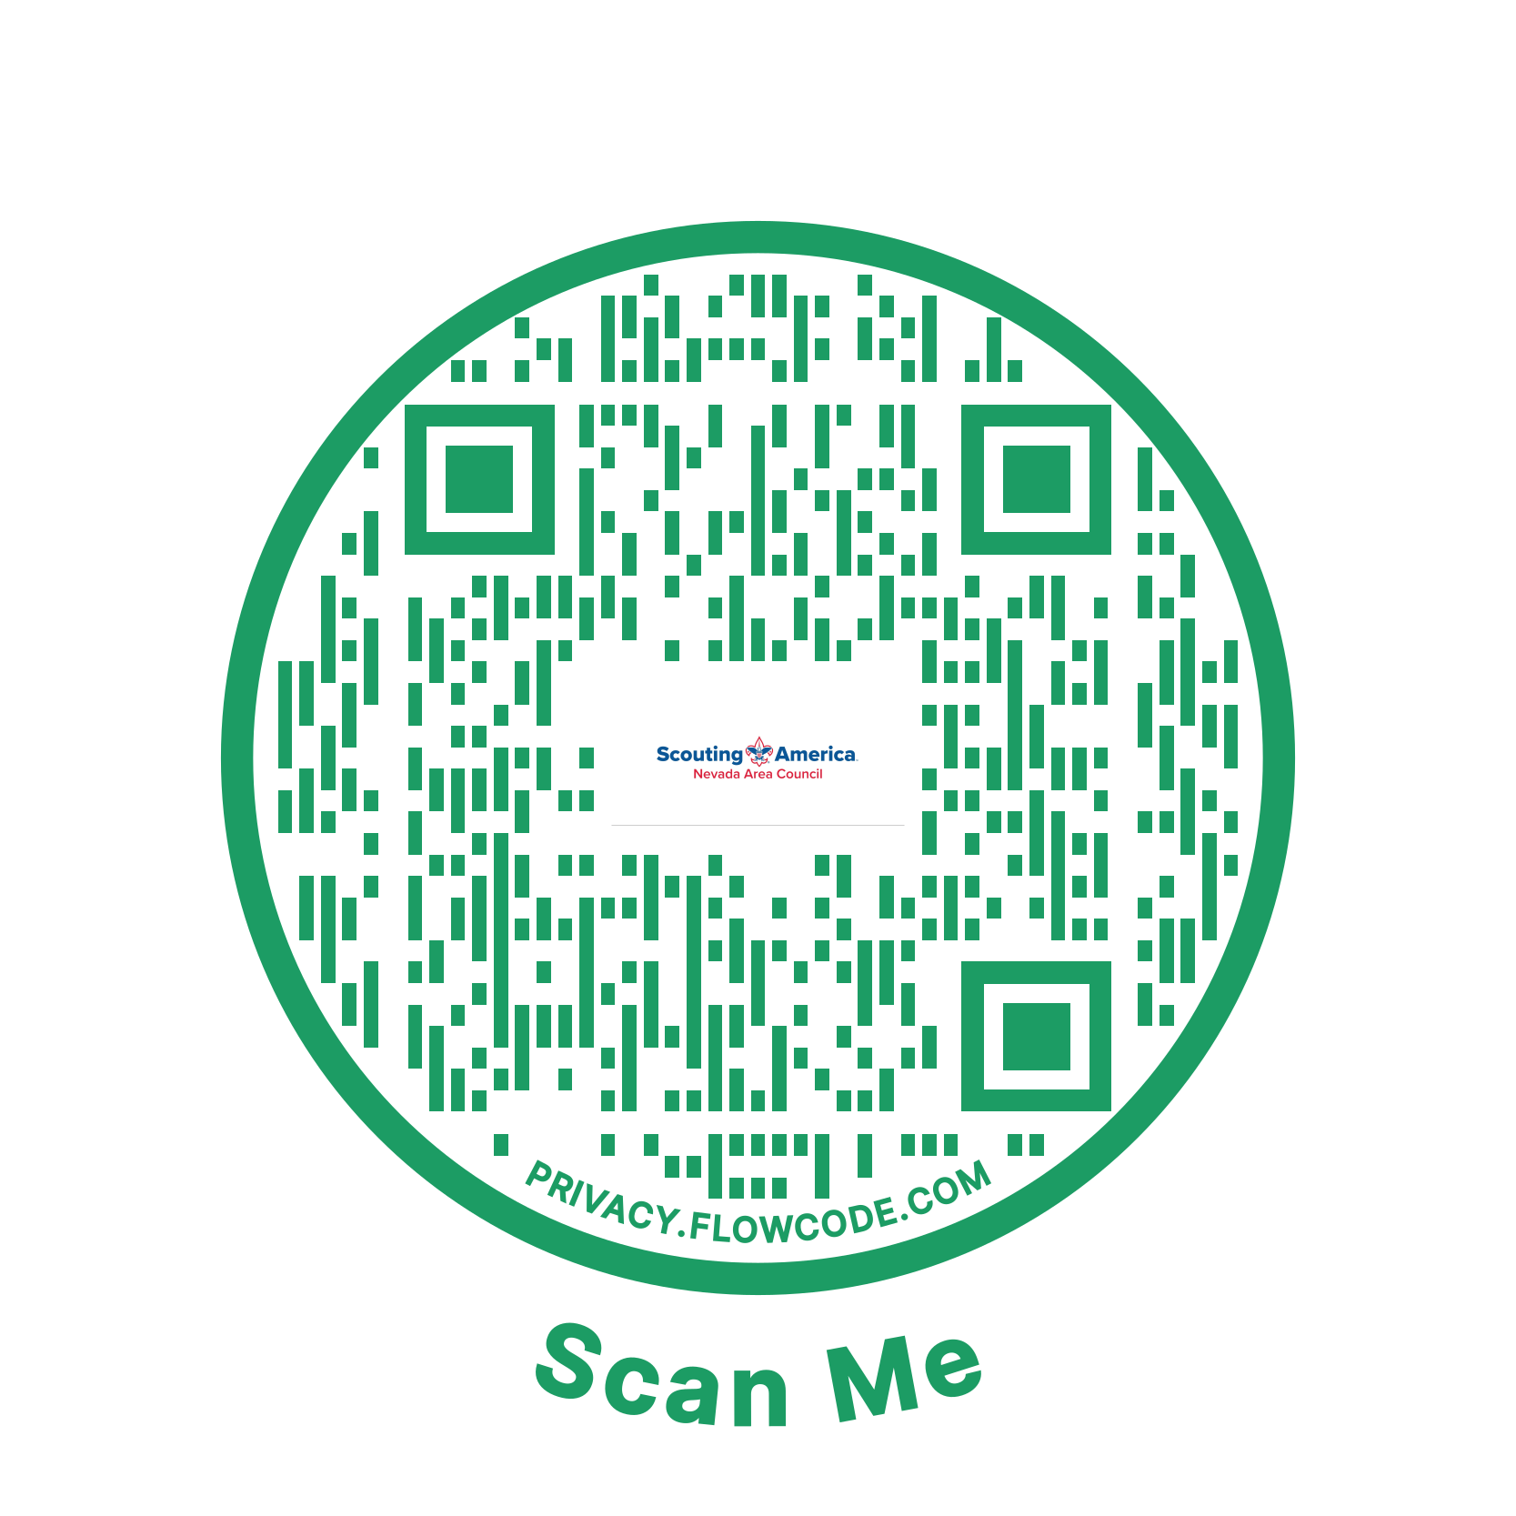

Saturday, October 17, 2026
9:00 am - 1:00 pm
Nevada Area Council - JOTA/JOTI
https://scoutingevent.com/329-100356

Nevada Area Council
500 Double Eagle Court
Reno, NV
89521

For more information:
Kathy Patterson 775-250-3773 Katherine.patterson@scouting.org
Barry Bettman 775-622-3801 k6st@arrl.net

