

What You’ll Learn & Do:
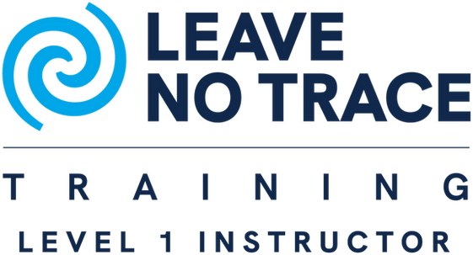

- 7 Principles of Leave No Trace
- Hands-on outdoor skills
- Teaching methods for youth & adults
- Short backpacking trek
- Participant-led mini-presentations
October 9-11, 2026
Time: 6 pm Friday – 2 pm Sunday
Location: Diablo Campground Tahoe National Forest (near Bassetts/Graeagle)

What to Bring:
- Weather-appropriate clothing & footwear
- Annual Health & Medical Record (A/B)
- Food and Water for all days
- Personal gear: water, notebook, etc.
- Enthusiasm for the outdoors

What You’ll Gain:
  - Certification as LNT Level 1 Instructor
  - Ability to teach LNT to units & groups
  - Outdoor ethics & stewardship skills

Cost & Registration:
  - Fee: $27 basic kit or $50 upgraded kit
  - Register: Nevada Area Council - Leave No Trace Level 1 Training
  - Nevada Area Council
  - Phone: 775-787-1111

Why This Course Matters:
This course embodies care for the outdoors. Certified instructors help future adventurers respect nature, minimize impact, and preserve beauty for generations.


Leave No Trace — Protecting Nature for Future Generations

