SUNDAY, APRIL 28, 1:05PM

GREATER NEVADA FIELD

Choice of Discount Tickets this year!

Right Field Reserved $16 or Infield Reserved $22

=

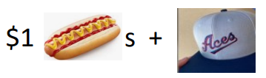

Save the Date: Tickets will be available online Mid-February

