2019 Exploring Veterinary Science Program

Omaha Animal Medical Group with Dr. Van Horn
When: Thursday, October 17th, 2019
Time: 6:00pm – 7:15pm
Where: 3316 N 120th St, Omaha, NE 68164

Wildlife Encounters
When: Thursday, October 24th, 2019
Time: 6:00pm – 7:00pm
Where: 12401 West Maple Road, Omaha, NE 68164

Doe’s & Diva’s Dairy Farm
When: Tuesday, October 29th, 2019
Time: 5:30pm – 6:30pm
Where: 31140 185th St, Honey Creek, IA 51542

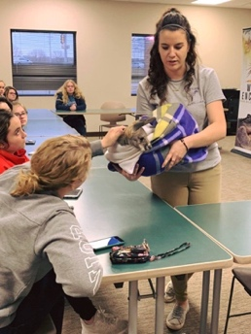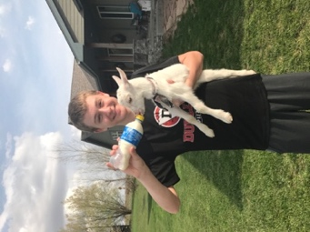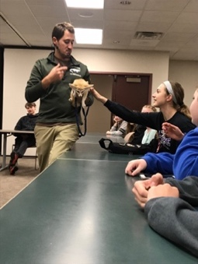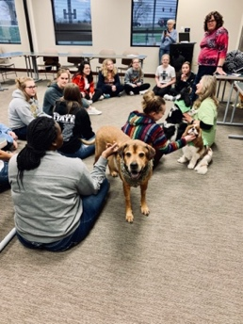

For questions, please contact Exploring Executive, Chelsea Clifton.

Work: (402)514-3065 Cell: (402)350-2502
Email: Chelsea.clifton@scouting.org
Website: www.omahaexploring.org

