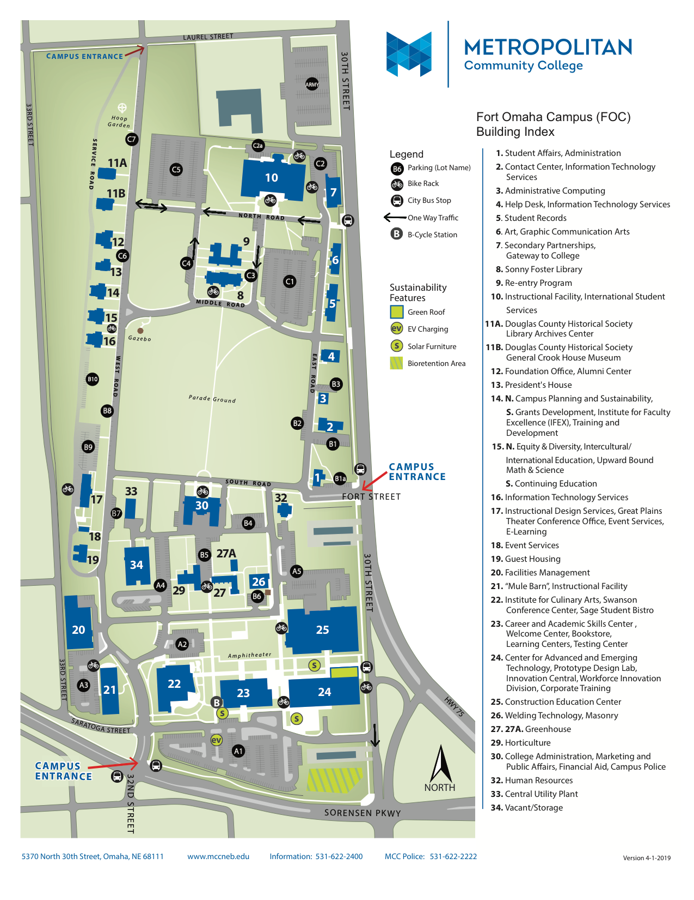
Starting Monday, September 30th meet at Metro Fort Campus Culinary Arts building
Building #22 – Institute for Culinary Arts

