Klondike Derby 2026
Leaders Guide
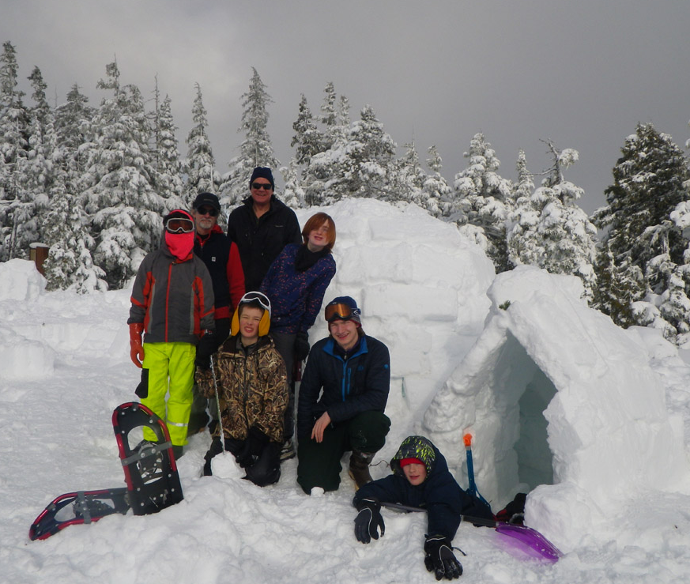

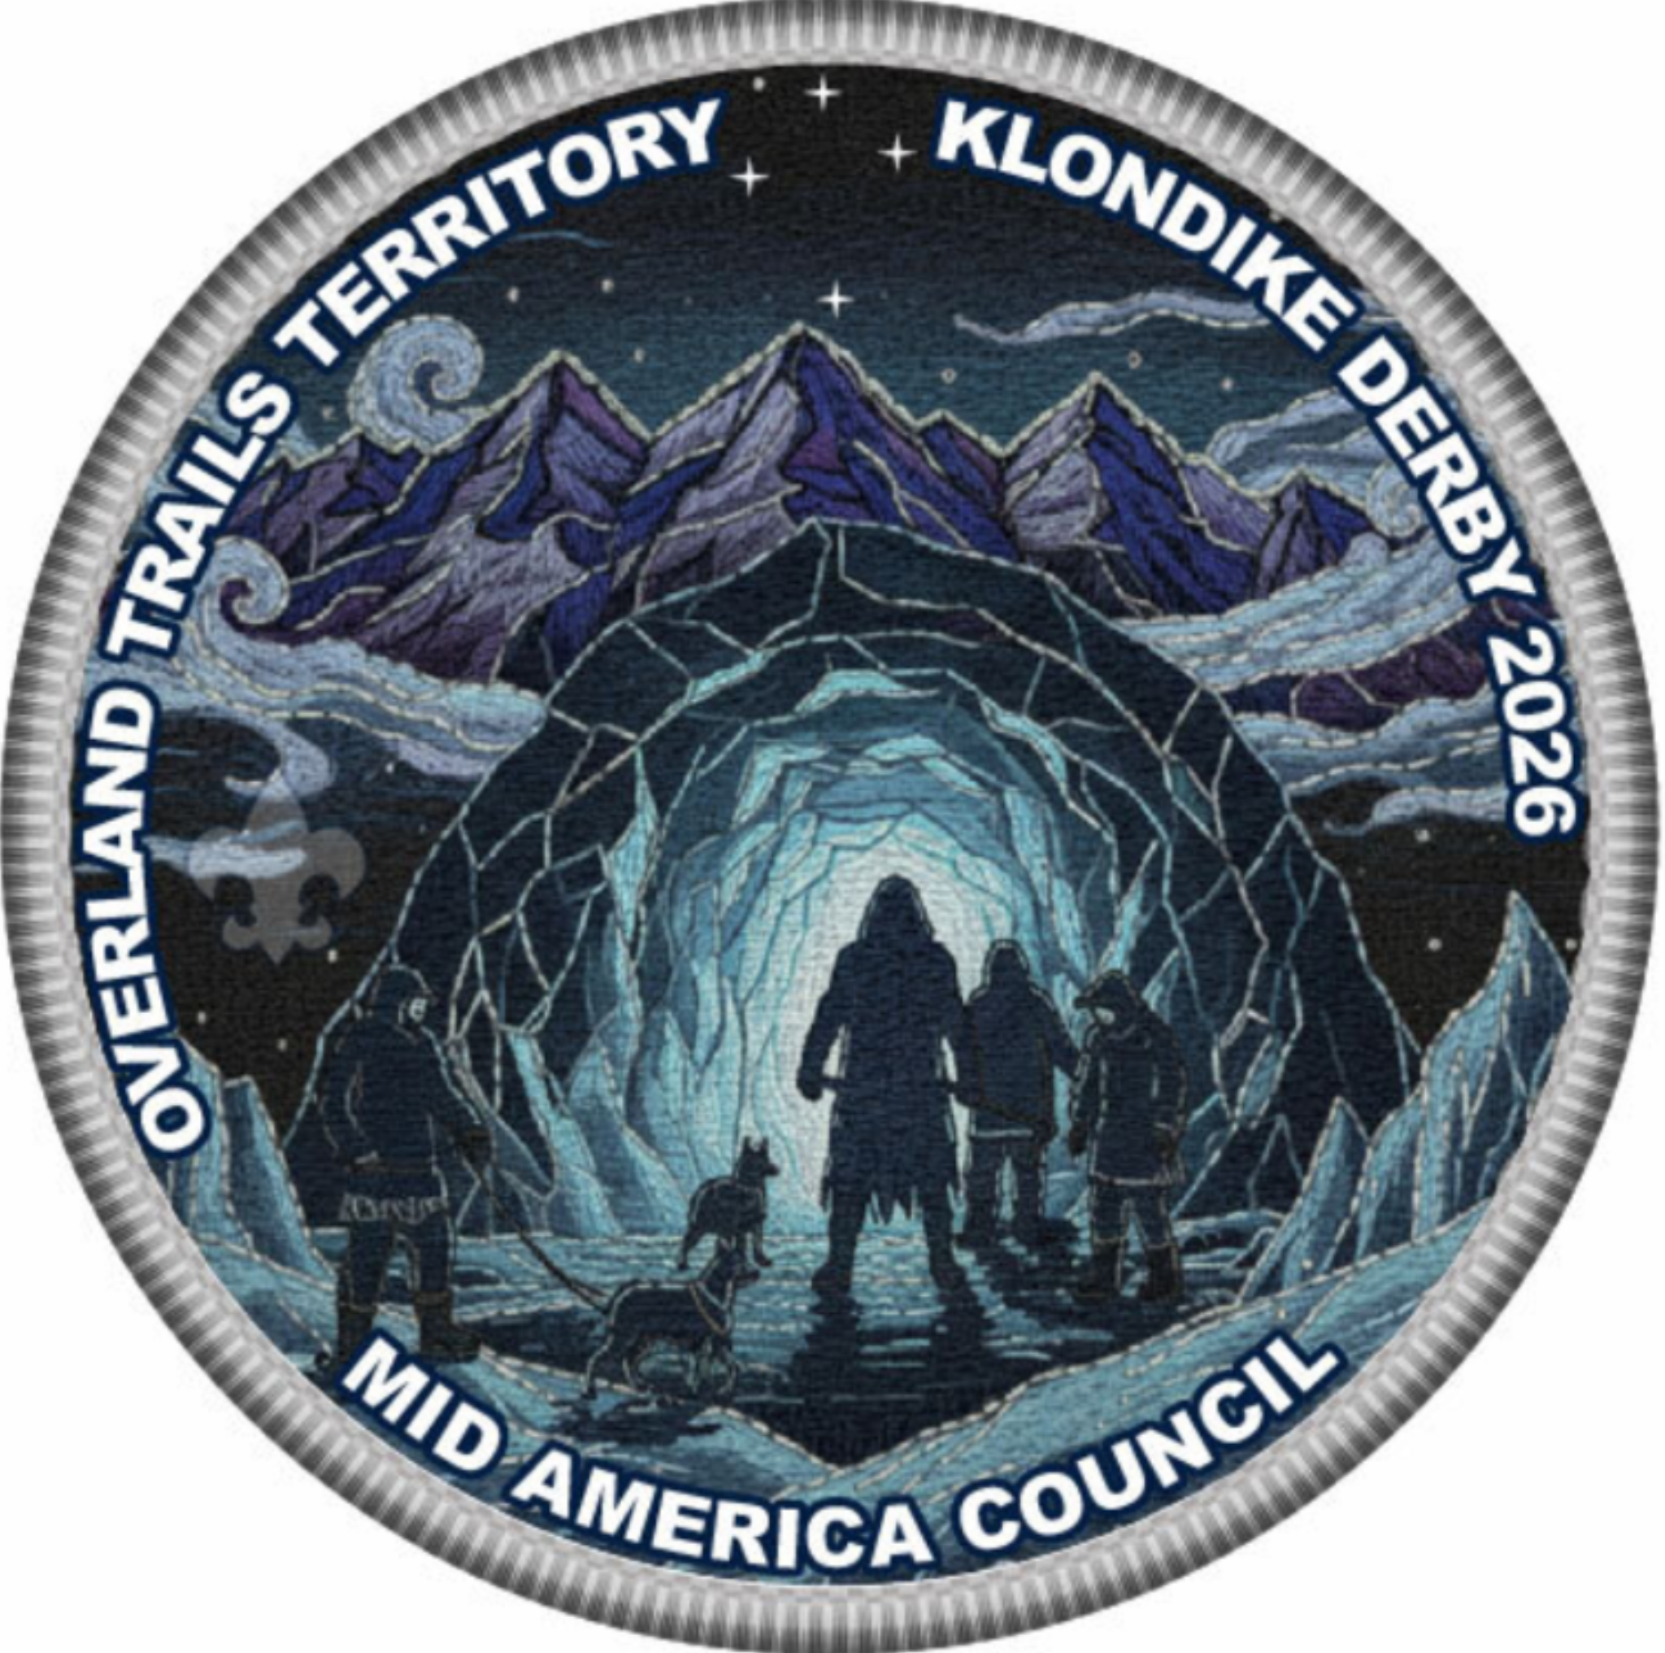

Nebraska Youth Camp
65 Sweetwater Ave S. Kearney NE 68847

January 24, 2026
REGISTRATION

ONLINE REGISTRATION
All registrations must be done on the Mid-America Council Website:
https://mac-bsa/our-council/events-calendar/

KEY DATES
Registration Ends | Jan 15 2026
Event Dates | Jan 24 2026

FEES
 | Youth Participant | Adult Leader / Non-Participant
Regular Through Jan 8 | $20.00 | $10.00
Late Jan 8-Jan 15 | $30.00 | $15.00

*Cabins will be available for units wanting to stay over on Friday. A $5.00 per person fee will be added for anyone using a cabin.

CAMPING

Nebraska Youth Camp
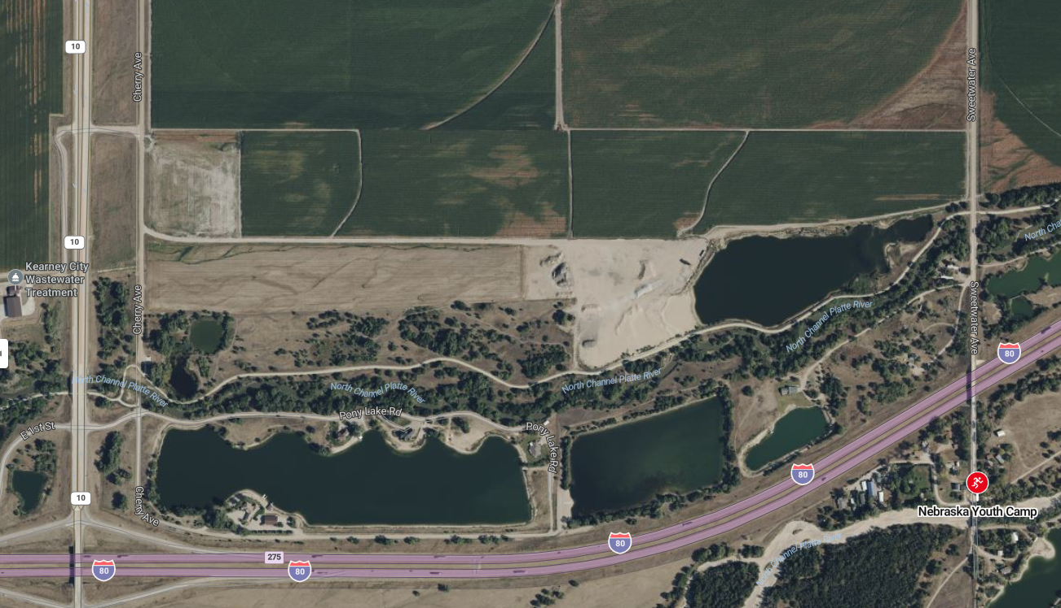
65 Sweetwater Avenue S. Kearney Ne 68847

WHO CAN ATTEND
Registered Scouts, leaders, and parents

ADULT LEADERSHIP
In accordance with Youth Protection Policies, each unit MUST provide a minimum of two-deep leadership for the event. Girl troops must have at least one female registered leader present. All adults camping overnight must be currently registered as an adult volunteer or as an adult program participant in the position(s) they are serving in and be approved by their chartered organization where applicable.

REFUND POLICY
Fees for most district and council activities are transferable to other Scouts within the unit. Partial refunds may be approved for all activities/events/camping programs including Cub Scout Family Weekends, Cub Scout Day Camps, Summer Resident Camps, MAC High Adventure Contingents, National Youth Leadership Training, Wood Badge, Powder Horn, and Exploring Programs. If approved, the refundable amount will be returned using the original method of payment, if possible. Refunds will not be considered for requests made more than two weeks from the conclusion of the activity/event/camp. There will be no refunds under $10.00. Refunds will only be considered if one of the following circumstances applies and will not exceed 80% of the fees paid.
Sickness or Injury (requires a physician’s note)
Death in immediate family (requires copy of obituary)
Relocation outside of Mid-America Council borders (requires copy of new BSA registration or military orders)
Refunds can be submitted through the Council website at: https://mac-bsa.org/camping-outdoors/scouts-bsa-camping

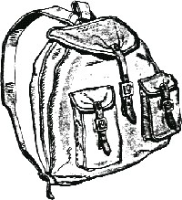
Personal Basic Packing List
Long underwear  Waterproof snow pants | Fleece or wool pants  Wool or synthetic socks
Insulated boots | Wool or fleece sweater
Winter coat | Winter Gloves
Stocking cap | Extra pair of gloves
Water bottle

Patrol Supplies
Boy Scout Handbook Pot
Pot hanger for over fire Measuring cup.
Tinder Insulated leather gloves.
Dish soap Compass
Firewood (untreated) Kindling (untreated)
Sparking device (no matches/lighters) First aid kit
Metal feed pan Splinting Materials
Notebook Pencil
6 poles at least 6 feet long 3 ropes at least 10 feet long
12 ropes at least 3 feet long (lashing) 2 warm blankets
16’ x 8’ tarp Large Bandages
Blindfold for each member Patrol Flag

*All Patrol items must be on/in/attached to a patrol sled that will be inspected upon check-in. No rules apply to the patrol sled other than it must be transportable from station to station.

PROHIBITED ITEMS
- Shooting equipment | - Illicit drugs
- Fireworks | - Knives w/blades over 3.5”
- Alcohol | - Inappropriate clothing
- Valuables | - Laser pointers
- Pornography  - Pets | - Aerosol cans  - Excessive jewelry

ACTIVITIES

Fire Starting Your patrol must use your scout skills to start a fire.

Penguin Walk Can you walk like a penguin?

First Aid You have wandered into an emperor penguin rookery and have upset all the adult penguins. They immediately start attacking you. As you try to get away from them, you trip and fall, breaking your right lower leg. While you are laying on the ground, they start pecking at you creating a large wound on your abdomen. As you try to protect yourself, one of them pecks you in the left eye. The rest of your patrol comes to your rescue, chases the penguins away, and starts treating your injuries. Treat the injuries in order of severity and transport your wounded scout to safety.

You will need two warm blankets, large bandages, splinting materials, two poles and a tarp, first aid kit, Boy Scout handbook.

Orienteering Your patrol becomes lost while looking for an abandoned outpost you heard about. In the endless frozen desert, everything looks the same. You must use your navigation skills to find your way.

Patrol Puzzle A series of crevasses has left your patrol confused. Solve a series of puzzles to find your way to safety.

Pioneering An unexpected blizzard has suddenly set upon your patrol. You must build a shelter for the night using what you can find to protect your patrol from the elements.

White Out The blinding snow has made it impossible to see. You must work together with your patrol to traverse the frigid wastes to safety.

Gather Components In addition to the seven activity areas for patrols to complete, each patrol has a supply of “Equipment Components” Every patrol has different components. Throughout the course of the day, each patrol will need to trade with each other patrol in order to acquire one of each component by trading their extra ones. This can be done between stations on the trail, at lunch, etc. Once a patrol has acquired the necessary components, they can “repair the radio” to call for help. They must still complete all 7 stations while help is on the way. These unique components will be given to each patrol’s leader at the beginning of the day.

SCHEDULE:

Friday
5:00p-7:30p: Unit check-in
10:30p: Quiet time

Saturday
8:00-8:30a: Check in/sled inspection
8:30-9:00a: Opening & Announcements
9:00-11:00a: Round robin events
11:00-1:00p: Patrol lunch. Units provide their own meal.
1:00p-3:00p: Round robin events
3:00p-3:30p: Sled race
3:35p-3:45p: Awards
3:45p-3:55p: Closing
4:00p: Depart

POLICIES

HEALTH FORMS
- Every participant, youth AND adult, must provide a copy of the Parts A & B of the Annual Health and Medical form as well as a copy of their insurance card. These will be returned at the end of the session.
- A fillable copy of the Annual Health and Medical Record can be found at:
http://www.scouting.org/filestore/HealthSafety/pdf/680-001_AB.pdf

MEALS
Units will bring and cook their own meals.

DAMAGE TO COUNCIL EQUIPMENT
- Any damage to council-owned equipment through abuse will be the responsibility of the unit.
- Replacement costs will be assessed to the unit based on the cost of the damaged item. Units will be responsible for damaged equipment before leaving camp.

PETS
No pets are allowed on camp property except for service animals or animals which are for a program/demonstration with the approval of the Ranger.

TOBACCO USE
As we set an example for our scouts, tobacco use is only allowed in personal vehicles. For the health of all scouts and scouters, please respect the rights of all others and refrain from tobacco use in your campsite or other non-approved areas. This includes the use of electronic cigarettes, personal vaporizers, or electronic nicotine delivery systems that simulate tobacco smoking.

PRIVACY
By participating in Overland Trails Council activities, you agree to allow Overland Trails Council to use your image in camp and council promotional materials.

ANTI-DISCRIMINATION
In the operation of the activity, no child, as defined by program regulations, will be discriminated against because of race, sex, sexual orientation, color, age, creed, ethnicity, national origins, or handicap.

CONTACTS
Staff Advisor: Kevin Boilesen  (308) 205-8963  kevin.boilesen@scouting.org | Event Chair: Carsen Rowley  (308) 850-6567  Troop14leader@gmail.com

