




Heartland Shooting Park
6788 W. Husker Highway
Alda, NE 68810

September 20

Cub Scout Day Camp
2025 Invention Convention
REGISTRATION

ONLINE REGISTRATION
All registrations must be done on the Mid-America Council Website:
https://mac-bsa/our-council/events-calendar/

KEY DATES
Registration Ends | September 16 2025
Event Dates | September 20 2025

FEES
 | Youth Participant | Adult Leader / Non-Participant
Regular Through Sept 10 | $25.00 | $10.00
Late Sept 10-16 | $35.00 | $15.00

CAMPING
Scheduled activities will conclude after supper, but units are welcome to camp overnight on Saturday on their own.

WHO CAN ATTEND
Registered Cub Scouts, leaders, and parents. Any non-scout youth in grades K-5 must have a parent with them for the entire event.

ADULT LEADERS
In accordance with Youth Protection Policies, each unit MUST provide a minimum of two-deep leadership for the event.

REFUND POLICY
Fees for most district and council activities are transferable to other Scouts within the unit. Partial refunds may be approved for all activities/events/camping programs including Cub Scout Family Weekends, Cub Scout Day Camps, Summer Resident Camps, MAC High Adventure Contingents, National Youth Leadership Training, Wood Badge, Powder Horn, and Exploring Programs. If approved, the refundable amount will be returned using the original method of payment, if possible. Refunds will not be considered for requests made more than two weeks from the conclusion of the activity/event/camp. There will be no refunds under $10.00. Refunds will only be considered if one of the following circumstances applies and will not exceed 80% of the fees paid.
Sickness or Injury (requires a physician’s note)
Death in immediate family (requires copy of obituary)
Relocation outside of Mid-America Council borders (requires copy of new BSA registration or military orders)
Refunds can be submitted through the Council website at: https://mac-bsa.org/camping-outdoors/scouts-bsa-camping

ACTIVITIES

Cubanapolis (Each Scout will bring their own prebuilt cardboard car. See instructions at the end of this leader guide)
Archery Stem Station
BB-Guns Fishing
Lego Pinewood Derby Leathercrafting
Raingutter Regatta Pop-Bottle Rockets

*BB Guns are not open to youth entering Kindergarten. Youth entering Kindergarten must have a parent or guardian to participate in archery. Youth entering First grade must have a parent or guardian to participate with the BB Guns and archery. All non-registered youth must have the Activity Consent Form filled out and a parent or guardian must be present throughout the whole event.

SCHEDULE

7:30-8:30 Units Check-in
8:45 Opening Flags
9:00-10:30 Cubanapolis
10:30a-12:30p Activity Stations Open, Round robin events
12:30p-1:30p Lunch
1:30p-5:00p Activity Stations Open, Round robin events
5:00p-6:00p Supper
6:00p Closing flags, event concluded.

*Activities and schedule are subject to the availability of program materials and qualified staff. While every effort is made to provide scouts with a top-notch experience, some activities may be substituted or eliminated.

Packing List

Water Bottle Closed Toed Shoes
Sunscreen Bug Spray
Completed Cubanapolis Car Jacket/Windbreaker

POLICIES

HEALTH FORMS
- Every participant, youth AND adult, must provide a copy of their annual health and medical form. Participants will receive their health form back at the end of the event.
- Parts A & B of the Annual Health and Medical Record must be completely filled out with all appropriate signatures.
- A copy of the participant’s health insurance card must be attached to the Annual Health and Medical Record.
- A fillable copy of the Annual Health and Medical Record can be found at:
http://www.scouting.org/filestore/HealthSafety/pdf/680-001_AB.pdf

DAMAGE TO COUNCIL EQUIPMENT
- Any damage to council-owned equipment through abuse will be the responsibility of the unit.
- Replacement costs will be assessed to the unit based on the cost of the damaged item. Units will be responsible for damaged equipment before leaving camp.

PETS
No pets are allowed on camp property except for service animals or animals which are for a program/demonstration with the approval of BSA leadership

TOBACCO USE
As we set an example for our scouts, tobacco use is only allowed in personal vehicles. For the health of all scouts and scouters, please respect the rights of all others and refrain from tobacco use in your campsite or other non-approved areas. This includes the use of electronic cigarettes, personal vaporizers, or electronic nicotine delivery systems that simulate tobacco smoking.

PRIVACY
By participating in Mid-America Council activities, you agree to allow Mid-America Council to use your image in camp and council promotional materials.

ANTI-DISCRIMINATION
In the operation of the activity, no child, as defined by program regulations, will be discriminated against because of race, sex, sexual orientation, color, age, creed, ethnicity, national origins, or
handicap.

PROHIBITED ITEMS
- Shooting equipment | - Illicit drugs
- Fireworks | - Knives w/blades over 3.5”
- Alcohol | - Inappropriate clothing
- Valuables | - Laser pointers
- Pornography | - Aerosol cans
 | - Excessive jewelry

CONTACTS
Staff Advisor: Kevin Boilesen  (308) 205-8963  kevin.boilesen@scouting.org | Event Chair – Aaron Blender  308-390 4578  Blender.aaron@gmail.com

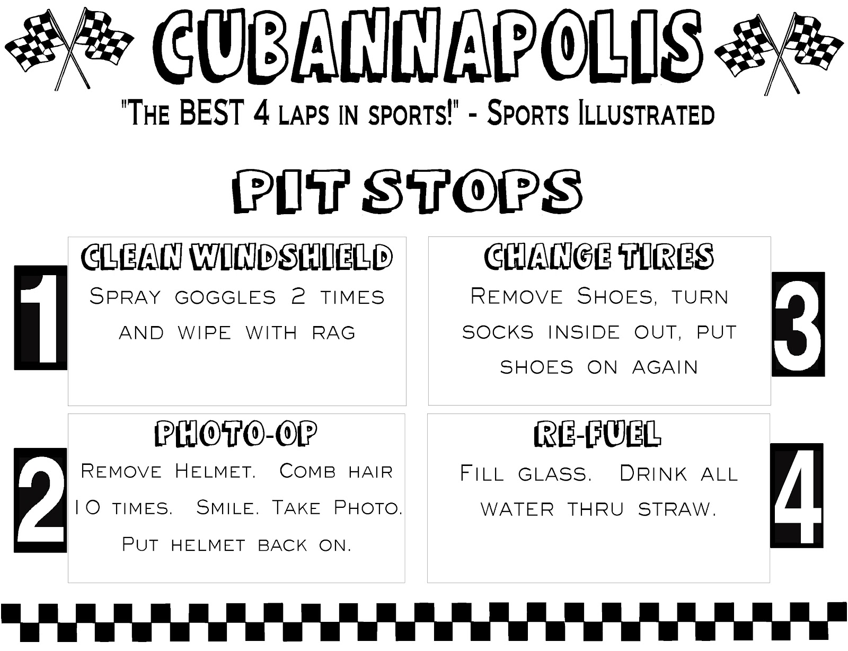

*Goggles, spray, rags, combs, and cups and straws will be provided.
For more information on Cubanapolis, go to:
Akelascouncil.blogspot.com/2016/01/cubanapolis-or-cub.html

*The final design of your Cub’s car is limited only by their imagination!

