Bear Adventure: Bear Claws 1. Learn about three common designs of pocketknives.
There are three common pocketknife designs: the pen knife, the jack knife and the multi-purpose knife.
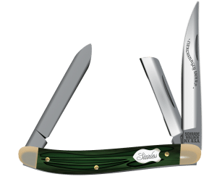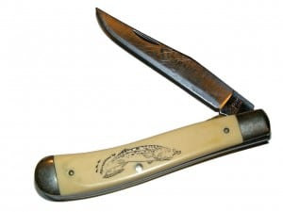
The pen knife has hinges and blades on both ends of the knife. Often, they will have two or three blades at each end. They are also smaller than the other two types.
The jack knife is only hinged on one end, but it may have more than one blade. Outdoorsmen such as hunters, campers and fishermen tend to like these knifes.
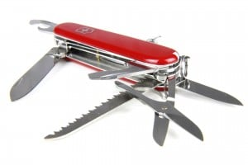
The multi-purpose knife is popular because there are so many different things they can have on them. Obviously, they'll have a knife blade, but they can also have a file, scissors, tweezers, can or bottle openers and even a mini-saw blade.

