MID-AMERICA COUNCIL OF BOY SCOUTS
PETAH LA SHAURO/DIAMOND DICK/GOLDENROD

“INTO THE WILD”

2023 LEADER GUIDE
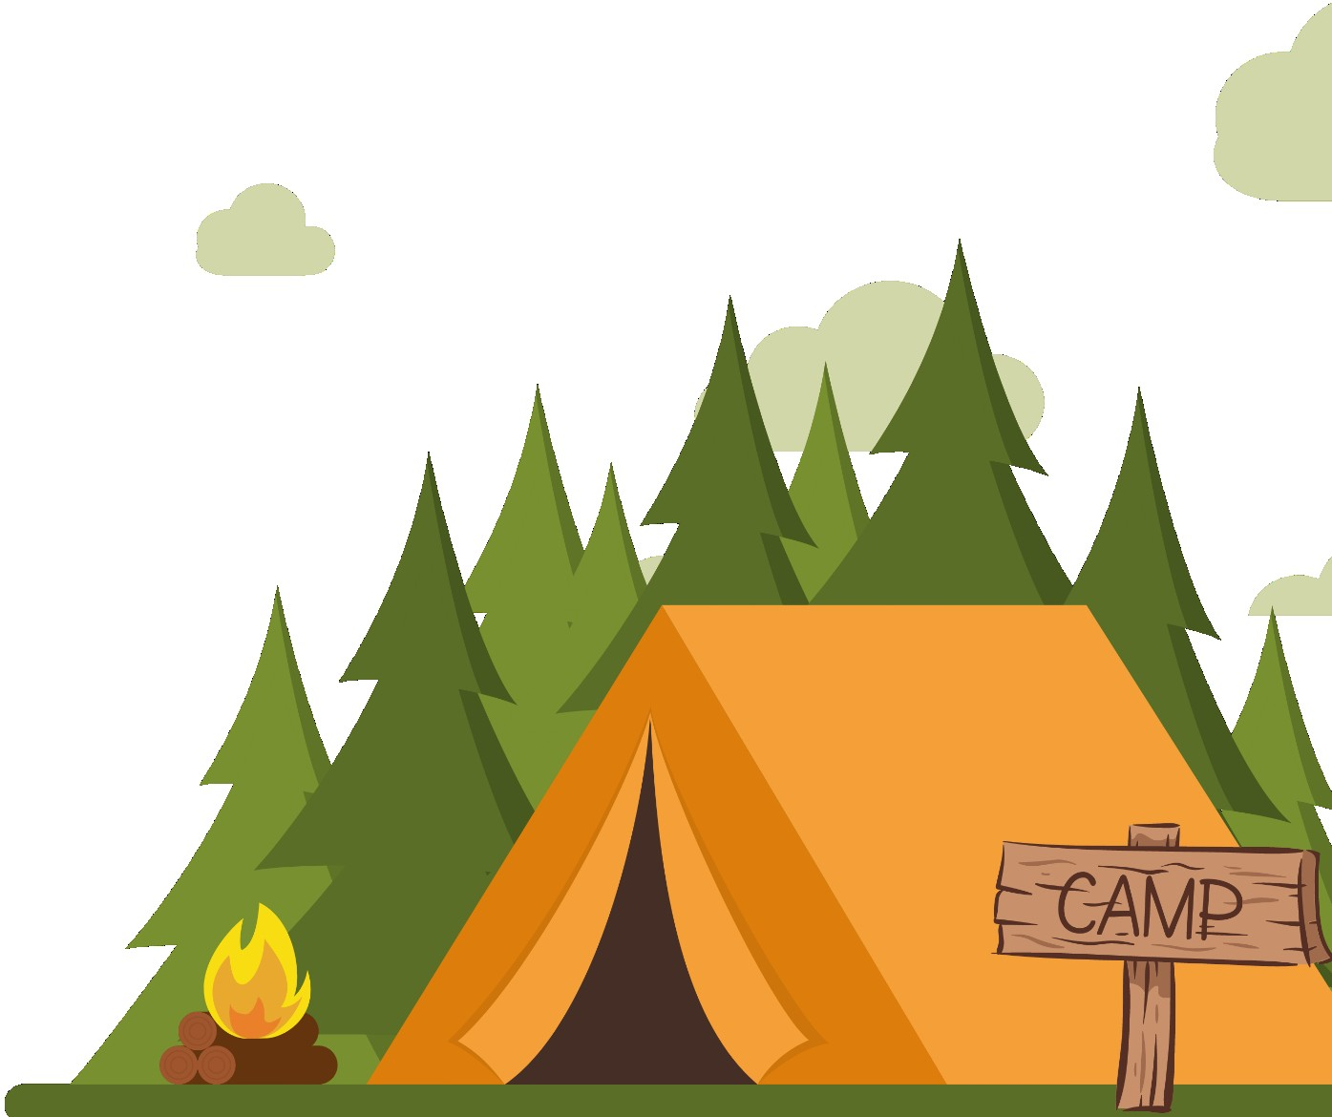

Welcome to Cub Scout Day Camp!
We are so excited to have you join us this summer at Cub Scout Day Camp! Whether you are brand new to Cub Scouts or you have attended several camps before, our Day Camp is sure to offer fun, challenges, and adventure in the great outdoors of Nebraska.

Our theme this year is “Into the Wild”! Some of the activities scheduled are archery, bb-guns, games, nature AND more. Our adventure begins with a trip to the Horn T Zoo Friday night and continues with camping at Loup Park Campground. On Saturday, we will have a full day planned with shooting sports, crafts and much more!

In this guide, you will find the information needed to prepare for a great camping experience. You will also find important details on how to be prepared for camp and what you need to bring.

We hope you find this information helpful, and we look forward to seeing you at camp!

Suanne Boswell Tracy Yost
Camp Director District Executive
Sboswell70@hotmail.com Tracy.Yost@scouting.org
402-910-8123 402-841-3037

SCHEDULE

DATES
July 28 - 29, 2023
Horn T Zoo
37692 NE 22
Monroe, NE 68647
Loup Park Campground
North of Columbus
East of 48th Ave on 83rd Street

July 28
Check In at Horn T Zoo | 6:15-6:30 pm
Horn T Zoo | 6:30 – 8:00 pm
Loup Park Campground | 8:30 – 10:30 pm
Lights Out | 10:30 pm
July 29
Check In | 8:00-8:30am
Camp Begins | 8:45am
Activities | 9:00am-12:00pm
Lunch | 12:00-1:00 pm
Activities | 1:15-4:15pm
Closing | 4:15 – 4:30pm

CAMP FEES

Participants:
- Scouts - $25
- Siblings − $15
- Non-Scout Youth - $35
- Adults - FREE with optional $15 t-shirt purchase
- Includes - Scouts will receive a patch, a t-shirt and supplies (if registered & paid by July 7th). Siblings and Non-Scout Youth will receive a t-shirt and supplies also.

Staff:
- Youth: FREE - t-shirt included (if registered by July 7th)
- Adults (18+) with Current BSA Registration: FREE - t-shirt included (if registered by July 7th)
- Non-BSA Registered Adults (18+): FREE - t-shirt included (if registered by July 7th)
- Youth staff must be 14 yrs. old to be considered staff. 12-13-year-olds will be volunteer assistants.

Day Camp is open to all registered Cub Scouts, leaders and parents. Siblings and Non-Scouts may attend camp. Youth who register and are paid in full by July 7th are guaranteed to receive a free camp t-shirt.

REFUNDS
Part of a Scout’s fee will be refunded only under one of the following circumstances:
- Individual illness or injury
- Death or serious illness in the immediate family
- Relocation of the family outside of the Mid-America Council

Refunds may be requested up to two weeks after the camp. Refund forms can be found at https://247scouting.com/forms/?OrgKey=BSA326&id=937 Registration fees can be transferred to another summer camp in the same year or to another Scout.

IMPORTANT CAMPER INFORMATION

CUB SCOUT TO ADULT ATTENDANCE RATIO
- Tigers Scouts (1st grade fall 2023) - All Tigers must have a parent/adult with them.
- Wolf & Bear Scouts (2nd & 3rd grade fall 2023) 2 adults per 1-8 scouts
- Webelos (4th & 5th grade fall 2023) 2 adults per 1-10 scouts
- Scouts not attending with their unit need an adult to attend with them.

BSA NATIONAL STANDARD OF TWO-DEEP LEADERSHIP
All adults must be at least 21 years of age and a registered leader or participating parent. National Scouting policy requires two-deep leadership (two registered adult leaders/parents). It is not required that each Scout have their parent/guardian attend for the Scout to attend except for Tiger Cubs, which do require the attendance of the Tiger Adult Partner. All Scouts must have adult leadership from either their parents or their unit present. Our Day Camp maintains the above ratios of leadership to ensure the BSA’s National Standard is met.

STAFF RESPONSIBILITIES
Our staff is responsible for making sure you have a great time at Day Camp. If there is anything we can do to assist in your camp experience, please let us know. Our staff are registered members of the BSA and are trained not only in their assigned areas, but also in things like Youth Protection Training, harassment identification, emergency procedures, and more. Staff are meant to support the program offered at camp, not to provide adult leadership and discipline for your pack.

CAMPER DISCIPLINE
Discipline is the responsibility of the adult leadership attending with the Pack. The camp staff are available to help with, but not take over, any discipline problem. Under no circumstances is corporal punishment allowed. Take all serious discipline problems to the Camp Director. The Camp Director reserves the right to remove any person from camp who may present a threat to any Camp Staff, camp attendees, or the camp property. All packs must provide the appropriate leadership ratios following the BSA guidelines outlined on scouting.org and in this Leader Guide.

MEALS
All campers, adults and leaders must provide their own lunch & snacks.

INSURANCE
The Mid-America Council has purchased the National Boy Scouts of America Council Accident & Sickness Insurance Plan, which will cover all registered Mid-America Council Pack, Troop and/or Crew member for both accidents and illnesses that manifest during participation in Scouting activities.

HEALTH & SAFETY
Our day camp will be staffed with a medical staff on hand during camp hours. Our health officer must check all medications, prescriptions and non-prescription drugs brought to camp, in accordance with BSA policy. All medications must be brought in the original container with the name of the person it belongs to clearly labeled. All injuries at camp must be reported to the First Aid station and registered in the camp’s first aid log.

HEALTH FORMS
All campers, including adults, MUST bring a copy of their BSA annual Health & Medical Record with parts A & B completed within the past 12 months. School physical forms cannot be accepted. Please use this form found online at
http://www.scouting.org/filestore/HealthSafety/pdf/680-001_AB.pdf and bring it to camp. There are no waivers nor exceptions. Each individual should have their own health form available to turn in during check-in. Do not list more than one person on the form. Health forms should be picked up before leaving camp.

WHAT TO BRING TO CAMP

- BSA Health History Form Parts A & B
- Sack lunch
- Water bottle
- Sunscreen
- Hat
- Tennis shoes
- Uniform – will be any scout T-shirt (would like everyone in the camp t- shirt for Saturday)
- Cooler for lunches

DIRECTIONS TO CAMP

Loup Park Campground:

From the North: Turn left on 265th St. There is a sign that states Lakeview High School. Entrance is 4.4 miles after turn off. Continue past 48th Avenue and entry will be on your right. Continue thru the park until you see the Shelter.

From the East: Turn right onto the bi-pass by Walmart. Turn right at Wilderness Park/Monastery Rd (first set of stoplights). Continue North until 83rd St., turn left. (Lake Stop will be on the right). Continue 2 miles and entry will be on your left. Continue thru park until you see the Shelter.

From the West: From Hwy 22, turn left onto Hwy 81. Continue North to 265th St. Turn right and continue for 4.4 miles. Once past 48th Avenue, entry will be on the right. Continue thru the park until you see the Shelter.

48TH AVENUE AT THE LOST CREEK PARKWAY

IS CLOSED FOR CONSTRUCTION!!

ARRIVAL AND CHECK-IN PROCEDURES
  - Please plan on arriving at camp between 8:00am – 8:30am. Parking space is limited at camp, so we recommend that packs carpool and caravan to camp.
  - Upon arrival, please check in at the shelter. Each person will be required to turn in the Health forms for ALL PARTICIPANTS and will receive their T-shirt & wristband.
  - ALL participants will be required to wear a wristband. This camp is being held at a public park and for security reasons, we need to know who is supposed to be in our dens. Anyone without a wristband should be asked to go to the Camp Headquarters.
  - Medical Forms will be reviewed by our medical staff and kept at the first aid station.
  - Scouts who need to leave early must have a signed permission slip from the parent and notify their unit leader and the Camp Director by the morning of the early release. Any individual planning to pick up a scout from camp should be listed on the medical form and must show ID at the time of pick up from the camp headquarters.

EMERGENCIES
We will have a health officer in camp each day. The First Aid Station will be located near the Camp Headquarter/check-in area. Staff in each area will have radios or phones that can communicate with the camp directors and health officer.

END OF CAMP
Prior to leaving, the Pack Leader should pick up the medical forms and evaluation forms. Your feedback and comments on your experience at camp are very important to us. Please complete the evaluations and turn them in before leaving. Your comments will help us to improve the experience for next year’s day camp.

OTHER IMPORTANT RULES TO KNOW
  - Do not bring any of the following items to camp: bikes, electronics, knives of any kind, tobacco, alcohol, unapproved drugs, pets or personal shooting equipment. See Camp Director for a
designated smoking area.
  - Do not attempt to touch or feed any wildlife. Report any wildlife that behaves in a strange manner to a staff member. This includes showing no fear of humans, biting, scratching, etc.
  - Do not wear open-toe sandals or flip flops to camp.
  - Any form of bullying, hazing, ridicule, or fighting is unacceptable and may result in expulsion from camp.
  - All scouts and adults must carry a water bottle or hydration pack at all times.
  - Scouts are required to use the “buddy” system when traveling through camp.
  - Profanity is unbecoming of a Scout and is not tolerated in camp from any participant or leader.
  - Sign-in and sign-out procedures are required. All visitors need to sign in and out through the Camp Headquarters.
  - Adult leaders must report any suspicion of abuse to the Camp Director immediately.
  - Please help us keep the park clean by placing all trash into the trash containers located throughout the park.
  - Lost items may be turned into the Camp Headquarters. Items not claimed within 2 weeks after the completion of camp will be given to a charitable organization.
  - Weather can be unpredictable throughout the summer. Everything from hot summer days, thunderstorms, and chilly days – BE PREPARED. Check the forecast each day. Don’t forget jackets or rain gear for chilly or wet days. The Camp Director and Short-Term Director will be watching the weather throughout the week. In the event of severe weather, the Camp Staff will guide the
campers to the nearest shelters.

