
In This Book  - Welcome Letter  - Registration Fees  - Registration Worksheet  - General Camp Information  - Program Schedule  - Personal Equipment List  - And Much More…   | 2026 Webelos Resident Camp  Session 1: June 21st – June 24th, 2026  Session 2: June 24th – June 27th, 2026  Parents and Unit Leader’s Guide    CAMP CORNHUSKER  https://scoutingevent.com/324-Webelos20  CAMP CORNHUSKER  https://scoutingevent.com/324-WebCamp26
TABLE OF CONTENTS
TOPIC | PAGE NUMBER
Welcome Letter |  | 3
Webelos Camp Information |  | 4 – 5
Camp Registration Fees |  | 6
Miscellaneous Camp Information |  | 6 – 9
Camp Safety |  | 10
Camp Registration Form |  | 11
Schedule |  | 12
What to Bring |  | 13
Contact Information |  | 14
Camp Map |  | 15
Welcome to Camp Cornhusker - 2026
Dear Parents and Cub Scout Leaders,
Welcome to our Webelos Resident Camping Program this year as we help your Webelos/AOL Scout transition to Scouts, BSA. Our team has been working hard to create a fun schedule to get your Webelos excited for camp this summer. This year we will be doing round robin rotations by Webelos and Arrow of Light. We hope that you enjoy the change as you get to select from our offerings the program that best suits your child.

The Cornhusker Council is pleased to offer 2 sessions of Webelos Residents Camp in June. These take place at our very own Camp Cornhusker in southeastern Nebraska, near the city of Humboldt. Each session is 4 days and 3 nights in the lovely outdoors.
Camp Cornhusker offers many other amenities as well as our Webelos Program. There will be scheduled free time with your campsite group to go visit the target ranges and aquatic activities as well as our other program areas. One can always hike the many trails we have around camp. We highly encourage adult participation in all of these activities.

Registration can be found on the Council website, https://scoutingevent.com/324-WebCamp26. When you register, you will be asked to choose what particular activity programs your youth need. This will be based on taking either the Webelos Activities or the Arrow of Light Activities.

We are looking forward to seeing you and your Webelos/AOL Scout at Camp Cornhusker this summer. I can assure you that this will be an opportunity to make life long memories with your Scout. Please contact us if you have any questions.
Sammi Lowery | Camp Cornhusker Camp Director
800 South 120th Street | P.O. Box 269
Walton, Nebraska 68461
C 1-402-770-4327| campcornhuskerbsa@gmail.com
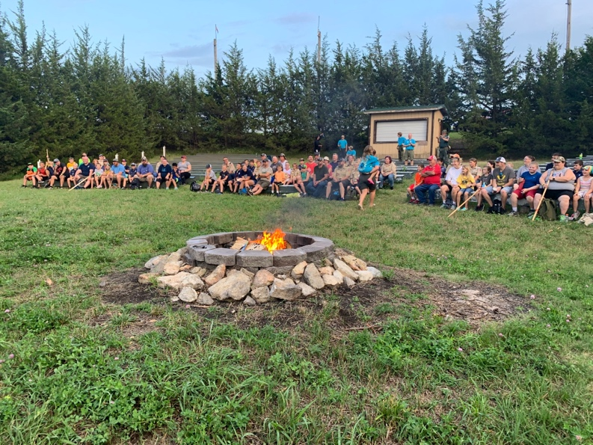
Webelos Resident Camp
Webelos Camp provides a fun-filled environment, with just the right mixture of challenge. Cub Scouts graduating third or fourth grade in your Bear/Webelos Dens are rapidly expanding their horizons. Webelos Camp gives them a peek at what is just over the hill. The activities are planned specifically for Webelos/AOL’s and will greatly aid the Webelos Leader in helping those energetic Scouts try new skills in the outdoors. Webelos/AOL’s will be instructed in a variety of activity and advancements throughout the entire four days at camp.

Webelos Camp provides an excellent growth opportunity as Scouts make the transition from Cub Scout Day camping to the long-term camping experience they will have in their future years in a Scouts BSA Troop.

How to Get in on the Action
Getting ready for Camp is easy. First, read the material included in this Parent and Unit Leader’s Guide. Second, contact your Scouts and their parents to discuss the exciting opportunity that going to these camps will provide for them. Talk it over and talk it up! It'll make for a high point in their years of Cub Scouting!

- Plan a simple money-earning project, use popcorn monies or begin to collect the camp fees.
- Decide on which Leaders and parents are going to accompany the scouts.
Get registered for Camp. You can register and pay on the Cornhusker Council website. https://scoutingevent.com/324-WebCamp26



Webelos Camp
Remember, Bear Cub Scouts will become First Year Webelos on June 1st of this year. Scouts will participate in exciting activities and leave well on their way to completing several activity pins.
Your current First Year Webelos will be Arrow of Light and are encouraged to attend any of these fun-filled sessions. They will have activities designed to get these Scouts ready for the fun of Scouts, BSA.
The staff will be working with the Scouts and Leaders to help them to improve their outdoor camping skills. Outdoor cooking, Scout crafts, and Scouting skills will be emphasized along with a few additional activities. Your Scouts will have the opportunity to tour the entire camp and see the different program areas that will be available to them when they return with their Scouts, BSA Troop.
Whether you have brand new Webelos, or an Arrow of Light, camp is for them. Webelos Camp is also for Leaders and parents of Webelos/AOL.

Camp Dates and Locations
Two exciting four-day/three-night Webelos sessions are planned.

Webelos Session 1: June 21st – June 24th, 2026
Webelos Session 2: June 24th – June 27th, 2026

*All Camps will be held at Camp Cornhusker, south of Humboldt. *

Online Registration
Participants will need to register for Webelos Camp online this summer. Using the Cornhusker Council website https://scoutingevent.com/324-WebCamp26.

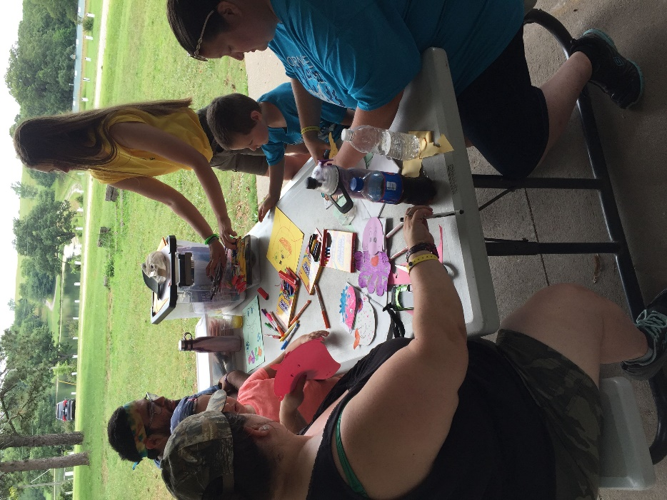
Camp Fees and Registration
Camp fees include the cost of 8 meals, a camp patch, a camp t-shirt (if registered by June 1st), qualified staff, and all program supplies. Please see scholarship information on page 8.

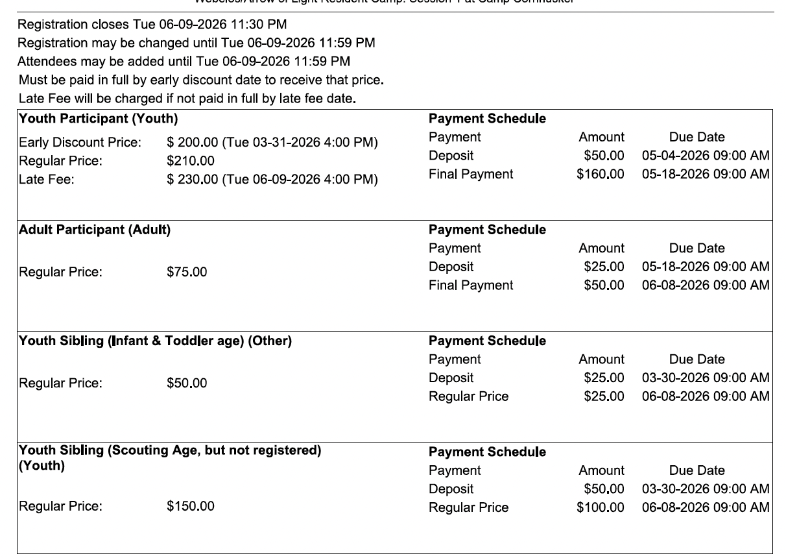

For youth siblings not enrolled in Scouting (ie: nonparticipant youth) $150 infants and toddlers $50 Webelos Resident Camp
All Scouts must be registered as members of Scouting America and have all camp fees paid in full to attend camp and participate.
Each participant, Scout, adult, or family member, must be registered using the Council Website.
If you cannot attend camp the same session as your Den or Pack, please feel free to register for a session that fits your schedule.
Payment of all fees must accompany your registration. No registrations will be accepted without the appropriate fees included.

Adult Leadership

In accordance with the National policies of Scouting America, Cub Scouts can go camping on a limited basis, only when accompanied by Cub Scout Leaders and/or parents. The leadership policy of the BSA states that a minimum of two adult Leaders (one age 21 or older, and the other a minimum of 18) are required for each Pack trip or activity.

While your group is in camp, they will be in campsites of more than one group/pack. It is recommended that parents take their Scouts to camp and meet their Leader there at the beginning of the session and pick them up at camp at the end of the session.

For each camp you will need enough adult leaders or parents attending to satisfy the following minimum adult to youth ratios.

*Webelos Camp - One Adult for every 5 Scouts, with a minimum of 2 adults for Two-Deep Leadership. *

If you have a question about this policy, please contact the Council Scout Executive at the Cornhusker Council Service Center.

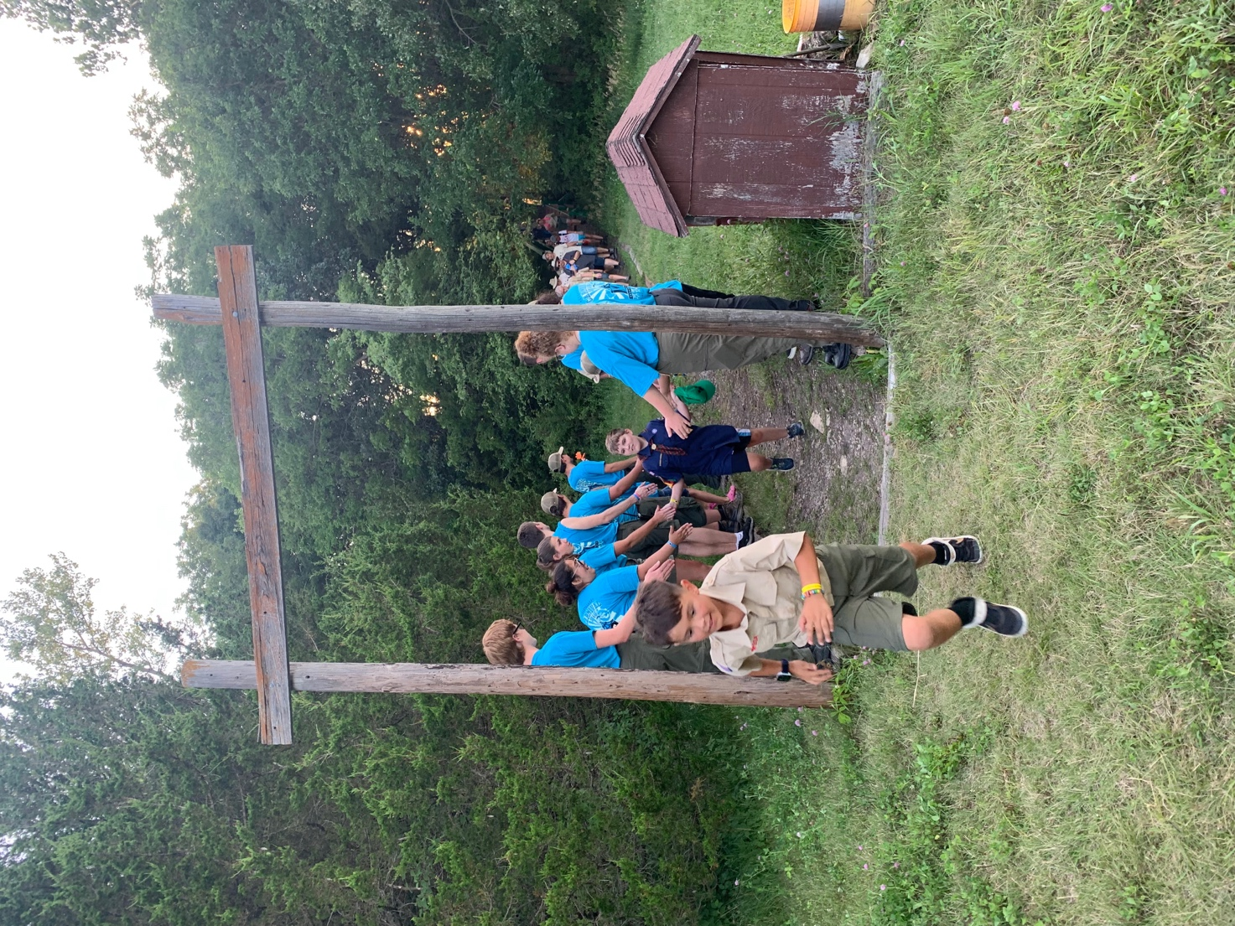
Camp Scholarships

Camp Scholarships for Cornhusker Council Cub Scouts demonstrating financial need is available. Visit https://www.cornhuskercouncil.org/camping/camp-fees-scholarship-and-refund.html or contact the Council Service Center for more details. Deadlines are rolling, so make sure you apply early. Scholarships are non-refundable and non-transferable.

Arrival
We would appreciate it if your pack arrives together. Activities start in the evening. The Staff will be on hand to greet you and take you to your campsite to get settled.

Check-In
You must check-in immediately upon arrival at camp at the designated check in location. Make any last-minute corrections to the registration information previously sent in. You will receive a wristband and go through a medical recheck at this time. After the staff transports all their equipment to the campsite, participants will need to change into their swimwear and bring a towel to orientation. They then proceed to the pool for a swim check. Upon completion of their swim check, participants will return to their campsite to set up camp.

***New: A Range Safety Briefing is needed for Scouts who will participate in BB guns during rotation time or free-time. All Scouts and Leaders must do this training, otherwise you will not be able to participate per BSA policy.

Check-Out
All campers will leave with their Leaders and/or parents by 9:00 a.m. on the final day of their program. Please coordinate this with the parents in your Dens. At any other time, campers will be released from camp only in the company of a parent or guardian and only after the approval of the Camp Director.

Camp Housing
All camp participants will need to bring their own tents and will sleep in designated campsites. No facilities are available for campers or motor homes. All cars are to be parked only in the designated parking lot. No vehicles are permitted in campsites.
The camp has tents and cots for rent on a first-come, first-served basis. Cots are available at a cost of $10.00 per session per person. Tents are available at a cost of $20.00 per session. If you want a cot or tent, you can request them upon check-in at camp.
It is the responsibility of the camper to pick up the rented material at the camp Quartermaster located on the north side of the camp Admin. Building, set it up and return it at the end of camp.
All campers and Leaders are reminded that they are responsible for any damage, above ordinary wear and tear, they might cause to camp facilities or equipment.

Dining Hall
All meals will be served in the Dining Hall

Camp Visitors
The last day of the event we will host family night starting at 4:00pm.

Trading Post
All activities and projects in camp have been included as part of the camp fee. There will be a Trading Post, however, to provide additional snacks and souvenirs. Scouts may wish to bring some spending money (est. $25.00 to $30.00).
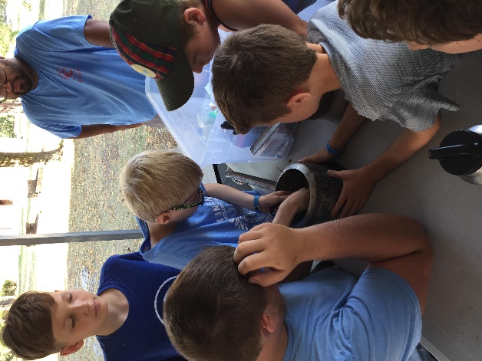


Camp Health and Safety

Footwear
Shoes are always to be worn in Camp.

Annual Health and Medical Record
The BSA recommends that all youth and adult members have annual medical evaluations by a certified and licensed health-care provider. Parts A and B are to be completed annually by all Scouting America unit members. Both parts are required for Webelos Resident Camp.
All participants, youth and adult, MUST bring the Annual Health and Medical Record with Parts A & B completed. This is the National Health Form, and it is required. You will not be allowed to stay in camp without one. Health forms are found at https://www.cornhuskercouncil.org/camping/scouts-bsa/. Health forms will be turned into the Camp Health Officer at check-in.

Camp First Aid Station and Health Office
A qualified Health Officer will be on duty at the camp. All illness or injuries must be reported to the Health Officer no matter how minor. In the event of serious illness or injury, the Camper will be taken to a clinic or hospital for treatment. Parents will be notified and billed directly by the doctor or hospital.

Prescription Medication
Medication may be kept at the First Aid Station or in a locked container that is held by the adult participate. It is the responsibility of the adult partner or Unit Leader to make sure all medications are properly taken.

Pets
No pets of any kind are allowed at camp.

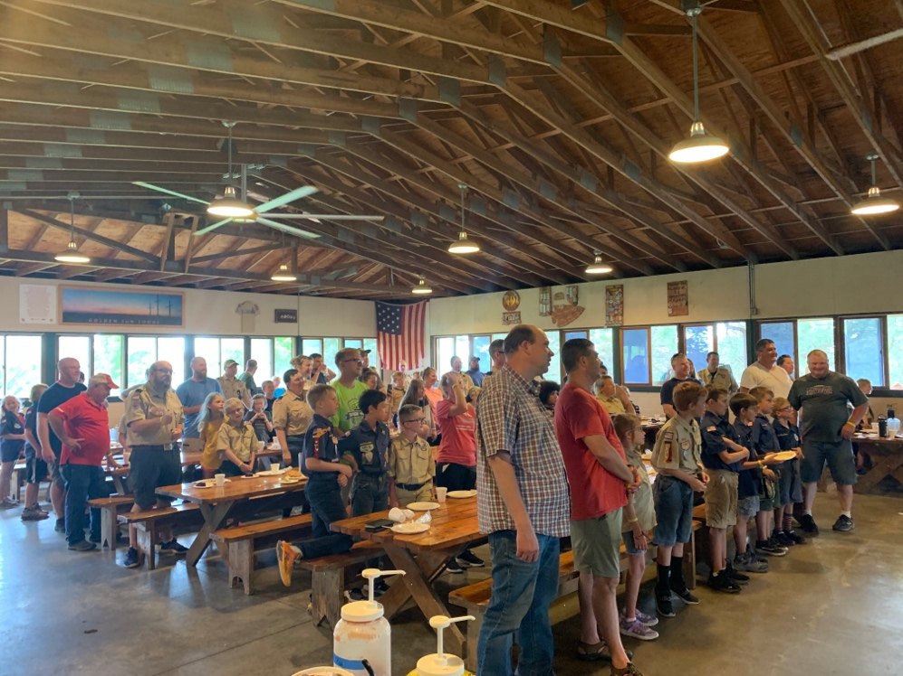
To reserve your spot at one of the great resident camps this summer, use this worksheet to help you prepare your online registration where you can submit your camp registration fee. If a Scout attends more than one camp, you will have to complete a registration for each camp.

Participant Information Pack Number
Name
Address
Telephone Age
T-Shirt Size_________________
Activity Selection Webelos or Arrow of Light

Adult Partner or Leader
Name
Address
Telephone Age ________
T-Shirt Size_______________

Camp Session Information
Which Camp Will You Be Attending? | __Webelos Camp 1  (June 21-24, 2026) | __Webelos Camp 2  (June 24-June 27, 2026)

For youth siblings not enrolled in Scouting (ie: nonparticipant youth) $150 infants and toddlers $50 Webelos Resident Camp

Camp Fee Calculation

Camper Fee (based on above)
Adult Partner/Leader Fee (based on above)
Total Fees

Time | Day 1 | Day 2 | Day 3 | Day 4
7:15 AM |  | Assembly Call | Assembly Call | Assembly Call
7:20 AM |  | Flag Ceremony | Flag Ceremony | Flag Ceremony
7:30 AM |  | Breakfast | Breakfast | Breakfast in campsite
8:30 to 11:30 AM  Session Rotations  8:45 to 9:30  9:45 to 10:30  10:45 to 11:30 |  | Sessions  *Archery Day 1  *Aquanaut Day 1  *Let’s Camp Webelos  **BB Gun Day 1  **Champions of Nature  **Fishing | Sessions  *Archery Day 2  Aquanaut Day 2  * Modular Design  **BB Gun Day 2  **Paddle Craft  **Into the Woods | 9:00 Check-Out and Depart
11:45 AM |  | Assembly Call | Assembly Call | *Activities for Webelos  **Activities for Arrow of Light  ~ When signing up online you will note Webelos or Arrow of Light and that will determine which Cohort and Classes you will participate in.  ~All Scouts and Leaders who are wanting to participate in BB Guns, even during free-time must attend a safety briefing
12:00 PM |  | Lunch | Lunch
12:30 PM |  | Personal Time | Personal Time
1:00 to 4:00 PM  Session Rotations  1:15 to 2:00  2:15 to 3:00  3:15 to 4:00 | 1:00 to 4:00 PM  -Camp Tour  -Swim Checks  -Set Up Camp | Sessions  *BB Gun Day 1  *Paddle Onward Day 1  *Catch the Big One  **Archery Day 1  ** Engineering  **Knife Safety | Sessions  *BB Gun Day 2  *Paddle Onward Day 2  *Earth Rocks  **Archery Day 2  **Into the Wild  **Swimming
4:30 to 5:30 PM | Finish Set Up Camp  4:30pm Range Safety Briefing with Cohort | Open Time:  All Areas Open  Pool Open | Open Time:  All Areas Open  Pool Open
6:00PM | Assembly Call | Assembly Call | Assembly Call
6:10 PM | Flag Ceremony | Flag Ceremony | Flag Ceremony
6:15 PM | Dinner | Dinner | Dinner
7:00 to 10:00 PM | 7:15 PM  -Finish Swim Checks  - Adult Leader Meeting  7:15pm-8:00pm  -Open Swim  8:30pm  -Opening Campfire | 7:30- 9:00pm  Open Time  All Areas Open  Waterfront Open | 8:00pm  Closing Campfire
10:00 PM | Taps – Good Night | Taps – Good Night | Taps – Good Night

Here is a suggestion list of equipment for Scouts to take to summer camp. Double check the list carefully and add items you feel necessary from the Unit’s point of view.
Need To Have Nice To Have
Tent 1/camper
______Coolers for transporting food _____ Cot/air mattress
Sleeping bag or blanket/sheet and pillow Fishing gear
Scout field uniform (Class A) Camera Watch
Clothing for length of stay including:
underwear, socks, shirts, long pants, shorts,
sweater/jacket, pajamas
Swim wear
Appropriate shoes
Toilet kit containing:
washcloths, towels, comb, toothpaste,
toothbrush, soap
Sunscreen and lip balm
Insect repellent-NO AEROSOL CANS!
Ground cloth/sleep pad Note
Rain gear or poncho *Be sure to label all clothing
Water bottle and equipment with Scout’s
Wallet and money name and Pack number.
Den level Scout Handbook *Remember that the Scout and
Current medical form Part A&B Leader are responsible for all
Any prescription medications their own items.
Flashlight and extra batteries
DO NOT BRING
- NOT BRING ANY KIND OF KNIFE (other than a pocketknife, must have Whittling Chip to carry) 2. ALCOHOL 3. PERSONAL ARCHERY EQUIPMENT 4. PETS 5. FIREWORKS OR FIREARMS. 6. SCOUTS SHOULD NOT BRING CELLULAR PHONES. 7. NO AEROSOL CANS ARE ALLOWED AT CAMP.

Camp t-shirts will be included as part of this year’s registration fee. Please indicate your size as you complete registration.
Deadline for pre-order Shirts is June 1st, 2026.
After that date, t-shirts cannot be guaranteed.

All of the forms needed for Camp are available for download from the
Cornhusker Council website at https://scoutingevent.com/324-WebCamp26

Address:
Camp Cornhusker
63375 703rd Trail
DuBois, NE 68345-5032
Phone:
402-862-2601
***Only during Camp season, call Council Service Center otherwise***

Cornhusker Council Outdoor Education Center
800 S 120th St P.O. Box 269
Walton, NE 68461-0269
Phone:
402-488-6020

Camp Management Team
Sammi Lowery | Camp Director
Thomas Bucks | Program Director

SCOUTING AMERICA
Cornhusker Council

C 1-402-770-4327 | campcornhuskerbsa@gmail.com

