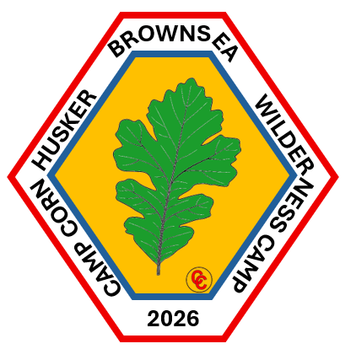
Camp Cornhusker Brownsea Wilderness Camp
Jun 21, 2026 - Jun 27, 2026
https://scoutingevent.com/324-BrownseaWilderness
What Makes Brownsea Wilderness Camp Special
- A true wilderness-style camp focused on outdoor living and Scout skills.
- Hands-on learning in Pioneering, Orienteering, American Indian Culture, Scouting Heritage, Nature, Wilderness Survival. first aid, and teamwork.
- Challenges, Games, and Some free time will also be included in the experience.
- Patrol-based program that builds confidence, leadership, and independence.
- Experienced, enthusiastic staff dedicated to helping Scouts succeed.
What Advancement Could be Earned:
- Pioneering, Orienteering, Wilderness Survival, Signs, Signals & Codes, Nature, and American Indian Culture.
- Other advancements may be possible in ranks and merit badges but will have to be done with other merit badge councilors and unit scoutmaster.
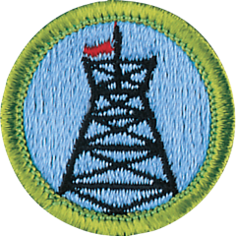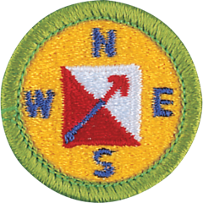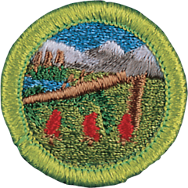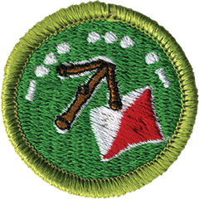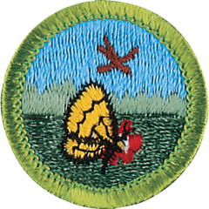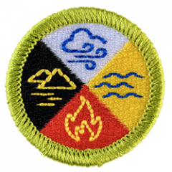

Pioneering: https://www.scouting.org/merit-badges/pioneering/
Requirement covered: 1,2,3,4,5,6,7,8, & 9
Requirements not completed or must be done in advance:

Orienteering: https://www.scouting.org/merit-badges/orienteering/

Requirement covered: 1,2,3,4,5,6,7,8, & 9
Requirements not completed or must be done in advance: 10

Wilderness Survival: https://www.scouting.org/merit-badges/wilderness-survival/

Requirement covered: 1,2,3,4,5,6,7,8, 9,10,11 & 12
Requirements not completed:

Signs, Signals, & Codes: https://www.scouting.org/merit-badges/signs-signals-and-codes/
Requirement covered: 1,2,3,4,5,6,7,8, 9, & 10
Requirements not completed:

Nature: https://www.scouting.org/merit-badges/nature/
Requirement covered: 1,2,3,4b,4c,4e,4g,4h,
Requirements not completed:

American Indian Culture: https://www.scouting.org/merit-badges/american-indian-culture/
Requirement covered: 1,2,3,4, & 5
Requirements not completed or must be done in advance:

Scouting Heritage: https://www.scouting.org/merit-badges/scouting-heritage/
Requirement covered: 1,2,3,4, &
Requirements not completed or must be done in advance: 5,6,7,& 8

Goals for Scouts:
- Provide a camp for individual campers
- Model part of the Brownsea concept that was initiated by Baden Powell and Silver Bay camping concept that was done by Seton Hall and Silver Bay Camp
- Provide advancement possibilities during the week long camp.
- Provide new and unique scouting adventures during a week long camp
- Provide experiences in the patrol and troop method.
- Provide scouting skills for lifelong character development.
What does the scout need to bring:
- Tent
- Sleeping bag
- Scout uniform
- Cloths for outdoor adventures
- Pants
- Swim Cloths for pool use
- Showering materials
- Pocket knife
- Notebook and Writing equipment
- Toiletry equipment
- Rain gear.
- Backpack (Large Day pack or small backpacking pack)
Basic Daily Schedule:
- Pre Breakfast Session
- Flags & breakfast at Dining Hall
- Morning Session
- Lunch at Dining Hall
- Afternoon Session
- Flags & Dinner at Dining Hall
- Evening Session
- Night Session

