
In This Book:  - Welcome Letter  - Registration Fees  - Registration Worksheet  - General Camp Information  - Program Schedule  - Personal Equipment List  - And Much More…   | 2026 Cub Scout Resident Camp  June 27th– 29th, 2026  For Tigers, Wolves and Bears  Parents and Unit Leader’s Guide    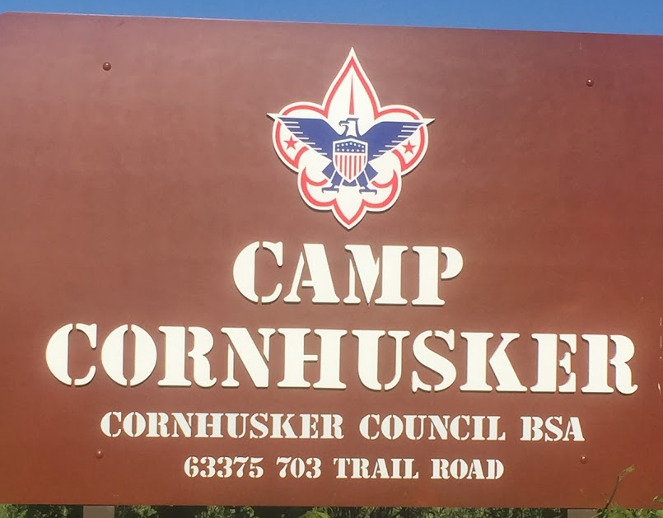  CAMP CORNHUSKER  https://scoutingevent.com/324-105538
TABLE OF CONTENTS
TOPIC | PAGE NUMBER
Welcome |  | 3
Cub Scout Resident Camp |  | 4
Webelos Camp/Camp Fees |  | 5-6
Adult Leadership/Check-In/Check-Out |  | 7
Miscellaneous Camp Information |  | 8
Camp Safety |  | 9
Registration Form |  | 10
Schedule |  | 11
What to Bring |  | 12
Contact Information |  | 13
Camp Map |  | 14
Dear Parents and Cub Scout Leaders,
Welcome to our Cub Scout Resident Camping Program. Come join us on our journey as we provide the Resident Camp tracks for the three younger tiers of Cub Scouts.
The Cornhusker Council is pleased to offer 1 session of Cub Scout Resident Camp in June. This camp will take place at our very own Camp Cornhusker in southeastern Nebraska, near the city of Humboldt. The session is 3 days and 2 nights in the lovely outdoors.
Cub Scout Resident Camp is an exciting adventure for new and returning Cubs. Held at Camp Cornhusker, this camp provides Scouts more focused time to spend in the program areas and allows them to enjoy the camp experience to the fullest as they experience programing for their age group.
Not only will they have the opportunity to dip their fingers in many areas of interest, but they will also be working on many different adventures for their appropriate rank. Some of the areas of interest include archery & BB-gun, as well as fishing, crafts, aquatics, and various athletic and nature activities.
Camp Cornhusker offers many other amenities as well as our Cub Scout advancement program. We will have open target ranges and aquatics activities for the Cubs and their AKELAS to enjoy while at camp. One can always hike the many trails we have around Camp. We highly encourage adult participation in all these activities.
This guide provides all the information you will need to help you choose Camp Cornhusker for your Cub Resident camping experience. Our staff is excited to work with you and your Cubs to help them gain the knowledge they will use in their future Scouting years.
Registration can be found directly on the Council website https://scoutingevent.com/324-105538. When you register you will be able to choose between the appropriate year program for your Scouts. *Youth who finish Kindergarten by June 1st should register as TIGERS. Youth who finish First Grade by June 1st are Wolves. Youth who finish Second Grade by June 1st are Bears.
We are looking forward to seeing you and your Cub Scout at Camp Cornhusker this summer, as we embark on another great summer at Camp Cornhusker
I can assure you that this will be an opportunity to make lifelong memories with your Scout. Please contact us if you have any questions.

Sammi Lowery | Camp Cornhusker Camp Director
C 1-402-770-4327 | campcornhuskerbsa@gmail.com


Cub Scout Resident Camp
Cub Scout Resident Camp provides a fun-filled environment, with just the right mixture of challenges. Cubs, no matter what age, are seeking adventure, an experience that is not like their classroom, and so are parents. Day camps are fun, but they do not provide the parent-child interaction that a true camping experience has to offer. These activities are planned specifically for Cub Scouts while aiding the Den Leaders and AKELA partners in helping those energetic Scouts try new skills in the outdoors. Cubs will be instructed in a variety of adventure and elective requirements throughout the entire three days at Camp.
Cub Scout Resident Camp provides an excellent growth opportunity as Cubs test the boundaries and find new ways to grow in the outdoors. Different from day camping, and not yet long-term camping, this is an experience that will strengthen the journey to Webelos/Arrow of Light and Scouts, BSA.
Den Specific Activities
All three Cub tracks will be running at the same time with a little overlap to make it easier for a Pack to come to Camp Cornhusker together. More details about the program are found later in this book. Participants will have to sign up for one of the Tiger, Wolf, or Bear Programs. (NOTE: All program tracks will run at the same time; a Pack DOES NOT need to sign all their Scouts up for the same program).
Webelos and Arrow of Light Scouts can attend this camp, but we recommend they take advantage of the camp designed especially for them: Webelos / Arrow of Light Resident Camp.

How to Get in on the Action
Getting ready for Camp is easy. First, read the material included in this Parent and Unit Leader’s Guide. Second, contact your Scouts and their parents to discuss the exciting opportunity that going to this Camp will provide for them. Talk it over and talk it up. It'll make for a high point in their years of Cub Scouting!
- Plan a simple money-earning project, use popcorn money or begin to collect the Camp fees.
- Decide on which Leaders and parents are going to accompany the Scouts and come as a whole Pack!
- Get registered for Camp. You can register and pay on the Cornhusker Council website at: https://scoutingevent.com/324-105538

WEBELOS / ARROW OF LIGHT CAMP: A Separate Camp Program
~Webelos/Arrow of Light Sessions are June 21st -24th and June 24th -27th 2026
Remember, Bear Cub Scouts will become Webelos on June 1st of this year. Scouts will participate in exciting activities and leave well on their way to completing several activity pins.

Your current Webelos will be Arrow of Lights on the same date and are encouraged to attend any of these fun-filled sessions. They will have designed activities to get these Scouts ready for the fun of Scouts BSA.

The staff for both these Cub Camps will be working with the Scouts and Leaders to help them to grow their outdoor camping skills. Outdoor cooking, Scout crafts, and Scouting skills will be emphasized along with a few additional activities. Your Scouts will have the opportunity to tour the entire Camp and see the different program areas that will be available to them when they return as Scouts BSA members.

Camp Fees and Registration
Camp fees include the cost of 6 meals, a t-shirt (if registered before June 1st), a camp patch, qualified staff, and all program supplies. A deposit of $50.00 is required for each youth and $25.00 for each adult. If your unit reaches its Gold Star Unit goal you will receive additional discounts per person by entering a voucher code and registering as a unit.

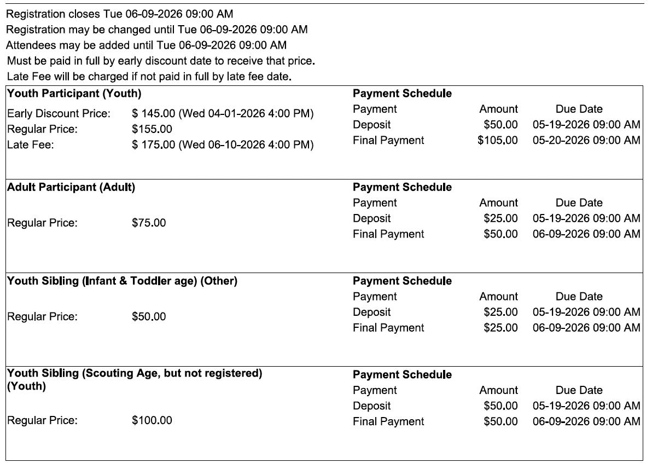

For youth siblings not enrolled in Scouting (ie: nonparticipant youth) $100 and infants and toddlers $50 for Cub Resident Camp

Each participant, Scout, adult, or family member, must be registered using the Council Website. When registering, participants must pick either Tiger, Wolf or Bear den specific Activities. Participants from the same Pack do not have to select the same option. The three programs will run at the same time with ample amounts of free time for Packs to be together. You will register, submit and pay for your entire registration via the Internet on the Cornhusker Council website at: https://scoutingevent.com/324-105538
Payment of all fees must accompany your registration. No registration will be accepted without the appropriate fees included.

Camp Scholarships (Filled out and submitted online only)
Camp Scholarships for Cornhusker Council Cub Scouts demonstrating financial need are available. Visit https://www.cornhuskercouncil.org/camping/camp-fees-scholarship-and-refund.html or contact the Council Service Center for more details. Deadlines are rolling, so make sure you apply early. Scholarships are non-refundable and non-transferable.
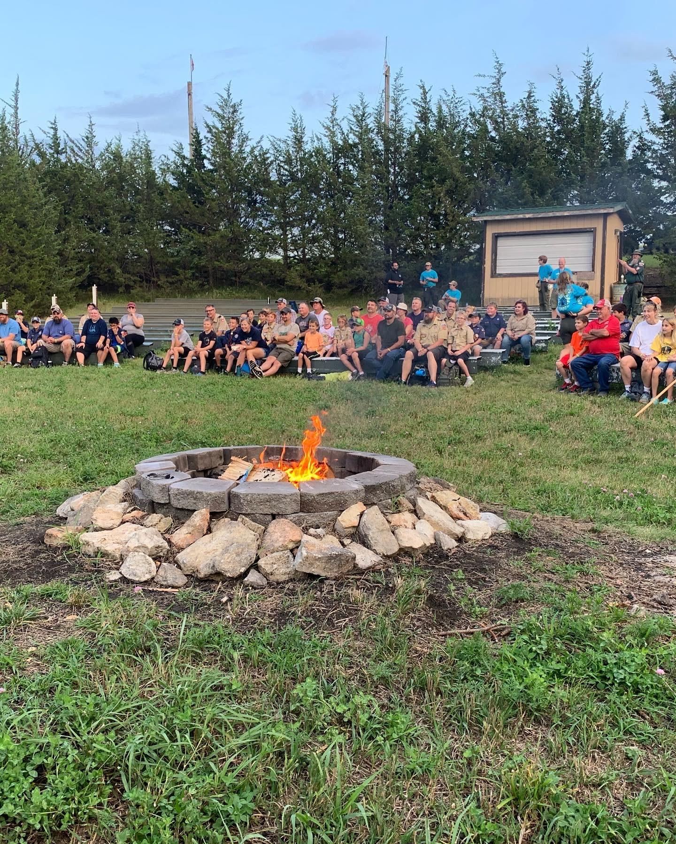
Adult Leadership
In accordance with the National policies of Scouting America, Cub Scouts can go camping on a limited basis, only when accompanied by Cub Scout Leaders and/or parents. The leadership policy of Scouting America states that a minimum of two adult Leaders (one age 21 or older, and the other a minimum of 18) are required for each Pack trip or activity. For cub scouts in the Tiger den there must be the mandatory 1 to 1 (parent/Akela) ratio*

While your group is in camp, they may be in campsites containing more than one group/pack. It is recommended that parents take their Scouts to camp and meet their Leader there at the beginning of the session and pick them up at camp at the end of the session.

For each camp you will need enough adult Leaders or parents attending to satisfy the following minimum adult to youth ratios.

- Cub Scout Resident Camp - One Adult for every 5 Scouts, with a minimum of 2 adults for Two Deep Leadership as well as an adult partner for each Tiger in attendance

If you have a question about this policy, please contact the Council Scout Executive at the Cornhusker Council Service Center.

Arrival
Plan to arrive at camp between 4:00 PM and 6:00PM on check-in day. Activities start in the evening. The Staff will be on hand to greet you and take you to your campsite to get settled. CHECK-IN CLOSES AT 6:00 PM. If you need special arrangements, call the Council Service Center.

Check-In
You must check in immediately upon arrival at camp at the designated check-in location. Make any last-minute corrections to the registration information previously sent in. You will receive a wristband and go through a medical recheck at this time. After the staff transports all their equipment to the campsite, participants need to change into their swimwear, bring a towel and report to the Dining Hall for orientation and to grab your sack dinner. They then proceed to the pool for a swim check. Upon completion of their swim check, participants will return to their campsite to set up camp.
Check-Out
All campers will leave with their Leaders and/or parents by 1:30 p.m. on the final day of their program. Please coordinate this with the parents in your dens. At any other time, campers will be released from camp only in the company of a parent or guardian and only after the approval of the Camp Director.

Camp Housing
All Camp participants will need to bring their own tents and will sleep in designated campsites. No facilities are available for campers or motor homes. All cars are to be parked only in the designated parking lot. No vehicles are permitted in campsites Pack Equipment Trailers will be brought in and parked by Authorized Personnel outside of the campsite gate close to the road.

The Camp has tents and cots for rent on a first-come, first-served basis. Cots are available at a cost of $10.00 per session per person. Tents are available at a cost of $20.00 per session. If you want a cot or tent, your registration contact can pre-order and pay via registration or you personally may request them upon check-in at Camp.

It is the responsibility of the camper to pick up the rented material at the Camp Quartermaster, set it up and return it at the end of Camp.

All Campers and Leaders are reminded that they are responsible for any damage, above ordinary wear and tear, they might cause to Camp facilities or equipment.

Dining Hall
All meals will be served in the Dining Hall.

Camp Visitors and Closing Campfire Meal
On the last day of the event we will host family at lunch starting at 12:00pm.

Trading Post
All activities and projects in Camp have been included as part of the camp fee. There will be a Trading Post, however, to provide additional snacks and souvenirs. Scouts may wish to bring some spending money (est. $25.00 to $30.00).

Camp Health and Safety

Footwear
Shoes are to be worn always in Camp. Shower shoes or water shoes may be worn in the shower house or on the beach but are not approved for travel to and from those locations.

Annual Health and Medical Record: PARTS A and B for Cub Scouts and Adults!
Scouting America recommends that all youth and adult members have annual medical evaluations by a certified and licensed health-care provider. Parts A and B are to be completed annually by all unit members. Both parts are required for Cub Scout Resident Camp. All participants, youth and adult, MUST bring the Annual Health and Medical Record with Parts A & B completed. This is the National Health Form, and it is required. No one will be allowed to stay in camp overnight without one. Health forms are found on the camp registration page. Health forms will be turned in to the Camp Health Officer at camp check-in.

Camp First Aid Station and Health Office
A qualified Health Officer will be on duty at the Camp. All illness or injuries must be reported to the Health Officer no matter how minor. In the event of serious illness or injury, the camper will be taken to a clinic or hospital for treatment. Parents will be notified and billed directly by the doctor or hospital.

Prescription Medication
Prescription medication may be kept at the First Aid Station in the lower level of the Camp Administration Building or in a locked container held by the adult participate. It is the responsibility of the adult partner or Unit Leader to make sure all medications are properly taken.

Pets
No camper pets of any kind are allowed at camp.
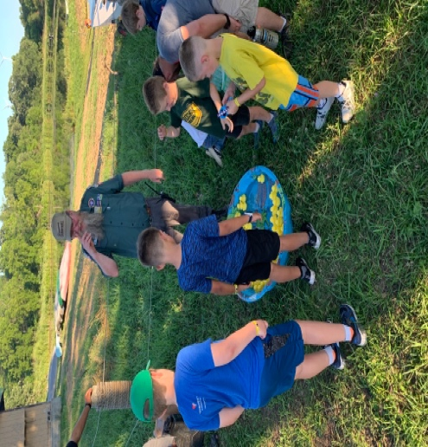
To reserve your spot at one of the great resident Camps this summer, use this worksheet to help you prepare your online registration where you can submit your Camp Registration fee. If a Scout attends more than one Camp, you will have to complete a registration for each Camp.

Participant Information Pack Number
Name
Address
Telephone Age
T-Shirt Size_________________

Adult Partner or Leader
Name
Address
Telephone Age ________
T-Shirt Size_______________

Camp Session Information
Which Camp Will You Be Attending? | _____ Cub Scout Resident Camp June 27th-29th, 2026) | Rental Tent @ $20.00 ______  Rental Cot @ $10.00________

For youth siblings not enrolled in Scouting (ie: nonparticipant youth) $100 infants and toddlers $50 for Cub Resident Camp

Cub Scout Resident Camp Fee
Camper Fee (based on above)
Adult Partner/Leader Fee (based on above)
Total Fees (Camp Fees and Rentals)

Time | June 27th | June 28th | June 29th
7:15 AM | Tiger Activity  Wolf Activity  Bear Activity | Assembly Call | Assembly Call
7:20 AM | Tiger Activity  Wolf Activity  Bear Activity | Flag Ceremony | Flag Ceremony
7:30 AM | Tiger Activity  Wolf Activity  Bear Activity | Breakfast | Breakfast
8:30 to 11:30 AM  Rotation 1:  8:30 – 9:15  Rotation 2:  9:30 – 10:15  Rotation 3:  10:30 – 11:15 | Tiger Activity  Wolf Activity  Bear Activity | Round Robin Sessions:  Fish On/ Floats and Boats/ Let’s Camp Tiger  BB Gun Wolf/ Air of the Wolf/ Paws of the Water  Archery Bear/Balancing Bears/Whittling | Round Robin Sessions:  Archery Tiger/ Tigers in the Water/ Good Knights  Finding Your Way/  Spirit of the Water/ A Wolf Goes Fishing  BB Bear/ Forensics/ Let’s Camp Bear
11:45 AM | Tiger Activity  Wolf Activity  Bear Activity | Assembly Call | Assembly Call
12:00 PM | Tiger Activity  Wolf Activity  Bear Activity | Lunch | Lunch
12:30 PM | Tiger Activity  Wolf Activity  Bear Activity | Personal Time | Pack Up to Leave
1:30 to 4:15 PM  Rotation 1:  1:30 – 2:15  Rotation 2:  2:30 – 3:15  Rotation 3:  3:30 – 4:15 | Tiger Activity  Wolf Activity  Bear Activity | Round Robin Sessions:  BB Gun Tiger/ Tiger Tag/ Sky is the Limit  Archery Wolf /Let’s Camp Wolf/ Digging in the Past  Bears Afloat/ Salmon Run/ A Bear Goes Fishing
4:30 to 5:30 PM | 4:00 – 6:00 PM Check-In  -Camp Tour  -Dining Hall Grab & Go Dinner  -Swim Checks  -Set Up Camp  -Dining Hall Closes at 6:30 PM | For All Scouts  *Open Pool/  Fishing/Games
5:45 PM |  | Assembly Call
5:50 PM |  | Flag Ceremony
6:00 PM |  | Dinner
7:00 to 9:30 PM | 8:00 PM Opening Campfire  *Trading Post Open After Campfire* | 7:30 – 9:30 PM Open Program Areas  *Open Handicraft/  Ranges/Lakefront
10:00 PM | Taps – Good Night | Taps – Good Night

Here is a suggestion list of equipment for Scouts to take to Summer Camp. Double check the list carefully and add items you feel necessary from the Unit’s point of view.

Need To Have Nice To Have
Tent _____ Cot/air mattress
Sleeping bag or blanket/sheet and pillow Fishing gear
Scout field uniform (Class A) Camera Watch
Clothing for length of stay including:
underwear, socks, shirts, long pants, shorts,
sweater/jacket, pajamas
Swim wear
Appropriate shoes
Toilet kit containing:
washcloths, towels, comb, toothpaste,
toothbrush, soap
Sunscreen and lip balm
Insect repellent-NO AEROSOL CANS!
Ground cloth/sleep pad Note
Rain gear or poncho *Be sure to label all clothing
Water bottle and equipment with Scout’s
Wallet and money name and Pack number.
Den level Scout Handbook *Remember that the Scout and
Current medical form Part A&B Leader are responsible for all
Any prescription medications their own items.
Flashlight and extra batteries

DO NOT BRING
- NOT BRING ANY KIND OF KNIFE (other than a pocketknife, must have Whittling Chip to carry) 2. ALCOHOL 3. PERSONAL ARCHERY EQUIPMENT 4. PETS 5. FIREWORKS OR FIREARMS. 6. SCOUTS SHOULD NOT BRING CELLULAR PHONES. 7. NO AEROSOL CANS ARE ALLOWED AT CAMP.


Camp T-Shirts will be included as part of this year’s registration fee. Please be sure and indicate your size as your complete registration.
Deadline for your Pre-order Shirts is June 1st, 2026.
After that date t-shirts cannot be guaranteed.

Address:
Camp Cornhusker
63375 703rd Trail
DuBois, NE 68345-5032
Phone:
402-862-2601
***Only during Camp season, call Council Service Center otherwise***

Cornhusker Council Outdoor Education Center
800 S 120th St P.O. Box 269
Walton, NE 68461-0269 Phone: 402-488-6020

Sammi Lowery | Camp Cornhusker Camp Director

SCOUTING AMERICA
Cornhusker Council

C 1-402-770-4327
campcornhuskerbsa@gmail.com
