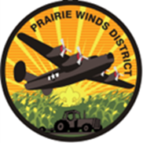 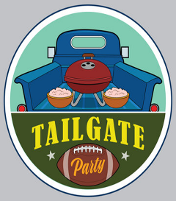

Prairie Winds/Seven Feathers District Fall Camporee 2025

**“TAILGATE-OREE”**

Sign up now for this AWESOME Fall Camporee September 19th, 20th, 21st  .

Located at Camp Ashland (Nebraska National Guard Base), 220 County Road A, Ashland NE, 68003. Northeast of the city of Ashland just off highway 6.

This event promises great camping and fellowship in Gov’t approved facilities 😉!

**Join us for food, fun and FOOTBALL.**

The host troop (34B of Greenwood NE) and the Districts’ Activities Committees are planning for a fun-filled weekend.

Planned events include football and football related games of skill, listening to football on the radio, participating in a patrol/troop team challenge course, and watching a game on the big screen (we hope it will be the broadcast of the NU Michigan game) and of course preparing our best tailgate foods/snacks for sharing with our great big tailgate.

**$20.00 For youth /$ 12.00 For Adults**

* Arrow of Light Den Members may attend as the invited guests of a troop or as a “Trails to Troops” group with their Den Adult Leadership to learn more about Troops in their area. **Arrow of Light Price is $15.00 per youth and $12 per adult**. Arrow of Light Dens are welcome to stay the night in a den group, or just come for the day (Saturday) and will not be participating in the Silver Skillet.

Registration closes Sept 19th at 12:00 pm and must be completed online via the Website. <https://scoutingevent.com/324-SFPWFallCamp>

Event check-in begins 5:00pm at the South Pavillion at camp Ashland (there will be signs to guide you).

--There are NO dug or in-ground fire pits allowed SO.. bring your charcoal and/or bring the unit propane burners for cooking. Potable water on site but be prepared bring 5 gallons to get started.

Troops should be prepared to participate in the **Silver Skillet Competition Saturday** for TAILGATE Cookery.

This year’s theme is your best tailgate menu: sliders, brats, wings, dips, bring your tastiest recipes. There will be bonus points available if your recipe includes the addition of SPAM (the real deal stuff no off brand substitutes) AS TROOP 34 swears that all meals must include this gift to the Midwest and Hawaiian Islands (Fun Fact SPAM is manufactured in Minnesota and Iowa)