**Salt Valley District**

**E-Prep-Oree**

**SPL & Leader Guide**

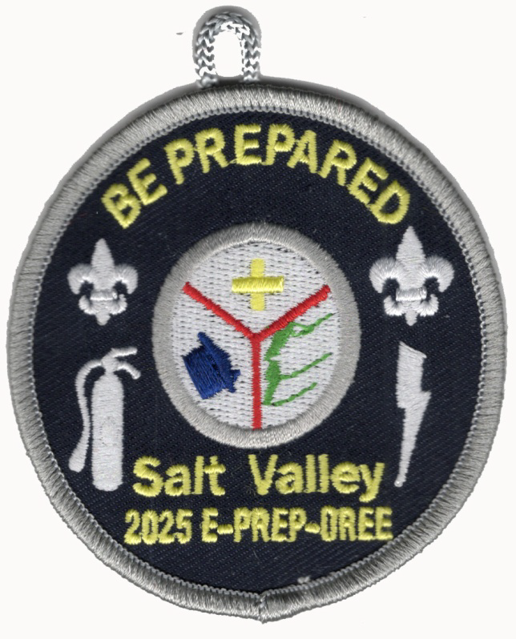

**April 25th to the 27th, 2025**

**Pioneers Park**

Camporees are a chance to join in one of the oldest traditions in Boy Scout history – Coming together as a District for Scouting. District gatherings provide an opportunity to match skills against others within our district. There will be fun, friendship, and fellowship. This guide is intended to help your unit prepare for the fun and excitement of this year’s Spring Camporee.

The Scout Oath and Law will govern the behavior of all participants during this weekend. The principles of leave no trace should be practiced at all times. All events will be based on the requirements for Emergency Preparedness Merit Badge.

## District Awards Available

Golden Skillet – Cooking award:

Silver Shovel – Campsite award:

Overall appearance and equipment for the campsite.

Bronze Spirit Award – Spirit award:

Observations during the event and include spirit at the events

# E-Prep-Oree Schedule

**Friday: April 25th, 2025**

6:00 PM to 9:00 PM – Registration and Check-in

9:30 PM – Scoutmaster/SPL Meeting and Cracker barrel

11:00 PM – Taps/Lights Out

**Saturday: April 26th, 2025**

7:00 AM to 7:45 AM Troop Breakfast

8:00 AM – Flag Raising and Opening

8:30 AM to 12:00 PM – Activity rotations.

12:00 PM to 1:15 PM Lunch – prepare your campsite for 9d

1:15 PM to 5:00 PM - Activity rotations continue

5:15 PM – Flag Ceremony

5:30 PM to 7:45 PM – Dinner/Clean-up

6:30 PM to 7:30 PM – Golden Skillet judging

8:00 PM to 9:15 PM – Campfire Program

11:00 PM – Taps/Lights Out

**Sunday: April 27th, 2025**

8:30 AM to 10:00 AM – “Leave No Trace” Check-out.

# E-Prep-Oree Events

45 minutes per station – 5 minute transit time

**AM - Station 1**

* 2-a: Discuss with your counselor the aspects of emergency preparedness and include in your discussion the kinds of questions that are important to ask yourself as you consider each of these:
  + Prevention
  + Protection
  + Mitigation
  + Response
  + Recovery

**AM - Station 2 – Items needed for this requirement will be DEMONSTRATED - this will not be marked as completed.**

* 3 -c: Using a checklist in the Emergency Preparedness Merit Badge pamphlet or one approved by your counselor, prepare or inspect a family disaster kit for sheltering-in-place and for evacuation of your home. Review the needs and uses of the items in a kit with your counselor.
* 9-c: Using a checklist in this pamphlet or one approved by your counselor, prepare or inspect a personal emergency service pack for a mobilization call. Explain the needs and uses of the contents to your counselor.

**AM - Station 3**

* 5. Dangerous Situations. Show how you could save a person from the following dangerous situations without putting yourself in danger:
  + Live household electric wire
  + A structure filled with carbon monoxide
  + Clothes on fire

**AM - Station 4**

* 10. Do ONE of the following:
  + Interview an emergency services coordinator or a civil servant about their work in disaster management. Learn about how they chose this career and about their duties. Discuss what you learned with your counselor and whether you might be interested in this career.

**PM - Station 5 - 6a, c**

* 6. Signaling for Help. Do the following:
  + (a) Show three ways of attracting and communicating with rescue aircraft or drones.
  + (c) Show ways to attract attention of searchers on the water if you are stranded with a capsized or disabled motorboat or sailboat.

**PM - Station 6**

* 7. Moving an Injured Person. With another person, show two good ways to transport an injured person out of a remote area using improvised stretchers to conserve the energy of rescuers while ensuring the well-being and protection of the injured person.

**PM - Station 7**

* 8. National Incident Management System (NIMS) and Incident Command System (ICS). Do the following:
  + Describe the National Incident Management System (NIMS) and the local Incident Command System (ICS).
  + Find out how your community and its leaders work to manage and to train for disasters. Discuss this information with your counselor, using the information you learned from requirement 1b.
  + Discuss how a Scout troop can help in an emergency situation using ICS.

**PM - Station 8**

* 5. Dangerous Situations. Show how you could save a person from the following dangerous situations without putting yourself in danger:
  + (d) Drowning, using nonswimming rescues (including accidents on ice).

**In campsite during lunch**

* 6. Signaling for Help. Do the following:
* (b) Show ways to attract attention of searchers on the ground if you are lost in the wilderness.