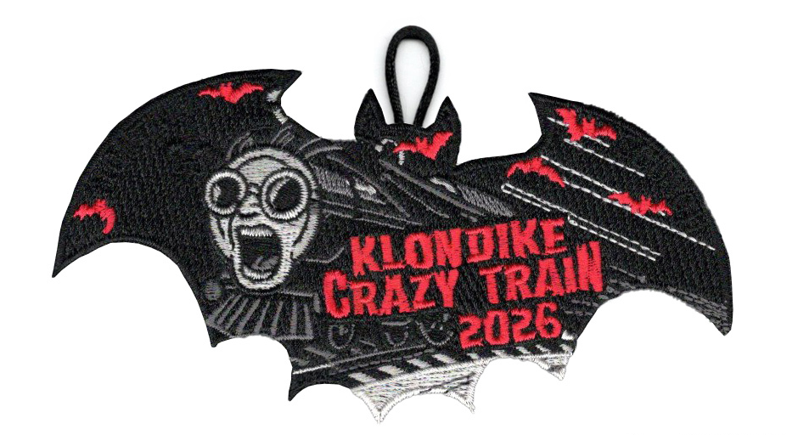

Saturday, January 10, 2026 at 7:30am
$25 per BSA Scout, $15 per Arrow of Light
$15 per adult. Lunch provided. Registered by Wednesday, January 7th or we don’t promise you food or ammo

This year’s stations will include:
Search and Rescue – troops need to bring materials to safely evacuate 1 immobile adult
Batapult – Build a catapult with timber and rope provided to launch rubber bats for accuracy and distance. Image of the structure the troop will build is on the back of this page.
Pancake Stack – Using the Camp Chef and ingredients provided, troops need to build the tallest stack (troops bring all tools needed to prepare and cook)
Crazy Train Pull – sled teams will pull the provided sled to navigate our crazy train course for the fastest time
Run-on-Joke Challenge – What troop has the biggest hams. 3 scouts from each troop will run to the front of the parade grounds to share a quick joke with the district. To make it more interesting, if a joke has already been told, it cannot be told again. The order of presentation will be a random drawing so you will want to have a few jokes in reserve. The troop that gets our honored judges to laugh the most will get a special ribbon unique to the spirit of this event for their troop flag
Logging Camp – 2-person saw and fire starting. Troops will demonstrate starting a fire with flint/steel, steel wool/battery, and either a bow or pump drill.
Rifle – AOLs will go to tomahawk bay
Shotgun – AOLs will work on an AOL adventure

Questions: Contact Tobin Spurlin 406-694-3021
EQUIPMENT LIST
- Patrol first aid kit
- Scout Handbook
- Pencil and/or pen
- Clipboard
- Watch
- Flashlight(s)
- Pocketknife
- 3 gallons of water for drinking and cleaning of cooking gear
- Equipment for cooking and cleaning of pancake breakfast
- Trash Bag
- Equipment for the transportation of an immobile person up to 1000 yrds. Across uneven terrain
- Flint and steel
- Steel wool and battery
- Bow or pump drill for fire starting
- Tinder and kindling

