

MBU Missoula

**2023 Leader Guide**

**MBU Points of Contact:**

**Graham Hughes (406) 565-1876**

**Duane Adelson (214) 876-5789**

[**MissoulaMBU2023@gmail.com**](mailto:MissoulaMBU2023@gmail.com)

**We’d like to welcome you to the Annual MBU MISSOULA, presented by UMROTC and Mullan Trail District.**

# Where:

Schreiber Gym, 32 Campus Drive, Missoula, MT

[Google Maps: https://goo.gl/maps/ThZxyUTPA9V715Hf6](https://goo.gl/maps/ThZxyUTPA9V715Hf6)

# Quick Schedule

* 2-17-2023 -- Last day to register.
* 2-24-2023 -- **Friday**
* 2:00 - 4:00 pm UM Day Campus Tour
* 5:00-8:00 pm Check-in table opens
* 5:00-10:00 pm Concession stand open in Schreiber Gym.
* 5:00-7:30 pm Dinner at the Food Zoo
* 6:30 pm - 9:30 pm University Center Game Room, Games in the gym.
* 7:30 pm - 8:00 pm Planetarium Show
* 8:30 pm - 9:00 pm Planetarium Show
* 8:00 pm- 9:30 pm Movie “October Sky”: Doors open at 7:30 p.m.
* 10:30 pm Quiet time.
* 11:00 pm Lights out.
* 2-25-2023 -- **Saturday**
* 6:00 am Wake up, Pack up all gear and return to vehicles.
* 6:30 am Breakfast - Ticket required.
* 6:45 am Check-in opens for troops arriving Saturday morning.
* 7:30 am Check-in closes.
* 7:45 am Opening Ceremony in Urey Lecture Hall
* 8:15 am Break Out/Load Buses
* 8:30 am Morning session begins.
* 12:00 pm-1:00 pm Lunch
* 1:15 pm Afternoon sessions begin
* 4:30 pm Bus Load Out
* 4:45 pm Classes end
* 5:15 pm Closing Ceremony in Urey Lecture Hall

The University of

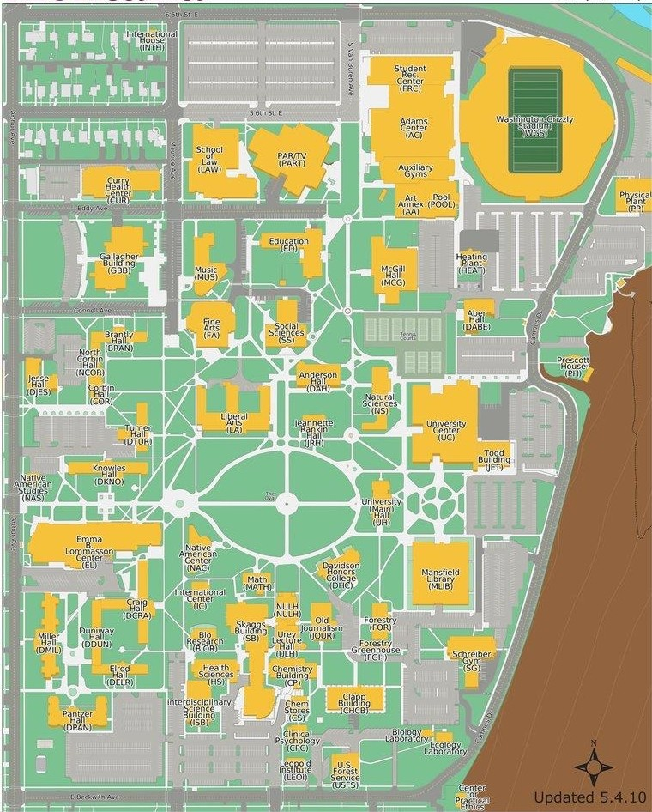

**Montana** Campus Map

# Registration & Merit Badge Info

* Only online class registration on Black Pug is accepted. A single Troop Representative will need to register all members of the troop. It is highly suggested that you create your Black Pug account and build your roster of participants ahead of time. If you wait until the day registration opens you may not be able to complete this step quickly enough to secure the desired classes before they fill up and close.
* Please review the list of Merit Badge classes offered at this year’s MBU and help your Scouts determine what classes they would be interested in and best suited to take. It is very important that leaders help their Scouts choose a badge that is appropriate to their age, rank and maturity level. Please go over the requirements with your Scouts before they are signed up and make sure they know what will be expected of them.
* To assist in the registration process, have each of your scouts fill out a copy of the class worksheet. It will help expedite your troop’s registration. Adult registration is also required for overnight stay, lunch or to attend shows. See the instructions for using Black Pug at the back of this guide.
* Most Merit Badges require preparation. Scouts need to complete the prerequisites noted before MBU Missoula in order to complete the merit badge; however, the Scout may complete those requirements with a Troop merit badge counselor at a later date.
* A few of the merit badges may require parental consent. A scout’s registration and participation in these merit badges implies parental consent. Supervision is provided at all times.

# Fees

* The cost for each Scout is $20. This includes lunch, a patch and many other supplies and materials needed to operate MBU. There is a $7 fee for every Scout and adult requesting breakfast on Saturday morning. Adults and Scouts wishing to eat dinner at the UM Food Zoom must purchase tickets for $10.50 for Friday night. Scouts wanting to attend a planetarium show on Friday night will need to register for the show they plan to attend on Black Pug. Cost is $3 for the Planetarium Show and is open to all scouts and adults. A movie is available Friday night at the University Commons Movie Theater, sponsored by the UM Admissions Office. University Center Game room is a pool and arcade room located on the second floor of the University Center, there is an hourly fee of $1 per hour. Games are included.

# Payment & Cancellation

* Payment can be made by credit card through Black Pug.
* Once registered for classes, you will have a total amount due listed on the Black Pug registration website. Registration fees are required within a week of your registration to confirm your class schedules.
* Refunds for participants who cancel after registration closes or do not show up for the event will not be issued. If your plans have changed and you will not be able to attend please let us know. We may be able to refund partial payments if the classes can be reassigned.

# Arrival

* Troops may arrive any time after 5:00 pm on Friday until 8:00 pm or Saturday between 6:45 and 7:30 am
* Parking will be open anywhere on campus.
* Please check-in before unloading gear. We will have specific instructions for parking and gear unloading.
* Troop check-in will be in the entryway of Schreiber Gym. (See Map)
* Leave your troop in a waiting area and send one adult leader to the check-in desk.

We need the following items in order to speed your Check-in

* Signed release form for Climbing Merit Badge
* Troop Roster
* Scout and Adult Medical Forms A & B – Turn in at check-in, pick up at check-out
* Once the Troop is registered, we will have each registered individual pick up their name tag at the attendance table.
* All the nametags will need to be returned at checkout in order to receive the checkout package. Scouts can keep the lanyard.

# Troop Point of Contact

Each Troop must have a point of contact registered with MBU Missoula. The point of Contact must be onsite at all times, as they are the direct line of communication between the MBU staff and Scouts. The Point of Contact must be a BSA registered adult.

The Point of Contact will be responsible for the following:

* Check-in
* Maintain a cell phone that can be reached all day by MBU Staff (provide the cell phone number, as well as the names, times of relief and cell phone number of any other adults that are taking over responsibility. There must be at least one Point of Contact for each troop onsite at all times.
* Maintain presence at MBU and be able to assist with problems or issues while troop members are in attendance.
* Support and enforce Scout Law and Scout Oath.
* Support and enforce LEAVE NO TRACE.
* Ensure their Scouts know who the Troop Adult Contact is.
* Hand out meal tickets, information, and schedules.
* Monitor attendance and early departure of Scouts.
* Sign their Troop out at the end of MBU and secure MBU Patches.

# Sleeping arrangements

* Gym City: Male Scouts will sleep overnight in the gym. Females Scout and Leaders will have separate classrooms to sleep and there will be locker rooms and bathrooms available.

# Friday Night On Campus Activities

* The Planetarium will be airing two presentations by the University of Montana Astronomy department. There are 30 seats available for each showing. These shows are open to scouts and adults at a charge of $3 each. Shows will begin at 7:30 p.m. and 8:30 p.m. You must register for which show you plan to attend on Black Pug.
* University Game Room, $1 per hour Pool, ping pong and arcade games.
* Your troop is encouraged to bring footballs, Frisbees, etc. and to start up some games with other troops. Make sure your gear is marked.
* Adults wanting to be helpful, please see Graham or Fabie at the check-in desk and we may have an area for you to help keep an eye on or a task to help lighten the load.
* There will be a snack bar open Friday night. Cash only.

# Saturday Morning

# 

* Overnighters will need to be packed and have their gears out of their sleeping area by 7:00 am
* Breakfast will be served in the 2nd Floor Hall of Honor from 6:30 to 7:15 am.
* Troops will gather at 7:45 am with their flag for the Opening Ceremony in Urey Lecture Hall.
* After the ceremony, each participant will gather under their class sign where their counselor will be expecting them and taking attendance.
* Counselors will then take their participants to their classes.
* Classes will take a bus to go to their location.

# Be Prepared

* All Troops need to bring their Troop Flags with Stands for Opening and Closing Ceremony
* Scouts should wear BSA field uniform.
* Scouts must have their Merit Badge Worksheets filled out with the completed prerequisites.
* Scouts should be prepared with a notebook and a pencil/pen.
* Scouts are responsible for any required materials for Merit Badges.
* Scouts should bring a water bottle for the day.
* Scouts need to bring clothing appropriate for the weather. Some classes take place outside, and all Scouts will be outside from time to time.
* Scouts and Adults MUST wear their name tag AT ALL TIMES. This is a safety requirement directed by Campus Security.

# A Scout is:

At Merit Badge University, we are guests at the University of Montana, please do your part to:

* Observe and live by the Scout Oath and Scout Law.
* Attend classes as assigned.
* Be courteous to other students, counselors, and staff.
* Be personally responsible for attitude and behavior.
* Take care in maintaining others’ property.
* Leave No Trace.
* Clean up trash after eating and camping/sleeping.
* Always have a buddy.
* Have a great time!

**Merit Badge Record**

Merit Badge Counselors will fill out their Badge Requirement Grid. At the end of the instruction period, MB Counselors will bring the completed sheet to the Admin Office in Schrieber Gym for the Merit Badges to be uploaded~~.~~

Black Pug will be used to record all the completed requirements at the end of each class. The unit leader will get a printed copy of the report showing what was completed for each scout after the closing ceremony.

This Merit Badge report can be exported from Black Pug and imported then in Scoutbook format using Scoutbook's **"advancement.csv"** template.

In Scoutbook, once logged in in your troop, simply select “Import Black Pug Data”, activate all the possible option, and import the file.

For the Merit badge that are not complete, the scouts will be able to work with the counselor after MBU. They should have had their contact info at the beginning of the class.

# Lunch

* Lunch will be served in Schreiber Gym from 12:00 to 1:00 pm.
* Merit Badge Counselors will escort their class to the gym at the conclusion of the morning session.
* Welding, Plumbing and Electronics/Electricity will remain at West Campus and food will be delivered to them.
* Adults are encouraged to be available to their Scouts in the area outside the gym when they are not eating lunch.
* At 1:00 p.m., after lunch, the Scouts will gather under the appropriate merit badge sign posted and follow their teachers to class.

**Health, Safety, and First Aid**

There will be a First Aid kit at the Check-in/Info table. The next level care will be at the Curry Medical Center. In the event of an emergency, Scouts not in classrooms should proceed to the Emergency Muster Point in front of Schreiber Gym, scouts in classrooms will remain in the classroom as directed by their Merit Badge Counselors, awaiting further instruction from MBU Administration. AED’s are located throughout the campus.

**Lost and Found**

The Lost and Found is located at the Check-in/info table. Please be sure to check before you leave. Put your name on EVERYTHING: books, papers, lunch boxes, coats, hats – EVERYTHING.

**Questions**

Please don’t hesitate to contact [missoulambu2023@gmail.com](mailto:missoulambu2023@gmail.com%20) if you have any questions that weren’t answered above.