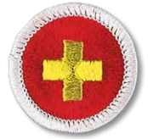

First Aid Merit Badge Prerequisites

Please complete requirement #5

