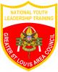
NATIONAL YOUTH LEADERSHIP TRAINING CAMP
Greater St. Louis Area Council BSA

