1A Hazards you may encounter while boating
FLAMMABLE FUEL
CARBON MONOXIDE
PROPELLORS
FALLS OVERBOARD
CAPSIZE
RUNNING AGROUND
COLLISIONS
1B Explain first aid for injuries or illnesses that occur while Motorboating
Hypothermia page 15
Heat Reaction pg 15
Dehydration pg 13
Motion Sickness pg 16
Blisters pg17
Bug Bites pg 17

1C Discuss Scouting America Safety Afloat Policy.
Tell how it applies to Motorboating
The Safety Afloat policy applies to all BSA boating activities, including canoes, kayaks, rowboats, rafts, floating tubes, sailboats, and motorboats, but excludes large commercial vessels, parasailing, kitesurfing, and personal watercraft. Its purpose is to promote safety, prevent accidents, and ensure Scouts can participate confidently in aquatic activities

Leadership and Supervision
- All activities must be supervised by a mature adult aged 21 or older who accepts full responsibility for participants’ safety
- Leaders must be trained in Safety Afloat within the last two years and have skills specific to the watercraft used
Leadership ratios: one trained adult per 10 participants (minimum two adults per group); for Cub Scouts, one trained adult per five participants
- At least one leader must be trained in first aid and CPR, and it is recommended to have a BSA Lifeguard or Aquatics Supervision-trained adult or older youth member
- If the trained adult lacks specific boat operation skills, they may supervise only with assistance from other qualified adults or staff
Participant Requirements
- All participants must have a completed health history and medical clearance as evidence of fitness for boating activities
- Swimming ability is required for most activities. Non-swimmers may ride as passengers in certain craft with a qualified adult annual swim tests are required to verify swimming competency
Equipment and Safety Measures
. US Coast Guard-approved life jackets must be worn by everyone engaged in boating
. All craft must be seaworthy, suitable for the activity, and capable of floating if capsized
. Leaders must check weather conditions and plan contingencies before the activity
. Rules are effective only when consistently followed, and all participants must have sufficient knowledge and skill to participate safely

Nine Points of Safety Afloat
While the full guide is detailed, the nine points emphasize:
- Qualified supervision
- Personal floatation devices
- Swimming ability verification
- Buddy system
- Proper equipment and craft suitability
- Planning and preparation
- Safety rules enforcement
- Emergency preparedness
- Continuous monitoring and accountability

2B Name the different types of personal flotation devices and explain when each type should be used. Show how to properly choose and fit a PFD pg 18

- Offshore Life Jacket – designed to turn most unconscious victims faceup. Not designed for recreational boating
- Near Shore Buoyant Vest – designed to turn unconscious victim faceup in calm waters.
III. Flotation Aid – designed to keep a conscious person in a vertical position and will not turn a person faceup in the water. May be used while riding in a boat of any size
IV. Throwable – Not for use as a life jacket
V. Special Use – for use when windsurfing, kayaking, waterskiing or wakeboarding

USCG Life Jacket Types

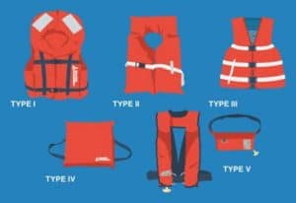
There are 5 categories USCG life jacket types that you will see when you shop. They are labeled Type I through IV. Each type corresponds to the type of activity you’re engaged in. It is important to have the right life jacket for the right activity. Think of it like having the right tool for the job. You wouldn’t cut a 2×4 with a knife, or use a chainsaw to cut your sandwich, right (hopefully!)? Or in this case, you wouldn’t want a pool floaty if you have an emergency a mile off-shore and have to abandon ship. While you’re looking at the label, make sure that it has the USCG life jacket types approval on there!
Pay special attention to key factors of the various US Coast guard approved life jackets. These are minimum buoyancy, activity type, and other safety features. Let’s run through some of these real quick:
Inherently buoyant vs inflatable
Inherently buoyant or inflatable? Most types come in both flavors, and the difference is that one is always at its maximum shape/size, while an inflatable is generally compact and inflates when needed. Ever see those stiff, orange foam life jackets on ferries or tour boats? Those are inherently buoyant, and they always stay the same shape. The downside is that they are usually bulky and uncomfortable for long periods of time. The upside of inflatable life jackets is that they are generally compact and out of the way, until they’re needed.
Another consideration to keep in mind is that you need to maintain the inflatable US Coast Guard approved life jackets, especially if they have an automatic inflation device. For inflatable jackets, there is a CO2 cartridge that fires when the jacket is submerged into the water and pumps air into the compartments. So, you need to keep an eye out on the mechanism to make sure it’s in working condition.
In the end, it sometimes comes down to preference and the activity type, as that can further inform you which type may be more suited for you.
Activity types
Offshore, near-shore, rough waters, protected waters? These are the questions you need to ask yourself when considering the type of activity you’ll be engaged in. Each jacket type corresponds to the type of activity as it has different features that are useful for each situation.
Safety Features
Minimum buoyancy, neck support, activity type, manual backup for automatic inflatables; These are the additional factors to keep in mind. The minimum buoyancy is what the USCG life jacket types will support in the water. Most life jackets range from 15 lbs. to 22 lbs. of buoyancy. We’ll save the math behind this calculation for another article, but a 200 pound person weighs about 10 pounds in the water. So a 15 pound rated life jacket will have no problem keeping that person afloat.
Neck support is another factor you should consider as that can help the life jacket turn an unconscious wearer face up. In a really severe situation, you wouldn’t want to be knocked unconscious, thrown in the water, and then drown from your head facing down.
Now that we have that out of the way, let’s look at the USCG life jacket types, and dig into what each means:
Type I
Type I US Coast Guard approved life jackets are meant for cruising, racing, offshore fishing or for stormy conditions. These are usually hardy life jackets meant for those that are serious about their on-water activities and need to be self-reliant. The key here is that if things go wrong, rescue may not come right away. Think of the sailors who cross oceans, or fishermen who are out in all kinds of weather. You don’t even have to cross oceans, as storms and weather can change at any time even if you are cruising just offshore. And you know Murphy’s law, you may run into trouble even on a perfectly sunny day.
Another key factor of Type I USCG life jacket types is that they will turn over most unconscious wearers. Should a person get knocked out while falling overboard, the life jacket will turn them face-up so they don’t drown. A very important feature, especially if you are out in open seas where the water can get very rough.
The minimum buoyancy for inherently buoyant life jackets is 22 pounds, and 34 pounds for inflatable type I’s. You’ll be hard-pressed to find an Inflatable Type I just because they are so extremely expensive to make that there aren’t any available for the general public!
Type II
These life jackets are recommended for use where chances of immediate rescue are good. This means that they are best for inland water near shore. Although they can be used for offshore, these US Coast Guard approved life jackets are not meant for extended survival in rough water. They will often require you to tread water to keep your head above water. If you get knocked out, the Type II USCG life jacket types will only turn SOME wearers over.
The inflatable Type II USCG life jackets are recommended for dinghy sailing, inland cruising and racing. Since they provide the floatation but also allow for a big range of motion, they are generally more desirable. The inflatable life jackets are also more buoyant as the minimum buoyancy for them is 34 pounds. Just remember to keep them in good maintenance and fully charged.
In summary, the Type II US Coast Guard approved life jackets provide less floatation than Type I.
Type III
When you look for Type III US Coast Guard approved life jackets, you are most likely taking part in activities in protected, inland water where chance of immediate rescue is very good. The life jackets are good for a wide range of activities such as sailing, dinghy races, water skiing, fishing, kayaking and more.
The inherently buoyant Type III USCG life jacket types are rated for 15.5 pounds minimum buoyancy, while inflatables should be at least 22.5 pounds. While having a good buoyancy rating, these are not intended for extended survival in rough waters, hence why it’s important to know that rescue should arrive quickly.
Type IV
Type IV US Coast Guard approved life jackets are actually throwable devices meant to throw to someone in need. What does this mean? It means you generally don’t wear them, but in some cases you must have them on board. They are used in Man Overboard (MOB) situations where someone falls into the water and you throw them a Type IV device so they can hang on.
For a ring buoy, the minimum buoyancy is 16.5 pounds and 18 pounds for a boat cushion. Remember that this is meant for calm waters with lots of traffic where help can be provided quickly. It is not meant for non-swimmers, or unconscious people, as they need to hang on.
Another thing to remember is that this device must be immediately available to throw over in case of emergency. If it’s stored in a locker under the seat, that can mean that it’s not immediately available. So be aware and keep it ready to toss overboard in case someone goes in the drink!
Type V
Finally, we come to Type V US Coast Guard approved life jackets. We feel these are very popular and there are some key things everyone should know. There are different flavors of these USCG life jacket types: Special Use, Automatic inflation devices and hybrids.
For special use Type V life jackets, these are designated by their activity type: sailboard harness, decksuit, commercial white water vest or float coats. They are more comfortable than their Type I counterparts, but they provide far less flotation.
When it comes to automatic inflation devices, these US Coast Guard approved life jackets are usually things that look like fanny packs. That’s the one you’ll see most often, even though they can also be decksuits, harness and so on. Again, these are meant to be worn specifically for the intended use.
The hybrid Type V USCG life jacket types are also intended for specific activities. They may be carried instead of another PFD but only if used according to conditions on the label. Most Type V life jackets will say they provide the performance of either a Type I, II, or III, so be sure to check that. Additionally, some may say that it must be worn to satisfy the conditions, so make sure it’s not sitting next to you or it won’t qualify.

3a Explain inboard, outboard and inboard/outboard motors and the uses and advantages of each. Discuss the special features of a bass boat and a ski boat. Pgs 35-37

Outboard Engines
Outboards have more power per pound of weight than do inboard engines.
- An outboard is a portable, self-contained package of an engine, gear case, and propeller that is attached to the transom of a boat.
- A growing number of outboard engines are of four-stroke design, but many are still conventional two-stroke engines that burn oil as a lubricant along with the fuel. New-technology two-stroke outboards are direct-injection engines and burn over 75% cleaner than conventional two-stroke outboards.
- Steering of outboard boats is controlled by a tiller or steering wheel that swivels the entire engine to direct propeller thrust

Inboard Engines
Inboards have automotive engines adapted to operate in marine environments.
- An inboard is a four-stroke automotive engine adapted for marine use. Inboard engines are mounted inside the hull's midsection or in front of the transom.
- The engine turns a drive shaft that runs through the bottom of the hull and is attached to a propeller at the other end.
- Many personal watercraft (PWCs) have two-stroke inboard engines that burn oil as a lubricant along with the fuel. New-technology two-stroke PWC engines are direct-injection engines and burn cleaner than conventional PWC engines.
- Steering of most inboard vessels, except PWCs and jet-drive boats, is controlled by a rudder behind the propeller.

Stern Drives
Stern drives have quieter and more fuel-efficient engines.
- Stern drives are known also as inboard/outboards (I/Os) because they combine features found on both inboard and outboard engines. Stern-drive engines are four-stroke automotive engines adapted for marine use and are mounted inside the boat.
- A stern-drive engine is attached through the transom to a drive unit (also called an "outdrive") that is essentially the lower unit of an outboard. The engine turns a drive shaft that is attached to a propeller at the other end.
- Steering of stern-drive boats is controlled by the outdrive, which swivels like an outboard engine to direct propeller thrust.

Jet Drives
Jet drives use an engine to power a strong water pump, which sucks up water and then forces the water out the back to thrust the boat forward.
- Jet drives propel a vessel by forcing a jet of water out the back of the vessel. Directing this jet of water steers the vessel.
- Personal watercraft are the most common type of vessels that use a jet drive.
- Jet drives also may power larger vessels (jet boats) and are used commonly for vessels designed for shallow water conditions. Jet boats can have inboard or outboard jet drives.
- Bass boats are usually of the outboard motor type to provide speed in getting to and from locations. Mounted on the stern of the boat the entire engine and prop are exposed. Ski boats are usually of the inboard motor type and provide greater safety to the skier as the propeller is not in proximity to the skier or ski rope.

3b Explain the safety procedures and precautions involving handling fuel and engine servicing, and equipment storage and placement. Page 39

Normally a boat can be fueled at same location you fuel your vehicle for towing the boat. Part of knowing the waters you are traveling is also knowing if fuel is available at a marina.
When fueling a boat remove all passengers from the boat. Make sure no one is smoking in the vicinity of the fuel pump and that there is no other sources to spark an ignition
Fuel only in a well ventilated area with the ignition switch on the boat “OFF”
If boat is an inboard make sure all window ports and hatches are closed to prevent fumes from settling in the lowest parts of the boat as gas fumes are heavier than air.
Before beginning to fuel touch fuel nozzle to metal piece of boat to discharge any static charge
Do not start pumping of fuel until nozzle is securely set in the tank opening
Wipe up any spilled fuel
Tightly secure gas cap
Activate blower motors for several minutes prior to starting the engine to remove any gas fumes.
If a PWC open top cover and perform sniff test for any fumes before starting engine
When storing boat for extended periods disconnect batteries and ventilate boat

3C EXPLAIN HOW TO WINTERIZE A BOAT

Winterizing Guide checklist for outboards, inboards, and sterndrives.
- Add gas stabilizer
- Check plugs, wires, rotor, cap
- Check belts, adjust tension
- Check hoses
- Clean fuel screens, replace fuel filter
- Check shift/throttle cables and settings
- Lube shift/throttle cables and linkages
- Flush cooling system
- Drain block, manifold, circulating pump and coolers
- Fill block, manifold and circulating pump with antifreeze
- Change gear lube
- Change oil and oil filter
- Check gimbal bearing
- Grease U-joints and gimbals
- Lube engine coupler splines
- Check/replace sacrificial anodes
- Fog engine
- Check steering and power trim fluids
- Touch up nicks and scratches
- Check propeller/hub
- Check/lube splines
- Replace water pump impeller
- Spray electrical connections with moisture repellent
- Spray entire engine with anticorrosion treatment
- Check fuel line and bulb
- Remove battery and recharge if necessary

3d Explain the safety procedures and precautions involving swimmers and skiers in the water, passenger positions under way and boat wakes.

Requirements for Towing
Motorboat and PWC operators towing a person(s) on water skis, a wakeboard, a parasail, or any other device must also obey these laws.
Every motorboat or PWC towing a person(s) on water skis, a wakeboard, or any device other than a parasail must have either:
  - A person on board, in addition to the operator, observing the towed person(s) at all times (preferably the observer is at least 12 years old) or…
  - An approved ski mirror that is at least three inches in height and eight inches in length, gives 180 degrees of vision behind the operator, and is designed as a ski mirror. The Missouri State Highway Patrol does not recognize the manufacturer’s mirrors on personal watercraft as being sufficient for this purpose.
- Every motorboat or PWC towing a parasailer must have a person at least 12 years old on board, in addition to the operator, actively observing the parasailer.
- It is strongly recommended that all persons being towed behind a motorboat or PWC on water skis or any other device wear a U.S. Coast Guard–approved PFD. Ski belts are not U.S. Coast Guard–approved.

Skier-Down Flag Requirement

An operator of a motorboat (other than a PWC) on the waters of the Mississippi River, the Missouri River, or Missouri lakes between the hours of 11:00 a.m. and sunset must clearly display a skier-down flag whenever the towed person(s) is in the water.
A rectangular orange or red flag, at least 12 inches x 12 inches, must be displayed when the person is in the water before or after being towed. The flag should not be displayed while the motorboat is engaged in towing but should be displayed again when the towed person enters the water. PWCs and moored or anchored motorboats are exempt from this requirement.

Towing a Person with a Vessel Legally

Persons may be towed behind a motorboat or PWC on water skis, a wakeboard, a parasail, or any other device only during daylight hours (sunrise to sunset).
A reasonable distance from other vessels, people, and property must be maintained so as not to endanger life or property. It is illegal to cause the person being towed to collide with any object or person.

Before Towing a Skier

Water-skiing, along with being towed on a tube, kneeboard, or similar device, is very popular with boaters. These activities are both fun and challenging; however, towing people on skis or other devices requires additional knowledge and skills.

Before towing a skier, the operator should:
- Have a second person on board to act as an observer.
- Review hand signals with the skier to ensure proper communication.
- Make sure the skier is wearing a U.S. Coast Guard-approved PFD designed for water-skiing. Keep in mind that ski belts are not U.S. Coast Guard-approved. A PFD with a high-impact rating is recommended.
- Be familiar with the area and aware of any hazards such as shallow water, rocks, or bridge pilings in the water.
- Make sure the tow lines are of the same length if towing multiple skiers.
- Never tow a skier at night. It is both hazardous and illegal.

When Starting To Tow a Skier

When starting to tow a skier, the operator should:
- Start the engine after making sure that no one in the water is near the propeller.
- Start the boat slowly until the ski rope is tight. When the skier is ready and there is no traffic ahead, take off in a straight line with enough power to raise the skier out of the water. Once the skier is up, adjust the speed according to the signals given by the skier.

Remember…
Some personal watercraft are capable of pulling water-skiers. Even if it's not required in your state, it is recommended that the PWC be rated for at least three people—the driver, the observer, and the retrieved skier.

While Towing a Skier

While towing a skier, the operator should:
- Keep the skier at a safe distance—at least twice the length of the tow rope—from the shoreline, docks, hazards, and people in the water.
- Avoid congested areas, beaches, docks, and swimming areas. Water-skiing takes a lot of room. Some areas may have designated traffic patterns.
- Maintain a sharp lookout for other vessels and obstructions in the water. Let the observer watch the skier.
- Always respond to the skier's signals. If you need to turn the boat, signal the skier of your intentions.
- Once the skier has dropped or fallen, circle the skier slowly either to return the tow line to the skier or to pick up the skier. Always keep the skier in view and on the operator's side of the boat. Some states require the display of a red or orange skier-down flag under certain conditions.
- To avoid propeller injuries, always shut off the engine before allowing the skier to board the boat. After the skier is on board, retrieve the tow line unless you are pulling another skier.

What a Skier Should Do

When in the water, the skier should:
- Wear a PFD. You never know when a fall will knock you unconscious.
- Learn to use hand signals.
- Never ski under the influence of drugs or alcohol. This is illegal and extremely dangerous because of the damage to your judgment and reflexes.
- Never spray swimmers, vessels, or other skiers. Such activity is illegal, dangerous, and discourteous.
- Never wrap any part of the tow rope around your body.
- Always hold a ski up out of the water after falling or after dropping the rope so that the boat operator and other vessels can see you.
- Never approach the back of the boat unless the engine has been shut off. Otherwise, you could be seriously injured by the boat's propeller.

4A Explain how each item of BSA Safety Afloat applies – checking weather prior to and while on the water, confirming all required equipment is present and functional and following a float plan.
- Personal Flotation Equipment
- Planning Float Plan, Local Rules, Notification, Weather, Contingencies
- Checking weather prior to departure and while on the water
- Confirming all required equipment is present and functional
- Follow a float plan
- Be aware of seasonal weather before and during your boating/ Bring craft to shore if rough weather threatens/ Make sure all equipment is suited to the water craft and is in good repair and meets Coast Guard Requirements and rescue equipment is available for immediate use. Advise your plan as where you put in and out as well as your estimated time on the water

4B Explain the rules or laws that apply to recreational boating in your area or state. Have a permit to operate a boat if required by laws of your state. Discuss how to find information regarding the boating laws in different states
Missouri Boating Safety Course online https://www.boat-ed.com/missouri/

Three Major Responsibilities of Every Boater

Collisions can be prevented easily if every vessel operator fulfills three major responsibilities.
- Practice good seamanship.
It is the responsibility of every boat or PWC operator to take all necessary action to avoid a collision, taking into account the weather, vessel traffic, and limits of other vessels. Such action should be taken in ample time to avoid a collision and at a safe distance from other vessels.
- Keep a proper lookout.
Failing to keep a sharp lookout is the most common cause of collisions. Every operator must keep a proper lookout, using both sight and hearing, at all times. Watch and listen for other vessels, radio communications, navigational hazards, and others involved in water activities.
- Maintain a safe speed.
Safe speed is the speed that ensures you will have ample time to avoid a collision and can stop within an appropriate distance. Safe speed will vary depending on conditions such as wind, water conditions, navigational hazards, visibility, surrounding vessel traffic density, and the maneuverability of your boat or PWC. Always reduce speed and navigate with extreme caution at night and when visibility is restricted.

Unlawful Operation of a Vessel
Missouri law designates these dangerous operating practices as illegal.
Reckless Operation of a vessel or the reckless manipulation of water skis, wakeboard, or similar device is the failure to exercise the care necessary to prevent the endangerment of life, limb, or property of any person. Examples of illegal, reckless operation are:
- Boating in restricted areas without regard for other boaters or persons, posted speeds and wake restrictions, diver-down flags, etc.
- Boating while under the influence of alcohol or drugs
- Chasing, harassing, or disturbing wildlife with your vessel
Overloading is loading the vessel beyond the recommended capacity shown on the capacity plate installed by the vessel manufacturer.
Riding on the Bow, Deck, or Gunwale is allowing passengers to ride on the bow, gunwale, transom, seat backs, seats on raised decks, or any other place where there may be a chance of falling overboard, unless the vessel has adequate guards or railings. Guards or railings must be at least 6 inches high (not to exceed 18 inches in height) to be considered adequate.

Improper Speed or Distance

Improper Speed or Distance is not maintaining a proper speed or distance while operating a motorboat or PWC or while towing a person on water skis or any similar device. Specifically, it is illegal to:
- Operate a motorboat or PWC at speeds that may cause danger, injury, damage, or unnecessary inconvenience. Be aware of and obey all regulatory markers, including those marked as “idle speed” or “no wake.”
- Operate a vessel at a speed in excess of “slow, no wake speed” within 100 feet of any emergency vessel that has red or blue emergency lights displayed.
- Operate a motorboat or PWC at speeds greater than “idle speed” or “slow, no wake speed” within 100 feet of:
  - A dock or pier
  - An occupied, anchored vessel
  - A buoyed restricted area
  - Areas where damage may be caused from the wake of your motorboat
Exceeding Night Speed Limit is operating a motorboat or PWC in excess of 30 miles per hour any time from one-half hour after sunset until one hour before sunrise when on the waters of the state.

Skier-Down Flag Violations
Violating the Skier-Down Flag Requirement is defined as failure to properly display the skier-down flag or failure to keep a proper distance from a displayed skier-down flag. Specifically:
- An operator of a motorboat (other than a PWC) on the waters of the Mississippi River, Missouri River, and Missouri lakes from 11:00 a.m. to sunset must clearly display a red or orange flag, at least 12 inches x 12 inches in size, whenever a person enters the water before or after being towed on water skis or other similar devices. Once the skier is up and being towed, the flag must be lowered. The flag must be raised again when the skier falls or stops skiing and enters the water in order to return to the motorboat.
- Operators of vessels must not knowingly operate within 50 yards of a displayed skier-down flag unless operating at idle speed or no wake speed.

Boating While Intoxicated

Missouri law prohibits anyone from boating while intoxicated (BWI)—that is, operating a vessel while intoxicated due to alcohol or any combination of alcohol, controlled substances, or drugs. Alcohol and drugs cause impaired balance, blurred vision, poor coordination, impaired judgment, and slower reaction times. Alcohol is a major contributor to boating accidents and fatalities.
Missouri law states that it is evidence of intoxication if a person has a concentration of alcohol in his or her blood of 0.08% or more, based upon a chemical analysis of breath, blood, or saliva.

Obstructing or Impeding Navigation

Vessel operators should always be considerate of other vessel operators even when stopping to anchor or moor.
Keep in mind that it is illegal to:
- Operate any vessel in such a way that it will interfere unnecessarily with the safe navigation of other vessels on the waterway.
- Anchor a vessel in the traveled portion of a river or channel that will prevent or interfere with any other vessel passing through the same area.
- Moor or attach a vessel to a buoy (other than a mooring buoy), beacon, light, or any other navigational aid placed on public waters by proper authorities.
- Move, displace, tamper with, damage, or destroy any navigational aid.
- Obstruct a pier, wharf, boat ramp, or access to any facility.
The boat operator is responsible for the wake of his boat and how it affects non motorized boats, docks and private property along the shoreline.

4C Discuss how the hazards of weather and heavy water conditions can affect both safety and performance in boating Page 71

Changes in the Weather

Weather can change very rapidly and create unexpected emergencies for boat and PWC operators. Even meteorologists have trouble predicting rapid changes in the weather. You should always watch for changes in the weather and monitor the weather forecast. As an operator, it is your responsibility to take appropriate action based on the weather.

How To Avoid Severe Weather
- Tune a portable radio to a local station that gives weather updates. Listed here are the VHF-FM radio stations that broadcast National Oceanic and Atmospheric Administration (NOAA) weather reports, which are updated each hour.
- Be alert to weather conditions. Accumulating dark clouds, shifting winds, and graying skies all may be indications of danger. Listen for distant thunder.
- Track changes in barometer readings. A rising barometer indicates fair weather. A falling barometer indicates foul weather is approaching.
- Watch for wind direction shifts, which usually indicate a weather change.
- Watch for lightning and rough water. If not electrically grounded, boats (particularly sailboats) are vulnerable to lightning.
- Be observant of weather from all directions; however, closely watch the weather to the west, the direction from which most bad weather arrives.
- Watch for fog that creates problems in inlets and bays. Typically, fog will form during the temperature changes of the early morning or evening hours and can persist for lengthy periods.
- Head toward the nearest safe shore if a thunderstorm is approaching.

If Caught in Severe Weather—Prepare Your Boat and Passengers
Prepare the boat to handle severe weather.
- Slow down, but keep enough power to maintain headway and steering.
- Close all hatches, windows, and doors to reduce the chance of swamping.
- Stow any unnecessary gear.
- Turn on your boat's navigation lights. If there is fog, sound your fog horn as instructed in Unit 2.
- Keep bilges free of water. Be prepared to remove water by bailing.
- If there is lightning, disconnect all electrical equipment. Stay as clear of metal objects as possible.

Prepare your passengers for severe weather.
- Have everyone put on a USCG–approved PFD. If a PFD is already on, make sure it is secured properly.
- Have your passengers sit on the vessel floor close to the centerline. This is for their safety and to make the boat more stable.

Boater’s Tip

To determine the distance you are from an approaching thunderstorm:
- Count the number of seconds between the flash of lightning and the clap of thunder.
- Divide the number of seconds by five.
- The result is roughly the distance in miles you are from the storm.

Shore or Ride it Out?

Decide whether to go to shore or ride out the storm.
- If possible, head for the nearest shore that is safe to approach. If already caught in a storm, it may be best to ride it out in open water rather than try to approach the shore in heavy wind and waves.
- Head the bow into the waves at a 45-degree angle. PWCs should head directly into the waves.
- Keep a sharp lookout for other vessels, debris, shoals, or stumps.
- If the engine stops, drop a "sea anchor" on a line off the bow to keep the bow headed into the wind and reduce drifting while you ride out the storm. In an emergency, a bucket will work as a sea anchor. Without power, a powerboat usually will turn its stern to the waves and could be swamped more easily.
- If the sea anchor is not sufficient, anchor using your conventional anchor to prevent your boat from drifting into dangerous areas.

4D Promise you will follow Scouting America Safety Afloat Guidelines. Explain each point.
Nine Points of Safety Afloat
While the full guide is detailed, the nine points emphasize:
- Qualified supervision
- Personal floatation devices
- Swimming ability verification
- Buddy system
- Proper equipment and craft suitability
- Planning and preparation
- Safety rules enforcement
- Emergency preparedness
- Continuous monitoring and accountability
4E Explain and show the correct use of equipment required by both state and federal regulations to be carried aboard a motorboat
Signaling Devices (Horns Whistles), Flashlight, Bailer, Paddle, First Aid Kit, Throw Cushion or Ring, PFD for each individual, Fire Extinguisher, Tow Rope, Anchor, Navigation Lights

4F Explain the federal and state rules for a ventilation system and tell why these rules are required.

How Ventilation Systems Work
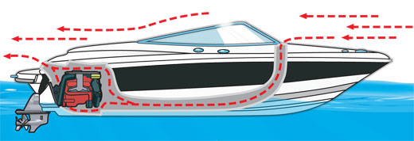
Ventilation systems are crucial. Their purpose is to avoid explosions by removing flammable gases. Properly installed ventilation systems greatly reduce the chance of a life-threatening explosion.
Powerboats are built to ventilate the engine when underway. As the boat moves along, an air intake scoops up fresh air and forces it down the air duct into the engine compartment. The exhaust sucks out the explosive fumes from the lowest part of the engine and fuel compartments.

Ventilation System Requirements

- All gasoline-powered vessels, constructed in a way that would entrap fumes, must have at least two ventilation ducts fitted with cowls to remove the fumes. At least one exhaust duct must extend from the open atmosphere to the lower bilge. At least one intake duct must extend from a point at least midway to the bilge or below the level of the carburetor air intake.
- If your vessel is equipped with a power ventilation system, turn it on for at least four minutes in either of these situations:
  - After fueling
  - Before starting the engine
- If your vessel is not equipped with a power ventilation system (for example, a personal watercraft), open the engine compartment and sniff for gasoline fumes before starting the engine.

4G Explain the use of lights and sound signal devices on motorboats Pages 29-31

Requirement to Have Sound-Producing Devices
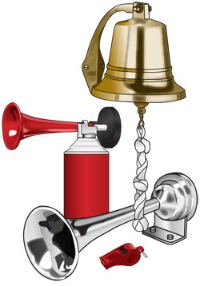
In periods of reduced visibility or whenever a vessel operator needs to signal his or her intentions or position, a sound-producing device is essential. For example, sound signals are required when meeting head-on, crossing, and overtaking.
- The following requirements apply to vessels operating on Missouri state waters.
  - Vessels more than 16 feet but less than 40 feet in length are required to carry on board a whistle or horn to make an efficient sound to signal intentions or positions.
  - Vessels that are 40 feet or more in length are required to carry on board a whistle or horn, and a bell.
- These requirements apply to vessels operating on federally controlled waters.
  - Vessels less than 65.6 feet (20 meters) in length, which includes PWCs, are required to carry on board a whistle or horn or some other means to make an efficient sound signal audible for at least one-half mile.
  - Vessels that are 65.6 feet (20 meters) or more in length are required to carry on board a whistle or horn, and a bell that are audible for at least one mile.

Common Navigation Lights

Navigation lights help you and other boaters determine which is the give-way vessel when encountering each other at night. These lights must be displayed from sunset to sunrise and during periods of restricted visibility, such as fog. There are four common navigation lights:
- Side lights: These red and green lights are called sidelights (also called combination lights) because they are visible to another vessel approaching from the side or head-on. The red light indicates a vessel's port (left) side; the green indicates a vessel's starboard (right) side.
- Stern light: This white light is seen only from behind or nearly behind the vessel.
- Masthead Light: This white light shines forward and to both sides and is required on all power-driven vessels. (On power-driven vessels less than 39.4 feet in length, the masthead light and stern light may be combined into an all-round white light; power-driven vessels 39.4 feet in length or longer must have a separate masthead light.) A masthead light must be displayed by all vessels when under engine power. The absence of this light indicates a sailing vessel because sailboats under sail display only sidelights and a stern light.
- All-Round White Light: On power-driven vessels less than 39.4 feet in length, this light may be used to combine a masthead light and sternlight into a single white light that can be seen by other vessels from any direction. This light serves as an anchor light when sidelights are extinguished.
4H Discuss types of anchors used in motorboating and under what conditions each would be preferred pg 60
Navy / Danforth- folds for easy storage/ Mushroom- light boats/ North Hill / Plow/
Anchor Rope ratio 7-1

4H Explain proper anchoring techniques pg 61
Before lowering insure rope attached to anchor/Lower Don’t throw/ Stand Clear of Rope/ Coil Ropes Neatly

Perform the following:
5A Board and assist others in boarding pg 51
Confirm all passengers on board and are wearing properly fitted life jacket.
5B Fuel the boat and complete a safety check

Pre-Departure Checklist
Another way you can assure a good time while operating your vessel is to perform a pre-departure check.
- Check the weather forecast for the area and timeframe during which you will be boating.
- Make sure the steering and throttle controls are operating properly.
- Check that all lights are working properly.
- Check for any fuel leaks from the tank, fuel lines, and carburetor.
- Check the engine compartment for oil leaks.
- Check hose connections for leaks or cracks, and make sure hose clamps are tight.
- Drain all water from the engine compartment, and be sure the bilge plug is replaced and secure.
- Make sure you have enough fuel or know where you can refuel.
- Check to be sure you have a fully charged engine battery and fire extinguishers.
- If so equipped, make sure the engine cut-off switch and wrist lanyard are in good order.
- Make sure that you have the required number of personal flotation devices and that they are in good condition.
- Leave a float plan with a reliable friend or relative.
5C If equipped attach a kill switch and safely start motor. Get underway from dock or from a beach launch 52
5D Run a course for at least a mile. Show how to overtake or pass slower craft, Yield Right of Way, Passing Oncoming Traffic, Make Turn, Reverse Directions, Use Navigation Aids
5E Stop and secure the boat in position on open water using anchors. Raise and stow anchor and get underway.
5F Land or dock a boat, Disembark and Assist others in doing the same 54
5G Moor, dock or beach the boat and secure all gear. 58
5H Demonstrate Knots used in Boating.
Cleating Hitch, Bowline, Clove Hitch, Anchor Bend, Sheet Bend

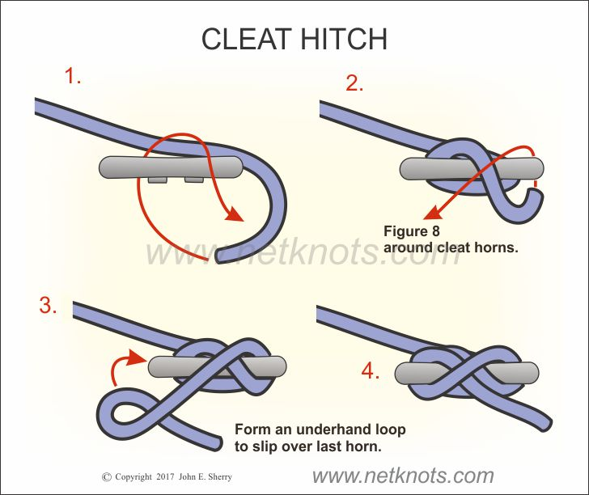

Bowline Knot
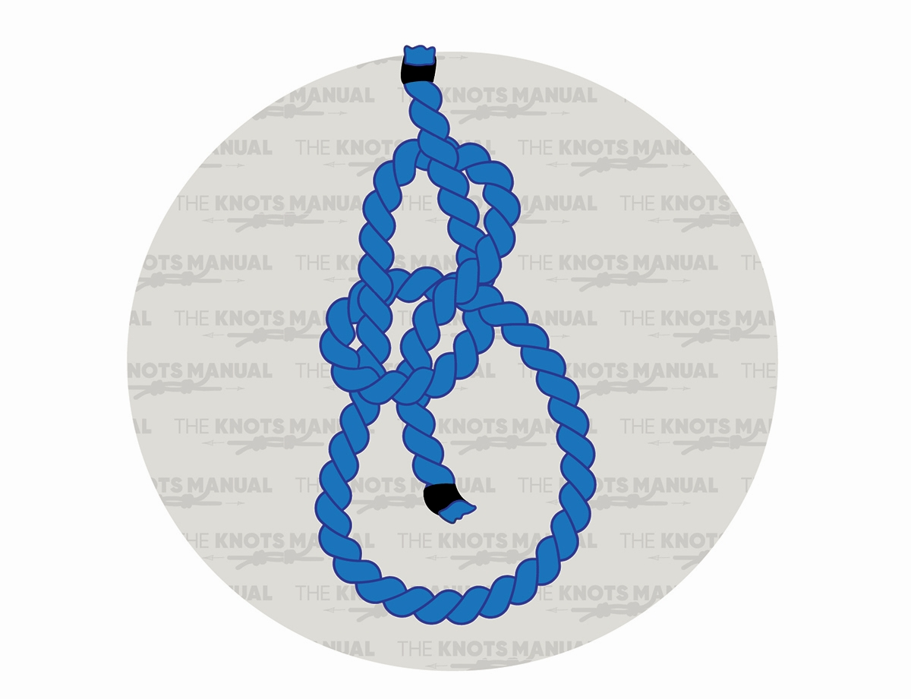

Clove Hitch

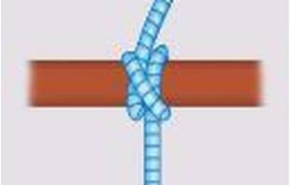
Anchor Bend
