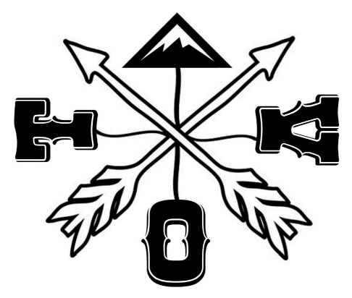
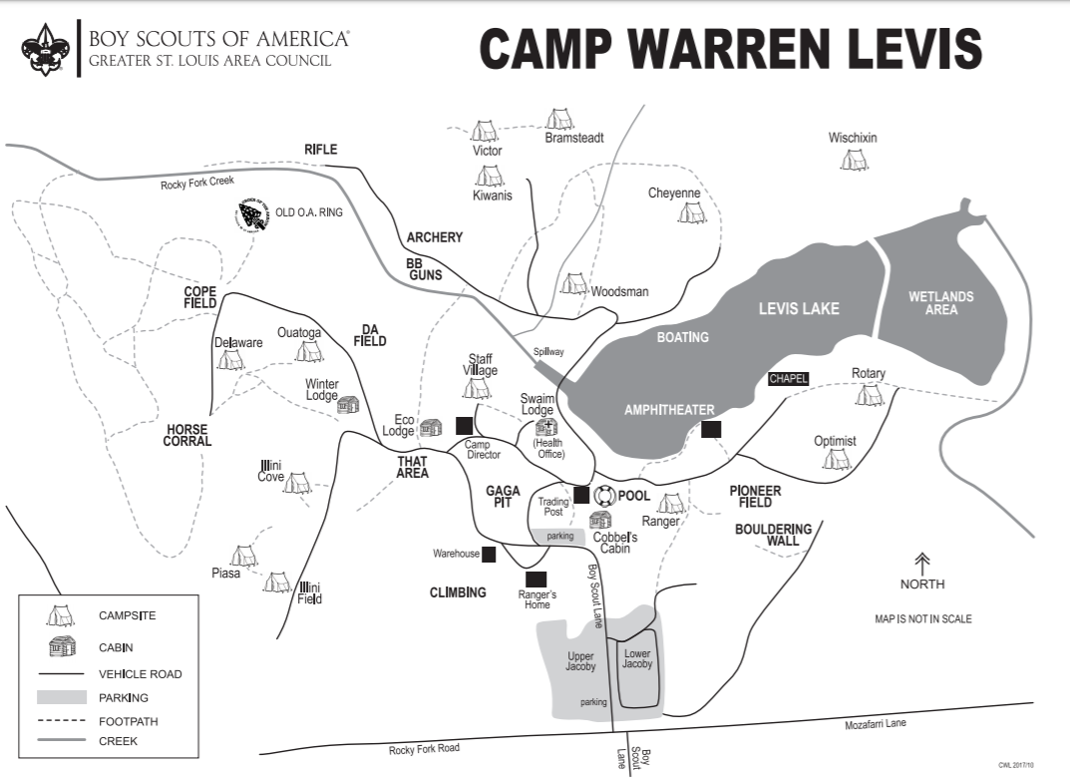
Sunday
11:30am all campers campsites cleaned and checking out of camp.

Saturday
- 8-9am Check in for day only participants @ Swaim
- 8:45am Opening Flag Ceremony outside Swaim
- 9 to noon, and 1-4pm Program/Open Areas
- 5:30pm Potluck Dinner @ Swaim
- 6:30-8pm Glow Canoes @ Lake
- 7:30-9:00pm Bingo @ Swaim
- 9:30pm-11:00pm Music & Dancing in Swain Lodge
- Winter lodge will be open for hanging out or in case of weather

- Swaim Lodge (TOV Headquarters)
- Morning only: Silk Screening, candle making, leatherwork, duck decorating,
- Afternoon only: Ice Block Sledding, Skillet Toss, Duck Race
- Medical Office (all weekend)
- Fishing all day
Glow Canoes—6:30-8pm only
- Duck Race 4pm
on road to Target sports bring your duck to race on the creek.
5. Target sports
- Cowboy Action (am only)
- Shotguns (all day)
- Rifles (pm only)
- Archery, knives & hawks, pellet guns
6. Winter Lodge _{all weekend}
- Inclement weather area
- Skillet Toss 2-3pm outside
7. Gaga Ball _{all day}
8. Climbing Tower & Crate Stacking near Rangers House) _{afternoon only}

(3)
(1)
(8)
(6)
(5)

(7)
Friday Night
- 5-10pm Check in at Swaim Lodge
- 7pm Movies & popcorn inside Swaim
- Winter Lodge will be open for hanging out or in case of weather

(2)

- Each Unit may have 1 vehicle at their campsite, along with your trailer, all other vehicles should be in the parking lots, please do not drive around on Saturday. (If there is a special need to drive please let the TOV advisor know)

.
Taste Of
Venturing
2026

Welcome to
Under the Sea
Friday Evening- Please do not arrive to camp before 5pm. Have 1 member of your unit check in at SWAIM (inside lodge)
- Camping will be in Illini field, DA Field and Ouatoga
- Please try to keep fires to pits.
Saturday
- 5:30pm..Each Crew needs to bring a side dish for dinner. Enough to feed your crew plus 2 more people. Please bring a list of ingredients for allergy purposes.

Sunday
- Pack up/Check out by 11:30am

Other Information
- Bring a Shirt or item to Silkscreen. Paint colors will be Green for the TOV logo and Blue for the theme print.
- Bring your own Camping Gear, Weather Gear, First Aid kit
- Bring a side dish (Enough for your crew plus two)
- Bring your own tackle & bait for fishing
- Please clean up your campsite at the end of the weekend, there is a dumpster at Swaim Lodge for trash, please make sure all fires are out when you leave on Sunday.
- If cold bring your own mug and hot chocolate packets. Hot water will be inside Swaim all day.
- Water may not be turned on at Latrines yet due to cold weather. There are frost free spigots in Illini and near Winter Lodge.

