Taste of Venturing
Service Project
We will be collecting used/new belts any style to be given to the unhoused community in the MO/IL area.
Bring your belts with you to the Taste of Venturing event where you will find a collection box.

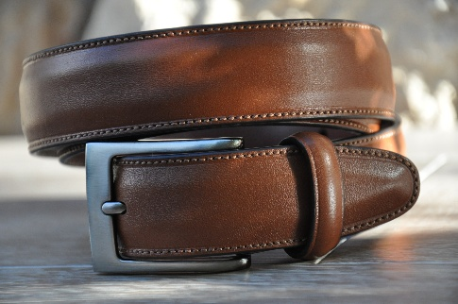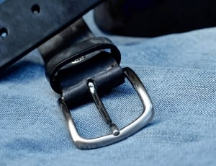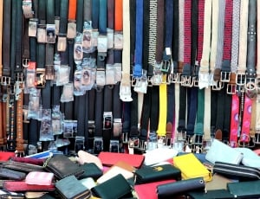

For more information contact the TOV Advisor, Jenn Barton at bartondanandjenn@gmail.com.
Not attending TOV (question would be why not) but want to donate belts contact Jenn Barton.

