Mining in Society Merit Badge Workshop
Saturday, February 28th, 2026

8:30am to 3:30pm at Knight Hawk Coal LLC

Belt, Long pants, and Hiking Boots required. Dress like you may get a little dirty.
Failure to comply will result in a non-complete

Address: Kight Hawk Coal IL-154, Pinckneyville, IL 62274
or
1 ½ miles West of Gander Hill Goose Club (2424 IL-154, Pinckneyville, IL 62274)
1 ½ miles East of Bottom to Top Construction (1103 IL-154, Cutler, IL 62238)
Use Google Maps for Best Result: https://maps.app.goo.gl/Gez1Bm2g3Fb8xFGy8

8:15 - 8:30 Arrive at Knight Hawk Coal – please park in front lot and enter building under the “Knight Hawk” sign. (see photo)

08:30-09:00 Requirement 3 – Mine Hazards and PPE Knight Hawk personnel

09:15-11:30 Requirement 5 – Underground Mine Tour Knight Hawk personnel

11:30-12:00 PIZZA LUNCH Courtesy of Knight Hawk Coal

12:00-12:30 Requirement 1 - Ore Minerals MB Counselors

12:30-01:00 Requirement 2 – Identifying Mines MB Counselors

01:00-01:30 Requirement 4 – Abandoned Mines MB Counselors

01:30-02:00 Requirement 7 – Interplanetary Mining MB Counselors

02:00-03:00 Requirement 6 – Preparation Plant Tour MB Counselors

03:00-03:15 Requirement 8 – Mining Careers & Mining Education MB Counselors

03:15-03:30 Final Remarks and Paperwork. MB Counselors
View from the East
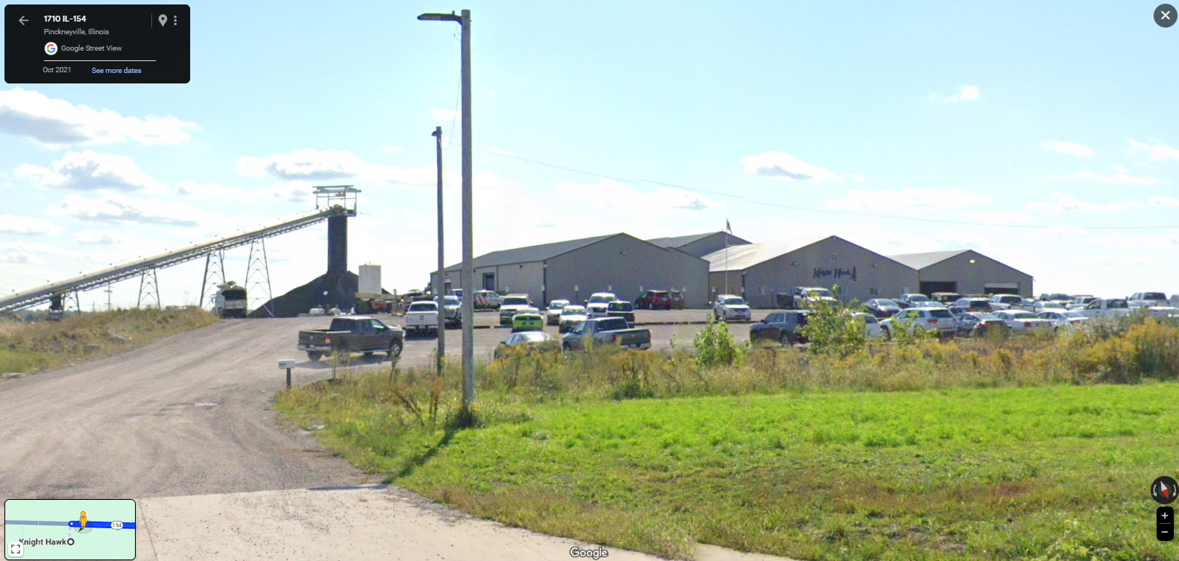
View from the West
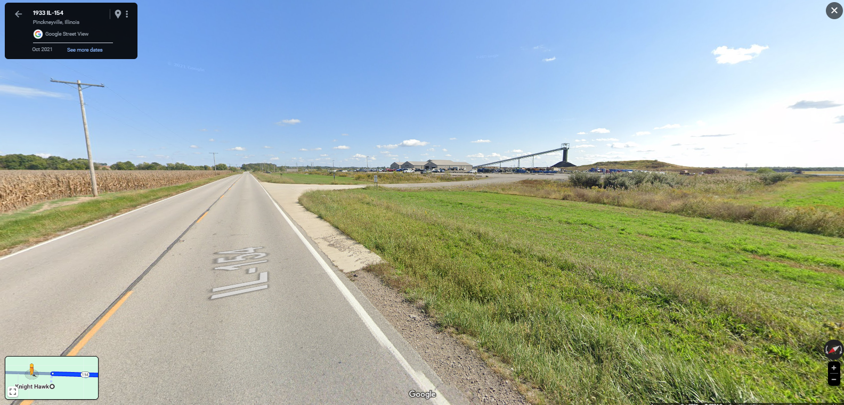

Google Maps link with coordinates
https://maps.app.goo.gl/Gez1Bm2g3Fb8xFGy8

