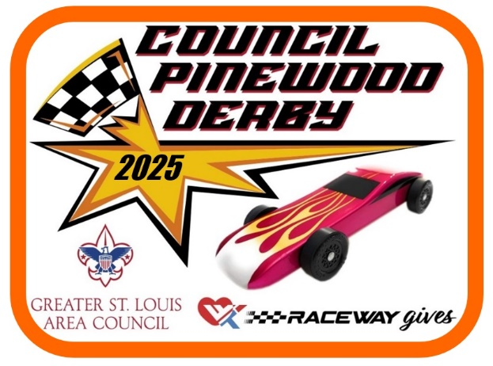

DESIGN CAR CATEGORIES
MOST REALISTIC Represents the balance, shape, proportion, and finish of an actual racing car.
NOVEL DESIGN The car reflects a novel/unique approach to shape, motif, and design that departs from the expected car.
PATRIOTIC SPIRIT The car reflects the best use of Red, White and Blue colors and Patriotic symbols.
KID DID The car in the view of the judges deserves special recognition for it demonstration of a Cub Scout skill level.
CLASSIC DESIGN A car that reflects a representation of an American Classic car design from the past years.
SCOUTING SPIRIT Best use of scouting insignia or scouting themes.
JUDGE’S SPECIAL The car in the view of the judges deserves recognition but the car does not fit into a specific category.

