# River Trails District

# Klondike Derby

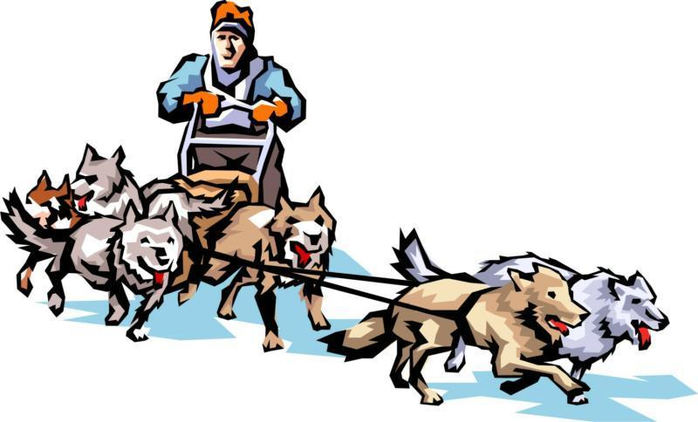

**Blast from the Past**

**February 8, 2025**

Greater St. Louis Area Council Boy Scouts of America

2025 River Trails District – Klondike Derby

Date: February 8, 2025

Location: Beaumont Scout Reservation – Nagel Area

Check-In: Registration for Klondike will begin Saturday morning from 7:00 am to 8:00 am at the Nagel Lodge. Please be prompt – we need time to finalize registration before opening. The Klondike will end at 5:00 pm after the races and awards presentation.

Cost: The Klondike fee covers the cost of a patch and all program materials. The cost is $10 per Scout and adult attending. Please pre-register on the Stlbsa.org Then to RiverTrails district.

General: The Klondike is a one-day event. If your Troop/Crew is planning to camp for the weekend, you need to make a separate reservation with the camping department, for tent camping, Laemmli is reserved for River Trails. ***The event is a District Scouts BSA event. Arrow of Light Scouts that are about to crossover may attend, but could be limited by The Guide to Safe Scouting from some events, and must follow age-appropriate guidelines if camping. Other Cub Scouts and siblings will not be permitted at the event.***

Adult Michael Stephens

Advisor: (314) 795-2272

[michael.stephens@shawneelodge.org](mailto:michael.stephens@shawneelodge.org)

Youth Lucas Maynard

Campmaster: (314) 366-0699

[lucas.maynard@shawneelodge.org](mailto:lucas.maynard@shawneelodge.org)

Questions? Contact your Scoutmaster, your OA Troop Representative, Mike or Lucas.

**Blast from the Past**

PLEASE NOTE: The Scout patrols should plan on having their sled with them as they move about during the day as it will be required at some events. They should also have on the sled their lunches and supplies for the day. The lunch break is short, and Scouts won’t have time to leave the Klondike area, eat and get back. ***All patrols are to bring flint and steel, team spirit, and the ability to laugh!***

**Water Supply** Well It seems we're out of water again. Someone has to get some water from the creek, but remember the bacteria potentially living in the water. Your patrol will be tasked to start a fire to boil the creek water and make it safe for drinking.

**Field Sports** After setting up camp your patrol leader decides to have some fun before your scoutmaster gets back and makes you start cooking dinner.

**Rub Some Dirt on It** You never know when you may need to use your first aid skills. Here your skills will be tested with a surprise your SPL has put up. Make sure to come prepared.

**Baden Powell's Time Capsule Hunt** Lord Baden Powell left a time capsule here at Beaumont in 1910 and asked for it to be opened on BSA’s 115th Anniversary. Your patrol must use your past experience on compasses and orienteering to navigate the lands finding the hidden treasure from the past.

**Chop the Tree** Your Scoutmaster has challenged everyone to see who can cut the most thin slices of wood to stack and create the tallest tower. You have to partner up and using a two person saw you are going to create slices of a log to make the tallest tower.

**Down Around Town** While walking down town your patrol gets invited to join a trivia show about scouting history. You all choose to join but they tell you the twist, using your sled your troop is tasked to race your sled around a course with stops along the way asking you trivia questions. Hopefully your patrol knows your scouting history.

**Gettin’ Across the River** One of your patrol members got stuck on the other side of the river. You must use all your knot tying knowledge to tie ropes together to save the lonesome scout. The faster you act and how accurate your knots are may just award you in the end.

**Shootin in the Range** Finally that time of day when your patrol gets to do range activities. After a long day of cheerful service your patrol gets to end the day on the range.

**SCHEDULE**

Saturday

|  |  |  |
| --- | --- | --- |
| Registration | 7:00 am - 8:00 am | HQ – Nagel Lodge |
| Opening Assembly | 8:15 am | Nagel |
| Event Rotation | 8:30 am -9:10  9:15 am – 9:55 am  10:00 am – 10:40 am  10:45 am – 11:25 am | Nagel |
| Lunch | 11:25 am – 12:00 pm | Nagel |
| Event Rotation (cont.)  Sled Races  Closing Assembly/Awards | 12:05 pm – 12:45 pm  12:50 pm – 1:30 pm  1:35 pm – 2:15 pm  2:20 pm – 3:00 pm  3:10 pm – 4:15 pm  4:30 pm – 4:45 pm | Nagel  Nagel |

**SLED RACING RULES**

Sled races will be held for two classes.

The younger class will be for Scouts aged 13 and younger.

The older class will be for Scouts aged 14 and older.

Scouts can only run in the appropriate class.

A Scout must be present all day to participate in the races.

Only registered Scouts are allowed to participate.

**SLED CONSTRUCTION**

1.The sled is to be 5-6 feet long by 18-24 inches wide with a comfortable handle height (approx 40”) for proper steering by the scouts.

2. The sled is to be made entirely of wood. No metal parts will be accepted. Lashings and glue are the **only** acceptable binding and connecting materials.

3. One scout must ride in the sled.

4. One scout will steer the sled.

5. All other members of the patrol will be “mushers” pulling the sled with properly attached rope or harness.

6. Adults are encouraged to supervise the building of the sleds, but the sled must be entirely built by the patrol or troop. Any sled proven to be constructed by adults will be disqualified. A Scouter – as well as a Scout – is TRUSTWORTHY.

7. The sled may be of any design that meets these requirements.

8. A Patrol flag is *required* on each sled.

9. The patrol is *encouraged* to adorn or decorate their sleds as per the designated theme.

***Be sure to follow the sled racing and construction rules to qualify for a Race Award.***

**Race Awards**

Awards presented in each class for the following:

* Best looking sled
* Best Design
* 1st Place - Older Class
* 2nd Place - Older Class
* 1st Place - Younger Class
* 2nd Place - Younger Class

Awards will be presented to the winning Patrol in each class.

**Station Awards**

* Baden Powell’s Treasure Hunt - Fastest Time
* Chop the Tree - Tallest Tower
* Gettin’ Across the River - Fastest Time
* Down Around Town - Fastest Time

**CAMP RULES**

1. The event is a Boy Scouts only. Cub Scouts and siblings will not be permitted at the event.
2. ***NO alcoholic beverages.***
3. No smoking! Please refer to the Guide for Safe Scouting. If you must smoke, please move to the parking lot out of view of others, especially youth.
4. No fireworks, firearms, bow and arrow, etc.
5. No pressurized fuel equipment (lanterns, stoves, heaters, etc.) ***unless*** you have taken the Greater St. Louis Area Council Training and have received your ***Toasted Chit and have it with you***. Charcoal or wood is recommended for all cooking.
6. No flames of any kind are permitted inside or near a tent.
7. No heaters of any kind are permitted inside or near a tent.
8. Kerosene lanterns may be used to illuminate the campsite. However, battery-operated lanterns are much safer and shed much more light.
9. Water sources are for filling water containers and drinking only, not for bathing or for washing the dishes. Please ask your scouts not to play with the faucets; this creates a muddy mess in a very short time.
10. NO live trees may be cut. Please follow the ***Outdoor Code***.
11. Digging the ground around any tents is not allowed. Use proper pitching of tents to avoid ditching. Please follow the ***Outdoor Code***.
12. The BSA Guide to Safe Scouting allows sheath knives, the River Trails District Committee has voted not to allow possession, wear, or use of sheath knives by any youth or adult at district activities. There may be further restrictions based on state law, local ordinances, or Council’s policy. A Totin’ Chip is required by a Scout to carry a folding pocket knife
13. These tools must be used safely and properly at all times.

**CAMP ROSTER**

Klondike Derby February 8, 2025

Beaumont Scout Reservation (roster due at time of registration)

TROOP/CREW: ______ DISTRICT: River Trails

Patrol Name: _______________

|  |  |  |  |  |
| --- | --- | --- | --- | --- |
| Name | Address | Phone Number | Age | Patch  ‘**F**’irst or ‘**R**’epeat |
|  |  |  |  |  |
|  |  |  |  |  |
|  |  |  |  |  |
|  |  |  |  |  |
|  |  |  |  |  |
|  |  |  |  |  |
|  |  |  |  |  |
|  |  |  |  |  |

Patrol Name: ________________

|  |  |  |  |  |
| --- | --- | --- | --- | --- |
| Name | Address | Phone Number | Age | Patch  ‘**F**’irst or ‘**R**’epeat |
|  |  |  |  |  |
|  |  |  |  |  |
|  |  |  |  |  |
|  |  |  |  |  |
|  |  |  |  |  |
|  |  |  |  |  |
|  |  |  |  |  |
|  |  |  |  |  |

Adults

|  |  |  |  |
| --- | --- | --- | --- |
| Name | Address | Phone Number | Patch  ‘**F**’irst or ‘**R**’epeat |
|  |  |  |  |
|  |  |  |  |
|  |  |  |  |
|  |  |  |  |
|  |  |  |  |
|  |  |  |  |
|  |  |  |  |

**EVENT EVALUATION**

**Event: Klondike 2025**

**Unit:**

**Contact Info:**

**What did the scouts like the best?**

**What should we keep doing?**

**What should we start doing?**

**What should we stop doing?**

**Other comments:**

**Troop Registration Form**

**River Trails**

**Klondike Derby 2025**

The Klondike Derby registration fee is $10 per scout and adult. The fee includes program supplies and a patch. This registration form and fee can be turned in at the council office before the event or at the event headquarters on the day of the event.

**Troop/Crew # ________ # of patrols _________**

Registered by: Name: ___________________________________________

Address: ______________________________________________________

Unit Position: ______________ Email: _____________________________

Home #: (____) _____ - _______ Cell #: (____) _____ - _______

|  |  |  |  |
| --- | --- | --- | --- |
|  | Number |  | Total |
| Scouts BSA |  | X $10 |  |
| Adults |  | X $10 |  |
| Total |  | X $10 |  |

Make Checks Payable to:

GSLAC BSA

Mail to:

Greater St. Louis Area Council

4568 West Pine Blvd., St. Louis, MO 63108

Attention:

River Trails Klondike Derby 2025