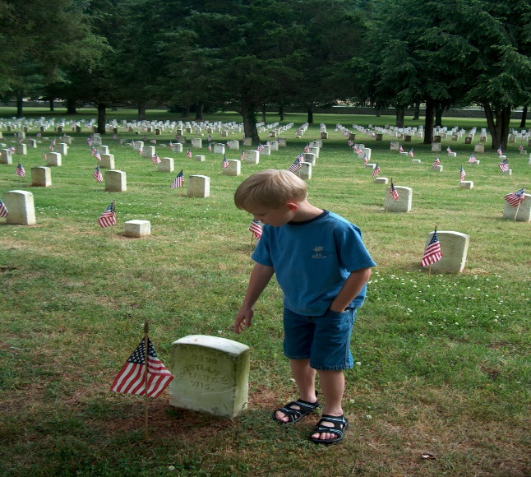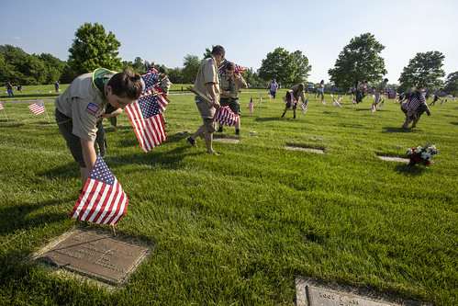
This Photo by Unknown Author is licensed under CC BY-SA-NC
MEMORIAL DAY GOOD TURN
SUNDAY MAY 28th, 2023

Jefferson Barracks Good Turn
Scouts of all ages are invited to participate in the Memorial Day Good Turn. Check in for Jefferson Barracks Good Turn, hosted by Gravois Trail District, registration will be from 10:30 am until 11:30 am in front of Beasley Elementary School at the south side of the cemetery. The procession from Beasley Elementary to the cemetery will begin at 11:30. Upon check-in, the unit leader or designated adult will receive a map and participation ribbon. A Memorial Day Good Turn patch is available for $4.00 and segment patches are $1.00.
Participants will attend the Flag Ceremony before proceeding to the flag boxes. No one will be allowed to begin placing flags until after the ceremony has been dismissed.
Here is some important information to know before you go:
- Plan for a hike. You will be walking 1 – 3 miles on the day of the event.
- The person who registers the unit should be our main contact person for the event.
- Please do not bring unit or American Flags.
- No Parking is allowed in the Cemetery. Plan to park Sylvan Springs County Park on Sheridan Rd.
- Bring rain gear. The event is held rain or shine. It is a good idea to bring hats and sunscreen.
- Make sure you bring plenty of water for you and your Scouts.
- Damaged flags should be returned to the box and not placed on a grave.
- REMEMBER THE SCOUT OATH AND LAW AND THE PURPOSE OF THE DAY. We are guests at Beasley Elementary and the Cemetery.

