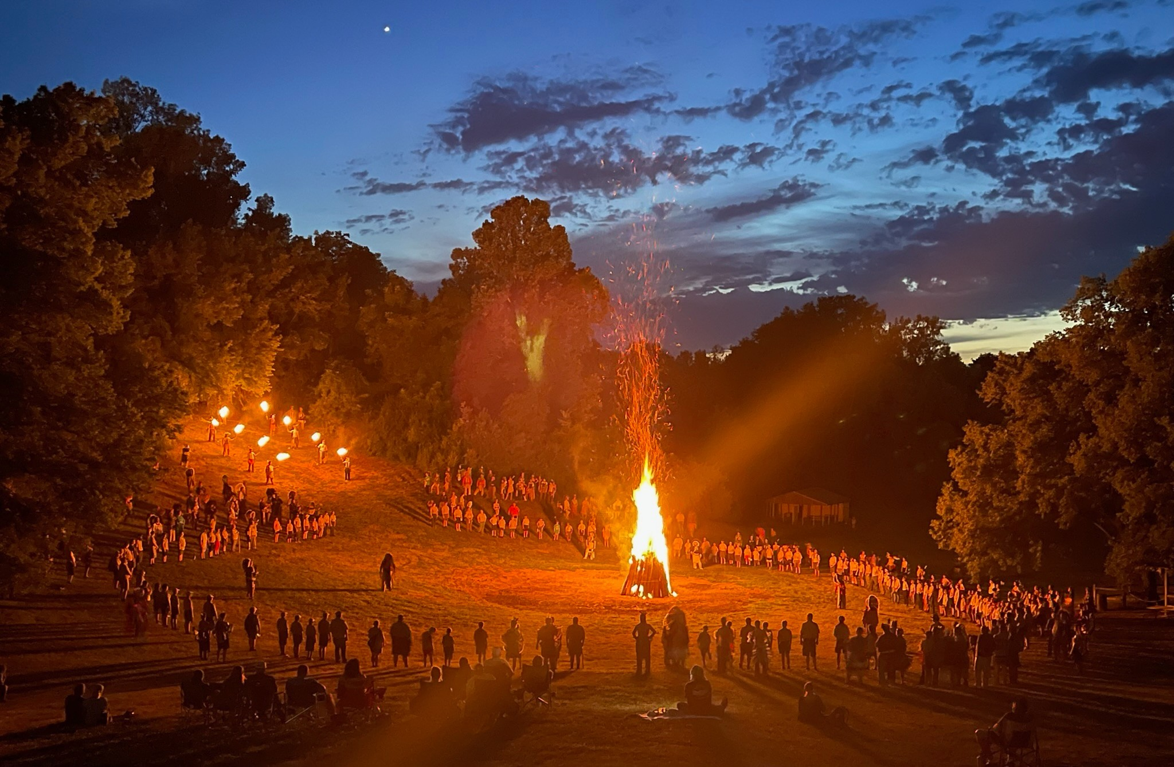
Scouting University

Sept 25-27, 2026
Camp Geiger
Corral Area and
Training Center
$35
Every Unit Deserves a fully trained Leader.

Ages 18 +
Register today at

ponyexpressbsa.org

Do you want to give a better experience to your scouts?
Do you want to better your unit and scouting in general?
Doesn’t every scout deserve a trained leader?
Cubmasters: Please complete the online portion of Baloo BEFORE attending the weekend.

Pony Express Council Training Weekend!!
Training offered: Scouts BSA Outdoor Leader, Scoutmaster Fundamentals, Cubmaster Fundamentals, Baloo, Safeguarding Youth Protection, Peer on Peer Training, Merit Badge Counselor
Things to bring with you for training weekend
Scout uniform
Tent (No RVs, you will be sleeping in the tent, if severe weather occurs substantial shelter will be available)
Sleeping Gear for the weather. All Training will be in Corral.
Comfortable solid shoes
You will be taking a hike over camp
A chair
Handbook for your scouting position
Note taking materials (staff will not be responsible for misplaced items)
Shower items and extra clothes, Showers and restroom in Training Center
Personal mess kit or eating materials
Medications
If you are on CPAP or other medical devices, power will be available but bring an extension cord
Personal first aid kit for demonstration
Water bottle
Compass if you have one
All Food and cooking supplies provided. IF you have a special food needs, please bring your own
Please arrive Friday evening having already eaten, the program will begin no later than 7pm with registration starting at 6. There will be a cracker barrel late in the evening
Training schedule
Friday
Check in 6:00 PM
Cracker Barrel discussion and prep 7:00 PM
Saturday
Breakfast by Patrol 7:00
Campsite selection 8:00
Backpacking items 9:00
Break 10:30
Woods tools 10:45
Lunch by patrol 12:00
Map and compass/Plant id 1:00
Knots 2:45
First Aid 3:45
Merit badge counseling 5:30
Dinner by Patrol 6:00
Scouts own & Campfire 7:15
Sunday
Breakfast by Patrol 7:00
Scoutmaster fundamentals /OWL 8:10
Closing cracker barrel and awards 12:00
Some basic snacks will be provided throughout the day but if you wish for a specific snack please bring it with you
WE PLAN TO CONTINUE TRAINING MATERIALS WELL INTO SUNDAY. IF WE FINISH EARLY, WE MAY DISMISS YOU EARLY.
If you wish to bring a dessert or snacks for the group, you are more than welcome to do so, but please let the training team know what you are bringing. You do not need to bring a dessert or snacks if you do not wish to.

