America Semiquincentennial Camporee 2026
Ozark Trails Council
Leader’s Guide
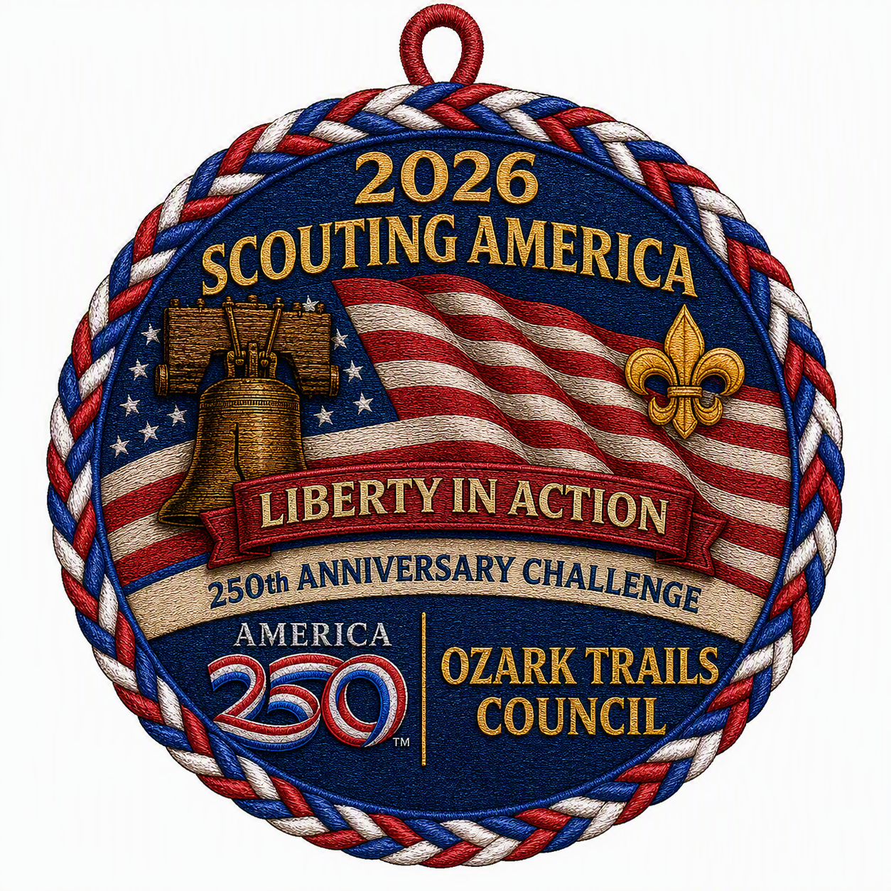
Hosted by Scouting America in partnership with the Sons of the American Revolution and the Daughters of the American Revolution.
Dates: September 11-13, 2026
Location: Camp Arrowhead, Marshfield, MO
Theme: Liberty in Action – Lexington & Concord
Register At: https://scoutingevent.com/306-America250Camporee

1. Event Overview
This camporee is built around the Sons of the American Revolution (SAR) America 250 program for Lexington & Concord. Scouts engage in hands‑on stations that explore the opening days of the American Revolution while building Scouting skills in first aid, pioneering, mapping, problem solving, and teamwork. Participation qualifies youth to earn the Liberty in Action patch.

2. Location
- Camp Arrowhead, 4202 State Rte DD, Marshfield, MO 65706

3. Pricing
- Early Bird Youth Registration: $25.00 (Early Bird Ends September 4, 2026)
- Regular Youth Registration: $35.00
- Early Bird Adult Registration: $10.00 (Early Bird Ends September 4, 2026)
- Regular Adult Registration: $15.00

4. Partners & Acknowledgments
Scouting America – Ozark Trails Council (host)
Sons of the American Revolution (program partner)
Daughters of the American Revolution (support partner)

5. Schedule
Friday, May 15
• 5:00–8:00 p.m. Unit Check‑in & Campsite Setup
• 9:00 p.m. Cracker Barrel & Leader/SPL Meeting
Saturday, May 16
• 7:00–8:15 a.m. - Breakfast (units) & campsite prep
- 8:00 a.m. – Volunteer Meeting/Handout Station Instructions
• 8:30 a.m. - Opening Flags & Announcements
• 9:00 a.m.–12:00 p.m. Morning Stations (open rotation)
• 12:00–1:30 p.m. Lunch (units)
• 1:30–5:00 p.m. Afternoon Stations (open rotation)
• 7:00–8:15 p.m. Closing Campfire & Awards
• 10:00 p.m. Lights Out / Quiet Hours
Sunday, May 17
• 7:00 a.m.: Breakfast (units)
• 8:30–9:30 a.m. Campsite breakdown & final inspections
• By 10:00 a.m. Check‑out complete (Leave No Trace)

6. Check‑In & Check‑Out
Check‑In (Friday 5–8 p.m.):
1) Proceed to HQ for unit check-in and campsite assignment.
2) Turn in: medical forms packet, and any remaining fees due.
3) Wristbands issued.
4) One vehicle may haul gear to site; all others to designated parking.
Check‑Out (by Sunday 10 a.m.):
• Make sure campsites are clean.
• Check Out and Receive Patches.

7. Safety, Youth Protection & Medical
• Two‑deep leadership and all Barriers to Abuse apply at all times. Current Youth Protection Training is required for adults.
• Annual Health & Medical Record (AHMR) Parts A & B are required for all participants.
• A designated Health Officer, first‑aid station, and emergency communication plan will be posted. Units should carry their own first‑aid kits and water at all times.

8. Camp Rules & Logistics
• Cooking: Unit‑provided meals (Fri/Sat/Sun all meals by units). Follow fuel safety; stoves/lanterns per Guide to Safe Scouting.
• Water: Potable water points will be identified; units should bring water jugs for stations.
• Fires: Follow posted fire danger level; use established fire rings or fire pans. Never leave fires unattended; cold‑out before departure.
• Knives/Tools: Totin’ Chip/Tool safety rules enforced. No sheath knives at stations.
• Vehicles: Park only in designated areas; no riders in truck beds.
• Pets, alcohol, tobacco, and fireworks are not permitted.

9. Leave No Trace (LNT)
All units are expected to model the 7 Principles of Leave No Trace throughout the weekend. Campsites must be clean and restored before checkout. Bring trash bags; pack out what you pack in.

10. Patrol 10 Essentials for Saturday Stations
• Pocketknife (only for Scouts with Totin’ Chip; adults secure otherwise)
• First‑aid kit (unit or patrol level)
• Extra clothing (layers appropriate for weather)
• Rain gear
• Water (each Scout + patrol water jug)
• Flashlight or headlamp
• Trail food/snacks
• Matches/fire starter (Firem’n Chit; adults supervise)
• Sun protection (hat, sunscreen, lip balm)
• Map and compass
Optional but recommended: whistle, insect repellent, duct tape, small tarp, and notebook/pencil.

11. Program Overview & Stations (Lexington & Concord)
Scouts rotate by patrol through themed stations inspired by SAR’s America 250 program. Unless noted, all program materials are provided at stations. Points or times may be used for patrol awards.
Station 1:
Spies Among Us – Invisible Ink & Coded Messages
Purpose: Decrypt and complete a secret mission using invisible ink and simple ciphers.

Station 2:
Old North Church – Light the Lantern (flint & steel)
Purpose: Safely spark tinder and light a candle.
Station 3:
The Midnight Ride – Rope & Saddle Paul Revere’s Horse
Purpose: Properly rig a simple lash/bridle simulation.
Station 4:
Lexington Green – Blanket & Pole Litter
Purpose: Build a makeshift litter and transport a ‘patriot’.
Station 5:
Dr. Joseph Fiske Takes Charge – First Aid: Stop the Bleeding
Purpose: Demonstrate bleeding control and patient care.
Station 6:
Minutemen Assemble – Map Making (Lexington to Concord)/Orienteering
Purpose: Sketch a usable map and route plan.
Station 7:
North Bridge – Build a ‘no‑lash’ Pole Bridge
Purpose: Assemble a bridge for three patriots to cross.
Station 8:
Barrett Farm – Build a Ladder (poles & twine)
Purpose: Construct a safe ladder to reach a loft line.
Station 9:
The British Threaten to Burn Concord – Fire Brigade
Purpose: Relay water by bucket brigade; most water wins.

Station 10:
Letter Writing To Troops

Station 11:
Long Range Shooting Sports

12. Patrol Score Sheet (turn in by 5:30 p.m. Saturday)
Station | Patrol Members | Score Initials
Spies Among Us – Invisible Ink & Coded Messages
Old North Church – Light the Lantern (flint & steel)
The Midnight Ride – Rope & Saddle Paul Revere’s Horse
Lexington Green – Blanket & Pole Litter
Dr. Joseph Fiske Takes Charge – First Aid: Stop the Bleeding
Minutemen Assemble – Map Making (Lexington to Concord)
North Bridge – Build a ‘no‑lash’ Pole Bridge
Barrett Farm – Build a Ladder (poles & twine)
The British Threaten to Burn Concord – Fire Brigade
TOTAL

13. Awards & Recognition
Liberty in Action Event Patch: Awarded to Scouts who participate in the camporee, attend opening flags and the campfire, and complete the program stations.
Unit & Patrol Awards : Top 3 Overall Patrols.

14. What to Bring
Units
- Troop/patrol flag
- First‑aid kit
- Cooking gear
- Food
- Water coolers and Drinking water for the weekend
- Shade canopy
- Trash bags
- Fire safety gear
- Standard camping gear
Scouts
- Personal camping gear
- Reusable water bottle
- Closed‑toe shoes
- Weather‑appropriate clothing
- Ten Essentials (see Section 8)
- Field uniform for flags/campfire
- Activity uniform for stations
- Flashlight/Headlamp
- Mess Kit

15. Contacts
- Council Contact: Jamie Fisher
- Council Contact: Michael Widman
- Volunteer Event Coordinator: Scott Radford
- Volunteer Event Coordinator: Becky Bonner

