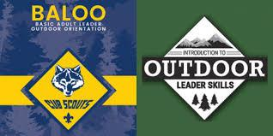
Introduction to Outdoor Leadership Skills or
Basic Adult Leader Outdoor Education
Saturday and Sunday September 26th-27th
Camp Plagens Conservation Area
1138 S. 220th Street, Pittsburg KS
Cost: $25 by Aug 29th or $35 after
Includes Saturday lunch, dinner, & cracker barrel Sunday breakfast, and course materials.
One Sign-Up Link, then pick your course!
IOLS - FOR SCOUTS BSA LEADERS
BALOO - FOR CUB SCOUT LEADERS
There is a pre-requisite training for BALOO. More information on how to locate it can be found here:
BALOO Pre-Requisite
WHO SHOULD COME?
Cubmasters, Scoutmasters, and their assistants
Den Leaders, Committee Members
Any interested adult leader
This training is mandatory for Units that do overnight camping.
DETAILS:
When: 8:00 AM Saturday September 26th through 12:00 PM Sunday September 27th.
Where: Camp Plagens Conservation Area (This training will take place outdoors so please be prepared to camp and for weather)
Contact Dawn Annecharico with Questions at scouter.ms.dawn@gmail.com

