COLLEGE OF COMMISSIONER SCIENCE
OZARK TRAILS COUNCIL
March 21, 2026
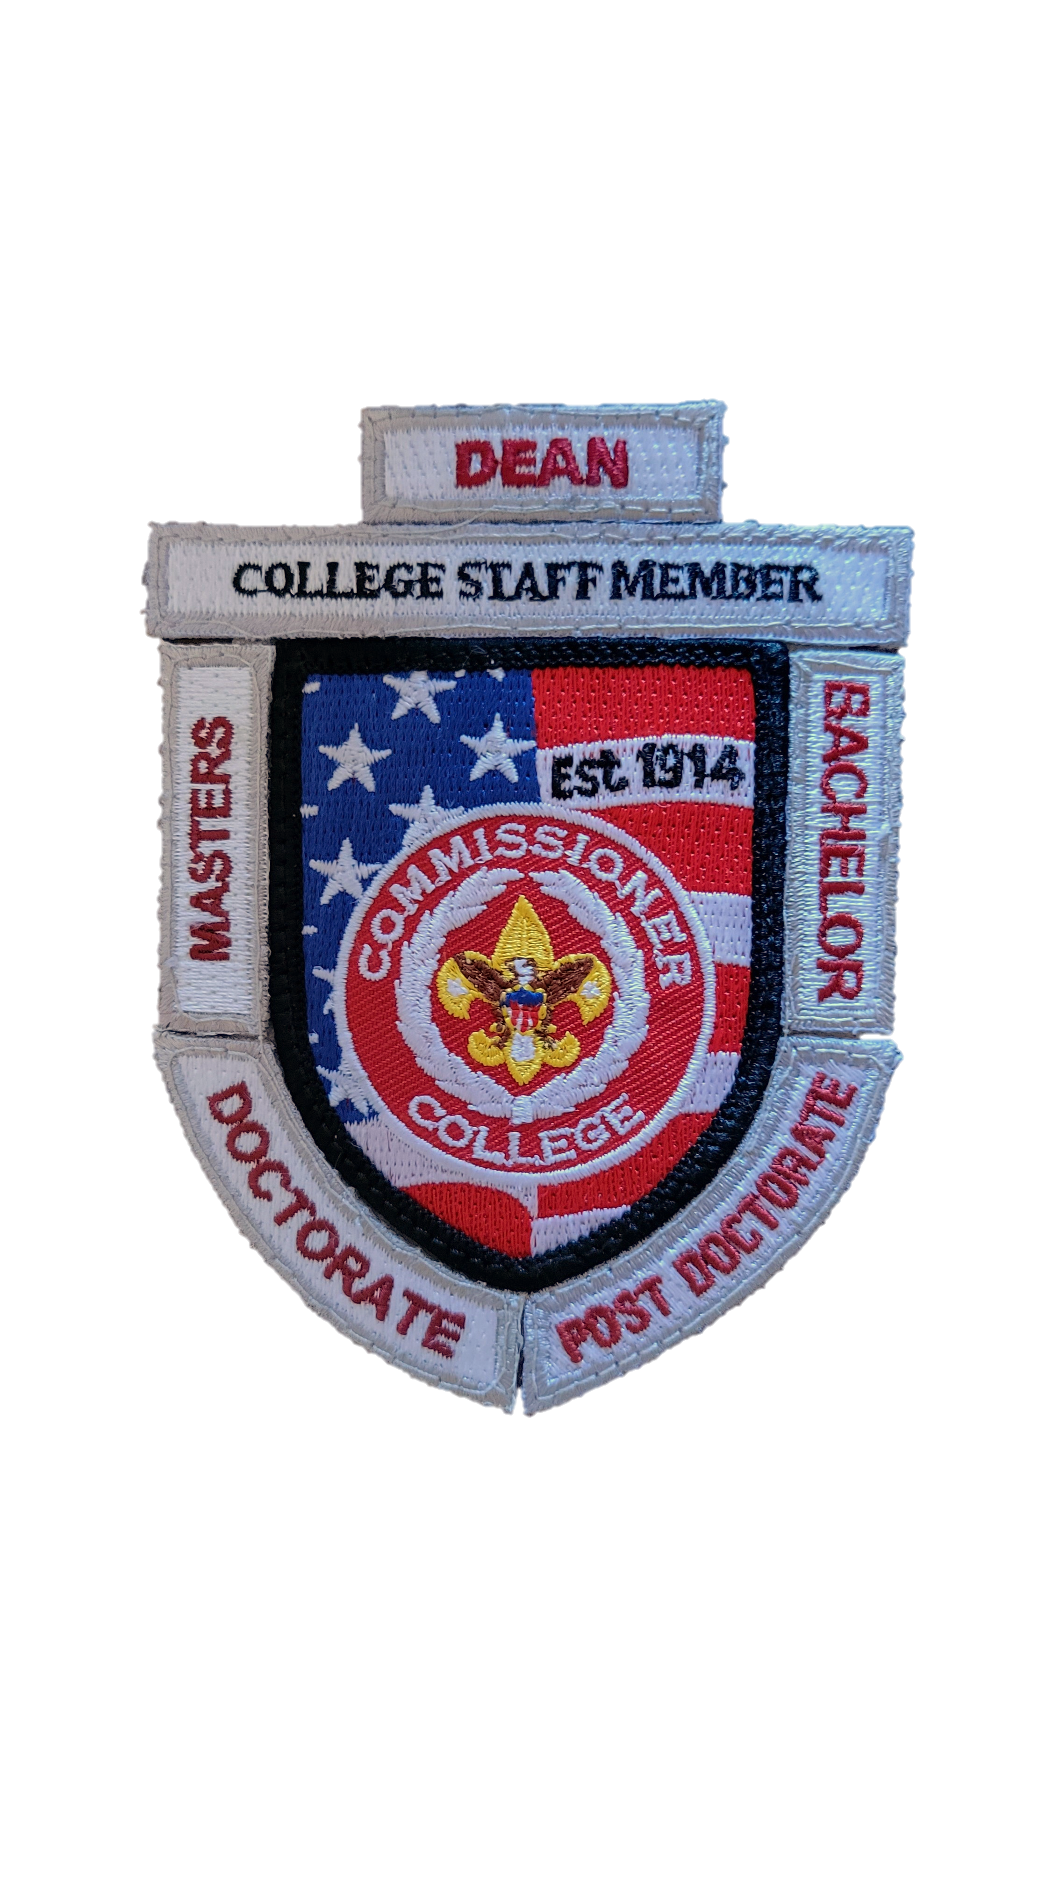
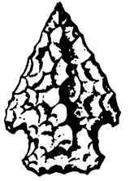
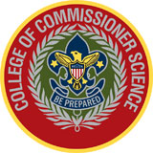

Where: Ozark Trails Scout Center, Springfield, MO
When: March 21st 8 am to 4 pm (Check in starts at 7:30 am)
What: Bachelors, Masters, and Doctorate of Commissioner Science programs advanced training for Commissioners.
Who: All Commissioners, Professional Staff, District Committee members, unit leaders, and all registered volunteers that want to learn more about the unit service function of Commissioner staff.

Tuition Fee: $20.00 for early registration on or before Saturday, March 1
After March 2, the registration fee is $25.00.
Registration is due by March 19, 2025 (to give presenters enough time to prepare).
Please register in advance - no walk-in registrations allowed.
Registration Link: https://scoutingevent.com/306-89836
For more information contact the Council Commissioner Tom Rouse 417-299-0627, Assistant Council Commissioner David Powell 417-833-7135 or our Staff Adviser Michael Widman 417-883-1636

MASTER’S DEGREE
Lead: David Powell
MCS 302 Supporting Unit and Membership Renewal
MCS 303 Unit Service Management at the District Level
MCS 306 Mentoring Skills
MCS 310 Succession Planning
MCS 350 Unit and Roundtable Commissioners Working Together
MCS 352 Roundtable is Over, Now What?
MCS 358 Roundtable: Addressing Unit Challenges
BACHOLERS DEGREE
Lead: Michael Rice
BCS 101 Core Concepts of Unit Service
BCS 103 Linking District Resources
BCS 104 Contacting Units
BCS 108 Mining Internet Resources
BCS 109 The Essential Element (A Servant’s Heart)
BCS 117 The Commissioner and the Unit Key Three
BCS 154 Roundtable Fundamentals

DOCTORATE DEGREE
Lead: Larry Quinalty
DCS 501 Selecting & Limiting the Scope of your Doctoral Thesis
DCS 503 Developing your Project or Thesis
DCS 506 Coaching Commissioners
DCS 509 Legacy of Servant Leadership
DCS 516 Growing and Strengthening our Unit Service Team
DCS 519 Turning Relationships into Partnerships
DCS 550 Leveraging Roundtables in Unit Service

