Merit Badges Offered at the 2026 Missouri State University Merit Badge University
While all the badges will take place on the Missouri State University campus, some will take place on the main campus and some will take place on the Brick City campus. Be sure to be aware if the badge you are signing up for is held on the main MSU campus or on the Brick City Campus in downtown Springfield. Classes held in Brick City will meet at Brick City and scouts are responsible for their own transportation to and from Brick City.
Blue Cards: Physical blue cards will not be issued to scouts on the day of the event. Digital blue cards will be available in Black Pug after the event.
Key
Morning/Afternoon: Two sessions offered-one in the morning (8am to 12pm) and one in the afternoon (1 pm to 5 pm)
Morning Only: Badge only offered during the morning session (8 am to 12 pm)
Afternoon Only: Badge only offered during the afternoon session (1 pm to 5 pm)
Full Day: Badge requires full day for completion (8 am to 5 pm)
Prerequisites: Requirements that cannot be completed at the MBU. Scouts may fill out the prerequisite form provided on the information website and turn in on the day of the MBU to receive credit for prerequisites completed outside of the MBU. If prerequisites are not completed prior to the MBU, scouts must contact an outside merit badge counselor to complete the requirements.
BADGES HELD ON MSU MAIN CAMPUS

American Business
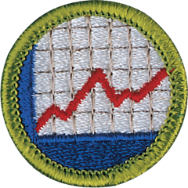
Earning the American Business Merit Badge can help Scouts learn practical business matters that will be useful throughout life. Learning how businesses function will help you understand society and uncover a number of career options.
Offered: Afternoon Only

Astronomy

In learning about astronomy, Scouts study how activities in space affect our own planet and bear witness to the wonders of the night sky: the nebulae, or giant clouds of gas and dust where new stars are born; old stars dying and exploding; meteor showers and shooting stars; the moon, planets, and a dazzling array of stars.
Offered: Morning Only

Crime Prevention
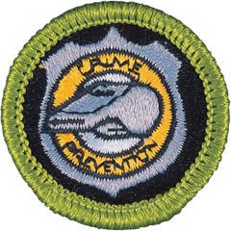
Preventing crime, which can be as simple as reducing the opportunities for crime to occur, is far less costly than apprehending and bringing legal action against those who break the law and it helps save people from the anguish of being victims.
Prerequisites: None
Offered: Morning/Afternoon

Digital Technology
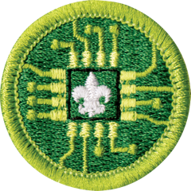
Comprehend how electronic devices work and how to use them effectively with the Digital Technology Merit Badge. Scouts will give a brief history of the changes in digital technology and discuss how technology today compares with the technology available to previous generations—all while imagining what kinds of devices might be available to them in the future.
Offered: Morning Only

Disabilities Awareness
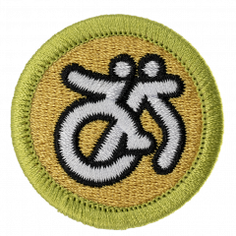
Understand various disabilities and how they affect your friends, family, and community members with the Disability Awareness Merit Badge. Scouts will learn about the experiences of someone with a disability, explain the significance of disability etiquette, and how it may differ depending on the specific disability.
Offered: Morning/Afternoon

Emergency Preparedness
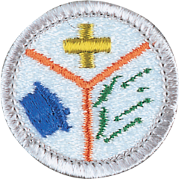
Scouts are often called upon to help because they know first aid and they know about the discipline and planning needed to react to an emergency situation. Earning this merit badge helps a Scout to be prepared by learning the actions that can be helpful and needed before, during, and after an emergency.
Prerequisites: (1) (3a) (4a) (10)
Offered: Morning/Afternoon

Entrepreneurship
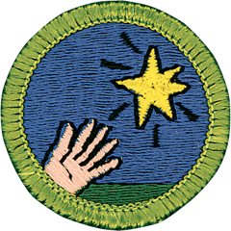
By earning the Entrepreneurship merit badge, Scouts will learn about identifying opportunities, creating and evaluating business ideas, and exploring the feasibility (how doable it is) of an idea for a new business. They will also have the chance to fit everything together as they start and run their own business ventures.
Offered: Morning Only

Fingerprinting
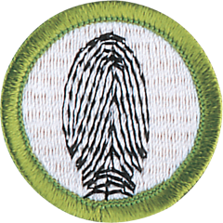
In earning the Fingerprinting merit badge, Scouts will learn about and use an important technique that is used by law enforcement officers, along with other materials like matching dental records and DNA sampling, to help identify amnesia victims, missing persons, abducted children, and others.
Prerequisites: None
Offered: Morning/Afternoon

Forestry
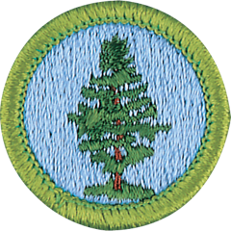
In working through the Forestry merit badge requirements, Scouts will explore the remarkable complexity of a forest and identify many species of trees and plants and the roles they play in a forest’s life cycle. They will also discover some of the resources forests provide to humans and come to understand that people have a very large part to play in sustaining the health of forests.
Prerequisites: All students should bring a notebook for sketching, at least two pencils and scotch tape.
Offered: Morning/Afternoon

Law
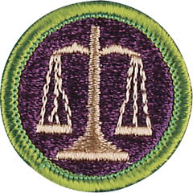
Earning this merit badge enables a Scout to learn about the history and kinds of laws, the purpose and methods of law enforcement, consumer protection agencies, emerging law, and careers in the legal profession.
Prerequisites: (4) (7)
Offered: Morning/Afternoon

Music
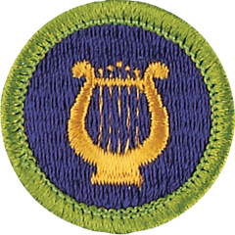
The history of music is rich and exciting. Through the ages, new music has been created by people who learned from tradition, then explored and innovated. All the great music has not yet been written. Today, the possibilities for creating new music are limitless.
Offered: Morning/Afternoon

Programming
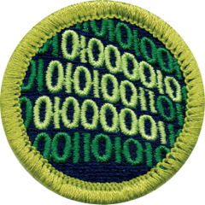
Programming merit badge will take you “behind the screen” for a look at the complex codes that make digital devices useful and fun.
Offered: Afternoon Only
Public Speaking
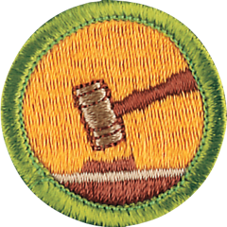
A lot happens during the course of every person’s life and your ability to communicate your feelings and ideas is the best way to connect to the larger world. Even if you haven’t stood at a podium on the stage and find the whole idea scary, sooner or later, someone is going to ask you to get up and say a few words. If you are prepared, it won’t be scary. It can even be fun.
Prerequisites: N/A
Offered: Morning/Afternoon

Reptile and Amphibian Study
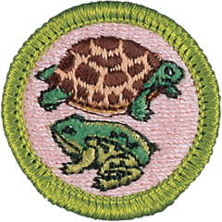
Kids always have been interested in snakes, turtles, lizards, and alligators, as well as frogs and salamanders. Developing knowledge about these captivating creatures leads to an appreciation for all native wildlife; understanding the life cycle of a reptile or amphibian and keeping one as a pet can be a good introduction to natural history; and knowing about venomous species can help Scouts to be prepared to help in case of an emergency.
Prerequisites: 8
Offered: Morning/Afternoon

Traffic Safety
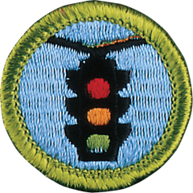
Staying safe in traffic wherever you live is getting more difficult all the time, as more and more people take to the road. Earning the Traffic Safety merit badge and will give Scouts some crucial tools to stay safer, when driving a car on a highway, riding a bike across town, or jogging across a busy street.
Prerequisites: N/A
Offered: Morning/Afternoon

BADGES HELD AT BRICK CITY

Art
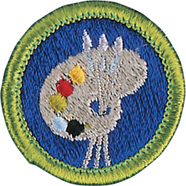
This merit badge concentrates on two-dimensional art, specifically drawing and painting in various media, including an introduction to design applications in the fields of graphic arts and industrial design, history and design principles, and how these fields relate to fine art.
Offered: Full Day

Graphic Arts
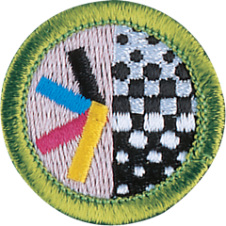
The field of graphic arts includes many kinds of work in the printing and publishing industries. Graphic arts professionals are involved in the creation of all kinds of printed communication, from business cards to books to billboards. The scope of printing communications is huge.
Prerequisites: N/A
Offered: Afternoon Only
Pottery
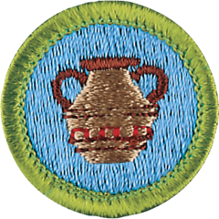
The Pottery merit badge provides an introduction to pottery making, enabling Scouts to gain skill and understanding from actually creating pottery. Completing the requirements will include hands-on production of a work of art, from start to finish.
Prerequisites: None
Offered: Morning/Afternoon

Sculpture
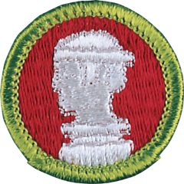
This merit badge introduces Scouts to sculpture, an art form that allows an artist to express what he sees and feels by using these three dimensions by shaping materials such as clay, stone, metal, and wood.
Prerequisites: N/A
Offered: Full Day

