Brick City and Parking
Lots: 57A 57B and 58
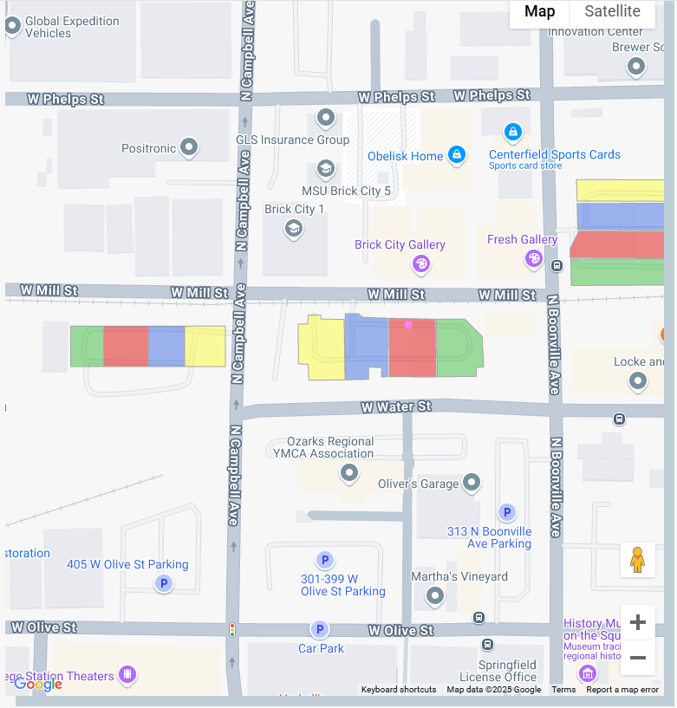
Parking Lot: 58
Parking Lot:
57B
Parking Lot:
57A
Enlarged:
