Glass Hall(Red) and Parking
Lots: 19 and 20(Do not park in circle drive)
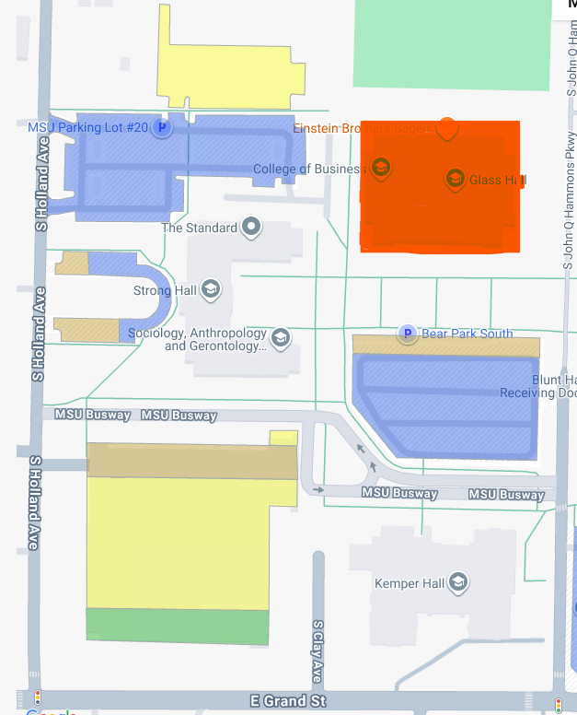
Bear Park South
Parking Lot 19
Parking Lot 20
Glass Hall

