Campmasters MBU

at

Camp Arrowhead, Marshfield, MO

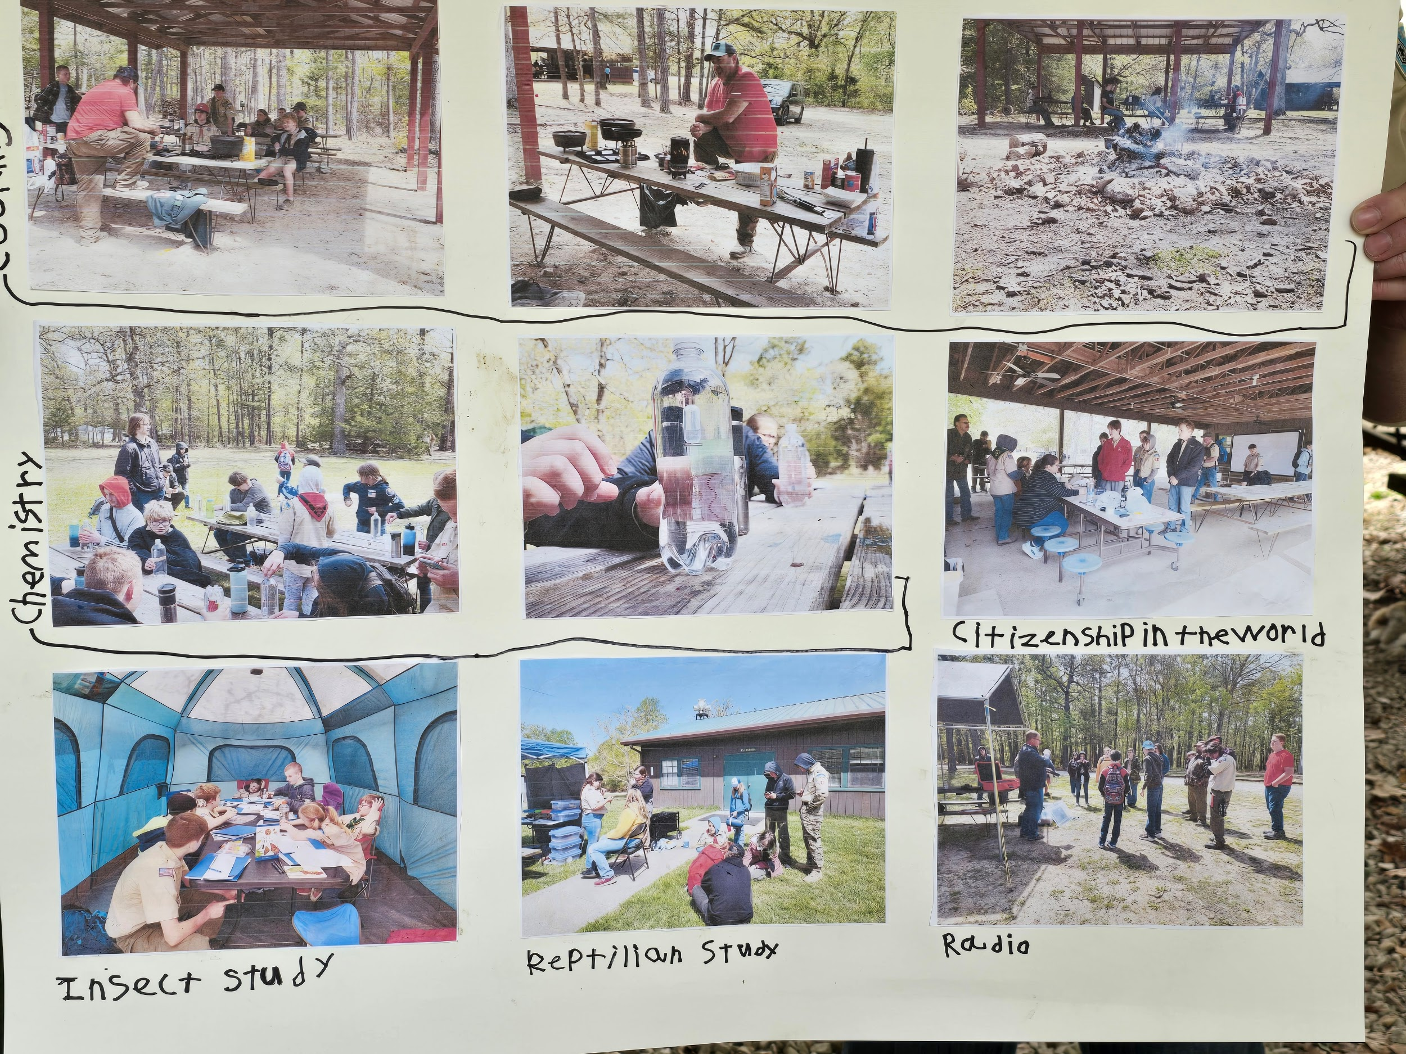

Photos by Greyson Bean from 2024 Photography

2025 Leader’s Guide

Dear Scouts and Scouters,

Thank you for choosing Campmasters Merit Badge University 2025. Our goal is to provide your scouts with a large variety of merit badge options including Eagle required merit badges. These will focus mainly on getting the book work out of the way so please make sure you check the prerequisites. Scoutmasters, please sign off on any prerequisites that your scout(s) have completed using the form at the back of this leader’s guide. Then have your scout bring it to Campmasters and turn it in to their counselor to be checked off. However, it is also ok to finish the merit badge after the MBU.

Registration is available on BlackPug.

If you have any questions or concerns, our contact information is provided below:

Donovan Hibbs 417-718-9377 donovan_hibbs@yahoo.com

Ashley Hibbs 417-718-9311 ahibbs_bandteacher@yahoo.com

We hope you learn something new, make new friends and have a memorable experience at Camp Arrowhead.

Yours in Scouting,

Donovan and Ashley Hibbs

Program Directors

**Registration**

Registration can be found on BlackPug. **Early bird registration will be $20 per youth and $15 per adult and will be open until April 4th.** ***If you would like to receive your patch at the event, please register at the early bird price by March 21st.*** Registration will **INCREASE** to $30 per youth and $25 per adult after the early bird deadline. This covers the patch, lunch, and supplies that counselors need as well as insurance.

Please sign up as soon as possible as there are a limited number of spots per class and allows our counselors time to prepare and obtain supplies. Registration will **CLOSE** on ***April 18th, 2025.* No late registrations or walk-ins will be accepted** so that counselors can plan accordingly for their class size.

**Class Sizes**

Due to class locations and requests of counselors, classes may have a limited number of seats available. Please check the program guide and sign-up early so that your scouts do not miss out on their top choice!

**Camp Availability**

Campsites are available for those who would like to campout Friday and/or Saturday night. Please make sure that you clean up your campsite and take trash to the dumpster prior to departure.

**Check-In Procedures**

Check-in will be Friday night (for those units who are camping) and Saturday morning (for those units coming for the day). Please have one adult check-in with the staff at Foster’s Lodge who has knowledge of scouts attending and their chosen classes. Please bring all medical forms A and B and any medication for check-in with the nurse/medic on staff. **Adult leaders are responsible for making sure their scouts are attending classes.**

**Two Deep Leadership**

We ask all adult leaders to help the Campmasters staff maintain two deep leadership by always having two registered adult leaders at each class location. Thank you.

**Be Prepared! Tips for Success at the MBU**

Merit badge counselors will be working from the most up to date requirements. We highly recommend that you look at what the requirements are for your class before arriving for class.

***If your course has any prerequisites, please bring logs/journals/documentation of completed requirements so that the counselor can sign off on them.*** However, things happen and that is ok. You can complete the course after the MBU by providing the appropriate documentation/finished projects/logs to your counselor and/or scoutmaster.

***Remember, our counselors are volunteers.*** Counselors will do their best to get through as many requirements as possible at MBU. Adult leaders and parents should realize and understand that participation and preparation by each Scout is of the utmost importance. It is up to the discretion of the Counselor to determine if Scouts are prepared and participating in the class. **If a scout does not show up, does not participate or do the work, counselors do not have to sign off on the merit badge.**

**Come prepared** - Scouts are advised to wear their class A (official uniform) and bring pencil/pen, paper, merit badge pamphlet (to use as a resource if needed), and merit badge workbook (counselors may or may not use this source so only complete the prerequisites if you have any indicated).

**Lunch**

Lunch will be provided. Lunch will be pizza, cookies and a drink.

**Check Out**

Please check out with camp staff at Foster’s Lodge during the indicated times. If camping, please make sure your campsite is clean before departure. During check out, you will receive your patches and medical forms will be returned.

**Campmasters MBU Schedule**

**Friday**

|  |  |
| --- | --- |
| 5:00 - 7:00pm | Check-In (Foster’s Lodge) |
| 10:00pm | Lights Out |

**Saturday**

|  |  |
| --- | --- |
| 7:45 - 8:15am | Check-In (Foster’s Lodge) |
| 8:30 - 8:50am | Flags and Announcements (behind dining hall) |
| 9:00 - 12:00pm | MBU Classes |
| 12:00 - 1:00pm | Lunch (delivered to class locations) |
| 1:00 - 4:00pm | MBU Classes |
| 4:00 - 5:00pm | Free Time |
| 5:00 - 7:00pm | Dinner (on your own at campsite)  Check Out at Foster’s Lodge for Saturday departures |
| 7:30 - 8:30pm | Campfire Program |
| 10:00pm | Lights Out |

**Sunday**

|  |  |
| --- | --- |
| 8:00 - 10:00am | Check Out (Foster’s Lodge) |

**Campmasters MBU Course List**

|  |  |  |
| --- | --- | --- |
|  | **Citizenship in the Community\***  Counselor - Jennifer Prewitt  Class Size Limit - 20  Location - Foster’s Lodge | Prerequisites: 2, 3, 4, 7, 8 |
|  | **Citizenship in the Nation\***  Counselor - Museum on the Square  Class Size Limit - 25  Location - Dining Hall  ***Morning Session*** | Prerequisites: 3 |
|  | **Citizenship in the World\***  Counselor - Museum on the Square  Class Size Limit - 25  Location - Dining Hall  ***Afternoon Session*** | Prerequisites: 7 |
|  | **Crime Prevention & Traffic Safety**  Counselor - Ryan Cooksey  Class Size Limit - 20  Location - Pool House Pavilion | Prerequisites: None |
|  | **Environmental Science\***  Counselor - Valerie Hauer  Class Size Limit - 20  Location - Classroom | Prerequisites: 6a or 6b or 6c, 7a or 7b or 7c |
|  | **First Aid\***  Counselor - Michelle Johnson  Class Size Limit - 15  Location - Pavilion outside Med Lodge | Prerequisites: |
|  | **Fishing**  Counselor - Ricky Taylor  Class Size Limit - 15  Location - Lakefront | Prerequisites: 4 |
|  | **Fly Fishing**  Counselor - Nathan Sayler  Class Size - 8  Location - Lakefront | Prerequisites: NONE but please have your knots prepared! |
|  | **Indian Lore**  Counselor - TOLB  Class Size - 10  Location - TOLB Pavilion | Prerequisites: 2 |
|  | **Mammal Study & Bird Study**  Counselor - Courtney Noell  Class Size Limit - 10  Location - Quartermaster | Prerequisites:  Mammal - 3c  Bird - 5, 8b, 12 |
|  | **Model Design and Building**  Counselor - Peter Hansen  Class Size Limit - 8  Location - Trailblazer Pavilion #1 | Prerequisites: 4 |
|  | **Radio**  Counselor - Tim Boettler  Class Size Limit - 15  Location - Behind Foster’s Lodge | Prerequisites: None |
|  | **Reptiles and Amphibians**  Counselor - Heather Benoit  Class Size Limit - 10  Location - Nature Pavilion | Prerequisites: 8 |
|  | **Rifle Shooting**  Counselor - Robert Jessen  Class Size Limit - 8  Location - Range | Prerequisites: Attend Friday Night Safety Meeting |
|  | **Sustainability\***  Counselor - Kate Carr  Class Size Limit - 20  Location - Inside Fishing Lodge | Prerequisites: NONE |
|  | **Welding**  Counselor - Shaun Coker  Class Size Limit - 10  Location - Behind the Ranger’s House | Prerequisites: NONE |
|  | **Wilderness Survival**  Counselor - Wesley Marr  Class Size Limit - 20  Location - Scoutcraft | Prerequisites: Scouts will need to bring a personal survival kit and knowledge of their knots. |

*Denotes Eagle Required Merit Badges

*\*\*Prerequisites will have to be done* ***prior or after*** *the MBU to complete the merit badge.*

**Special Opportunities/Awards**

|  |  |  |
| --- | --- | --- |
|  | Paul Bunyan Award  Counselor - Jesse Updegraff  Class Size Limit -  Location - Meet at QM | Prerequisites: |

**Merit Badge Prerequisite Sign-Off**

**Name: ______________________________________________________**

**Troop #: ____________________________________________________**

|  |  |  |
| --- | --- | --- |
| **Merit Badge Name:** | **Prerequisite #:** | **Date Completed:** |
|  |  |  |
|  |  |  |
|  |  |  |
|  |  |  |
|  |  |  |
|  |  |  |
|  |  |  |
|  |  |  |

**Scoutmaster Signature: _______________________________________**

**Notes to Counselor:**