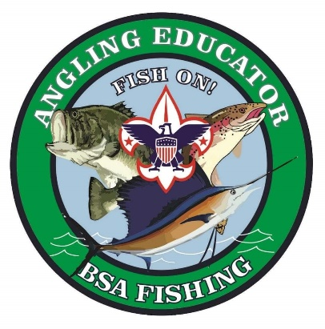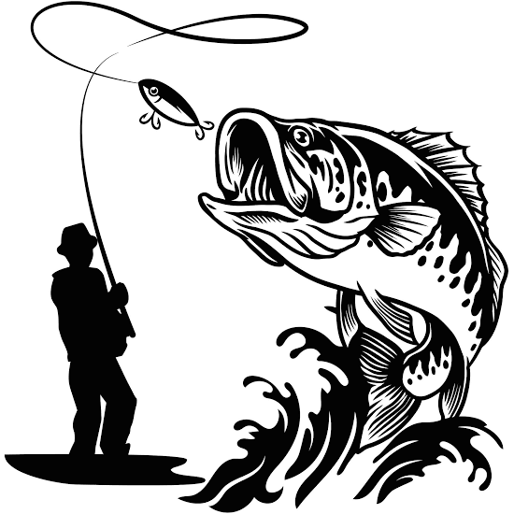
Fishing helps you to “Deliver the Promise of Scouting”. AEs learn age-based and skills-appropriate fishing tools and techniques for simple cane pole and spin cast fishing. This course highlights best practices in both the classroom and in the field.
Angling Educators:.
- Teach Cubs and Scouts to fish.
- Improve day camp & summer camp attendance through fishing programs.
- Provide a major tool for Recruiting and Retaining Cubs and Scouts.
- Gain knowledge and learn skills that can be enjoyed for a lifetime.

Fishing is one of the most popular youth activities - #5 for Cub Scouts, and #4 for Scouts BSA.
BSA fishing programs are very cost-effective recruitment and teaching tools!
BSA Owns Outdoor Adventure!
Help Fishing lead the way!
Become an Angler Educator today!

An Angler Educator training course will be held at Camp Arrowhead, in the Fishing Lodge, on 11 May 2024. Registration will begin at 08:00 am. Course will include a break for lunch. Course work will conclude approximately 2:00 pm. Participation is limited to the first 20 Scouters registered. Cost is $5.00 per person. Lunch WILL NOT be served. 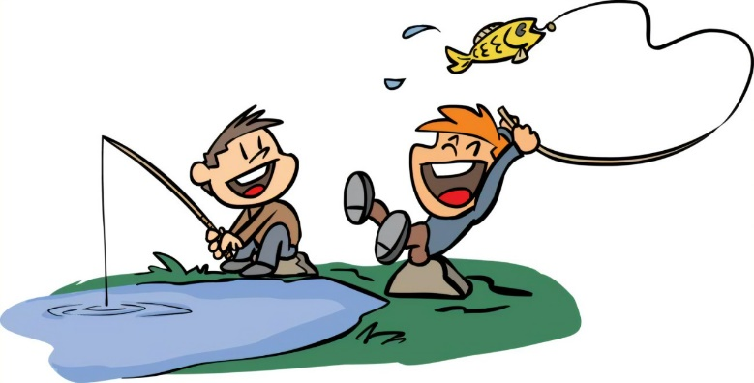
POC is David Cartner, dscartner@socket.net

