2026 EAGLE CLUB RECOGNITION BREAKFAST
Tuesday, February 17, 2026
Featured Motivational Speaker: Devon Harris

Olympian Jamaican Bobsledder and inspiration for the movie Cool Runnings. Author and motivational speaker.

Fact Sheet

Overview

The Andrew Jackson Council is excited to host the 3rd Annual Eagle Club Recognition Breakfast, which serves as the kick-off to launch another great year of Scouting in Central and Southwest Mississippi and the 2026 Friends of Scouting Campaign. The funds raised by this campaign provide for all Scouting programs that instill character and leadership and teach young people the skills they will need for life. The 3rd Annual Eagle Club Recognition Breakfast will be as follows:

When: 7:30 a.m. – 8:45 a.m., Tuesday, February 17, 2026 (Doors open @7:00 am)

Where: Sheraton Flowood -The Refuge Hotel & Conference Center

Why: Because Scouting’s community and business leaders are busy, active people, this breakfast is designed to create a stimulating environment demonstrating the achievements of Scouting and its impact on our daily lives.

The Friends of Scouting Campaign is the primary funding source for the council and provides over $400,000.00 in support.

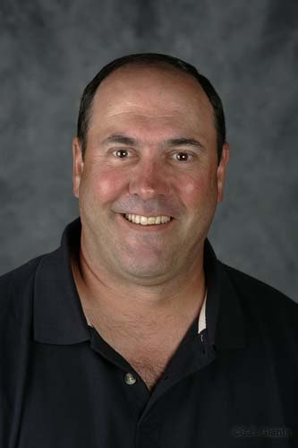
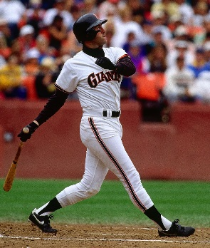

Purpose: The Eagle Club is an inspirational kick-off to our 2026 Friends of Scouting efforts. At breakfast, Eagle Club Table Hosts, Corporate leaders, Eagle Club Committee members, and Scouting volunteers will host their prospects and friends and encourage them to renew their Friends of Scouting gifts or give for the very first time. This is targeted to secure personal and corporate gifts from over 650+ donors who make gifts annually. This will also enable us to enroll new givers to our annual Friends of Scouting campaign. This breakfast will enable the council to have a strong position in the first quarter of its fiscal year while conserving staff and volunteer time. This time saved can then be applied to serving the council’s growing membership and program.

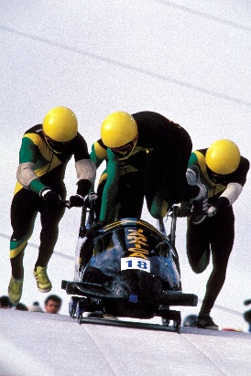
Cost:
Eagle Club participation levels:
Diamond Eagle $5,000.00 - up
Platinum Eagle $4,000.00
Golden Eagle $3,000.00
Silver Eagle $1,500.00
Bronze Eagle $750.00
Patron Eagle $300.00
Eagle Club $150.00

