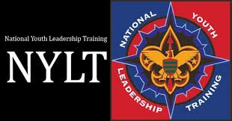

National Youth Leadership Training

National Youth Leadership Training will be held from Friday, April 28, 2023, through Sunday, April 30, 2023 and Friday, May 5, 2023, through Sunday, May 17, 2023, at Hood Scout Reservation. Youth troop or crew leaders, and those aspiring to be one, should attend the National Youth Leadership Training course! NYLT is an exciting, action-packed program designed for youth to learn and practice the leadership skills that will help them succeed in Scouting and in life!
Youth learn to chart a course to better leadership and performance with the skills they can take back and implement within their unit.
NYLT is a 6 day-long youth-oriented leadership training experience. Highly qualified youth staff, under the supervision of adult advisors, conduct the training using the National Youth Leadership Training course syllabus, as published by the National Council, Boy Scouts of America.
NYLT is an exciting, action-packed program designed to provide youth members of the Boy Scouts of America with leadership skills and experience they can use in their troops and crews, as well as any other life situations demanding leadership of themselves and teams.
Each NYLT participant is expected to live by the Scout Oath and Scout Law. There will be no tolerance for behavior that is not “Scout-like”. NYLT is a place where every person is respected and is a safe environment for every participant.
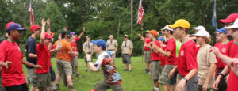
NYLT models a month in the life of a unit. The course uses the patrol method and patrols are selected carefully by staff to maximize the experience for all participants. Each of the first four days on course roughly represents a week in a troop or crew. Daily PLC (Patrol Leader Council) and patrol meetings lead to an overnight outpost experience. There will be various challenges and team-building opportunities throughout the week. While much of the NYLT course is interactive, be aware that there will be daily classroom-style sessions to further teach leadership theory and skills. We have assembled the most competent staff available to ensure that leadership skills are modeled as well as taught by the youth on staff. Above all, our course will fulfill Scouting’s ultimate mission of having fun while learning valuable skills.
Because we need the participants to focus on their patrol and the leadership skills being taught, we request that CELL PHONES AND ELECTRONIC devices be left at home.
In order to attend NYLT, youth must have the following qualifications by the beginning of the course:
● Must be a registered member of a Scouting unit.
● Must have a current BSA Health and Medical Record form parts A and B.
● Scouts must be at least 13, or 14 for Venturers. They must have completed Introduction to Leadership Skills for Troops or for Crews.
● It is recommended that they have had at least one year of camping experience. While NYLT is not an outdoor skills course, it is important that each participant have basic camping and outdoor cooking experience.
● Have a unit leader recommendation.
Only 48 spaces available, so not all who apply may be accepted and get to attend.

Participant signature:________________________Date:_______

Parent signature:___________________________Date:________

Course Director: Mike Mosley Assistant Course Director: Trey Curry
josephmosley@comcast.net iotagamma87@gmail.com
601-572-1682 337-967-0407

