A Unit Leader’s Guide to NYLT

National Youth Leadership Training

*NYLT 4-299-24*

# Index

|  |  |
| --- | --- |
| Index | 1 |
| 2024 NYLT Course Details | 2 |
| How to register | 2 |
| Who should YOU send to NYLT? | 3 |
| Course Schedule | 4 |
| Food Service | 5 |
| NYLT Leadership Team | 6 |
| Health Services and Medical Information | 7 |
| Packing List | 8 |
| NYLT Code of Conduct | 9 |

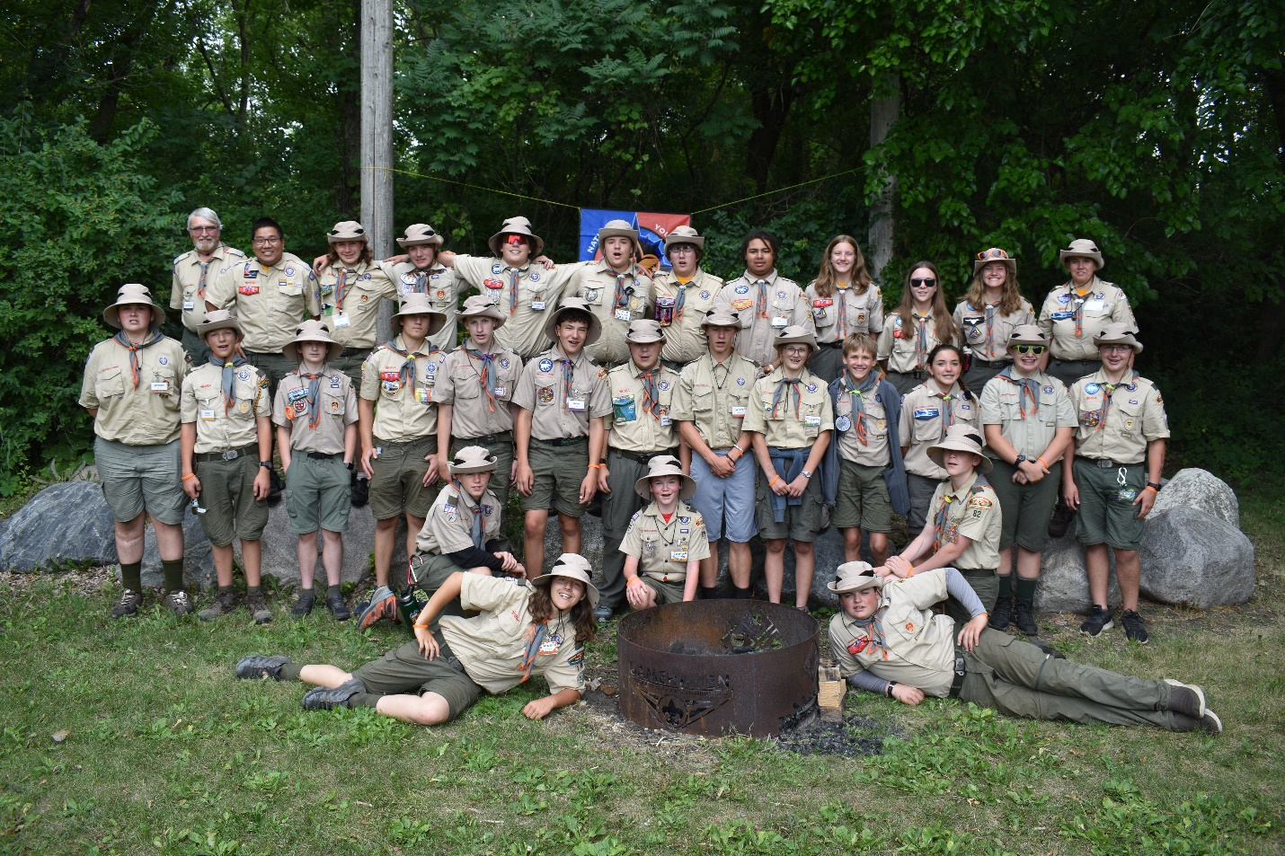  
*NYLT 4-299-2023 Troop Photo*

# 2023 Course Details

|  |  |
| --- | --- |
| WHY | “NYLT transforms the lives of the young people who attend, turning them into dynamic Leaders of Leaders. It creates the youth leaders of tomorrow that today so desperately demands.” |
| HOW | NYLT is more than just an intensive leadership course run at the gorgeous Gamehaven Scout Camp in Rochester, MN. It is a model of youth-led leadership in a Scout Troop, with young people leading the course, teaching the skills, and working with participants to improve skills.  The course models the ideal month in a Scout Troop, where each full course day (Monday - Thursday) models one week of the month. Youth see their peers model the leadership tools they have been taught through hands-on experiments and practices.  **We teach leadership by giving youth the chance to lead, away from outside pressures.** |
| WHERE | Gamehaven Scout Camp (5015 Simpson Rd. SE, Rochester MN 55904) |
| WHEN | Course begins on July 21st, 2023. Participants are to show up at 11:30 on that Sunday in Field Uniform. Lunch is not provided on Sunday.  Course ends on July 26th, 2023. Parents and/or Scoutmasters are invited to attend the closing ceremony, which begins at 2:30pm Friday Afternoon. Participants depart immediately following the closing ceremony. |
| COST | NYLT costs $250 per Scout, which covers training materials, NYLT apparel, and food for the week. It is highly encouraged that troops cover half of the training cost ($125), as the training provided will positively influence the troop for years to come. |

# How to Register

Go <https://scoutingevent.com/299-NYLT24> to register today!

*Cancellation Policy*

Refund of fees: outside of a deposit if there is one for the event, refunds will be evaluated based on the date that they are received in our office.

* 30+ days before the event– you will receive 100% of the total event fee
* 14-29 days before the event – you will receive 50% of the total event fee
* 13 days or less before the event– No refund will be issued, except in the event of a documented medical reason (doctor’s note required), a death in the immediate family, or a natural disaster.
* No refund requests will be accepted after 14 days following the end of the event.

Registrations are transferrable within the same unit to a Scout not currently registered for the activity.

# Who should YOU send to NYLT?

## Requirements:

Prior to July 21st, 2023, all participating Scouts must:

* Achieve First Class rank
* Be at least 13 years of age OR have completed eighth grade

## Accommodations:

At least three female staff will be present at all times and appropriate accommodations are made for female participants. All participants must bring and sleep in their own tent. They should familiarize themselves with setting up their tent prior to arrival.

Participants with dietary or medical restrictions will be accommodated to the best of our ability, however we cannot allow parents to attend camp with Scouts due to the team dynamics that must be developed.

## Prerequisites:

All Scouts attending NYLT should, at the bare minimum:

* **Be:**
  + Ready to be away from home for a week and engage with the course.
  + Mature enough to interact with scouts from many backgrounds and beliefs.
* **Know:**
  + Basic (First Class) camping skills
  + The EDGE method
* **Do:**
  + Introduction to Outdoor Leadership Skills (ILST) with their troop prior to arrival

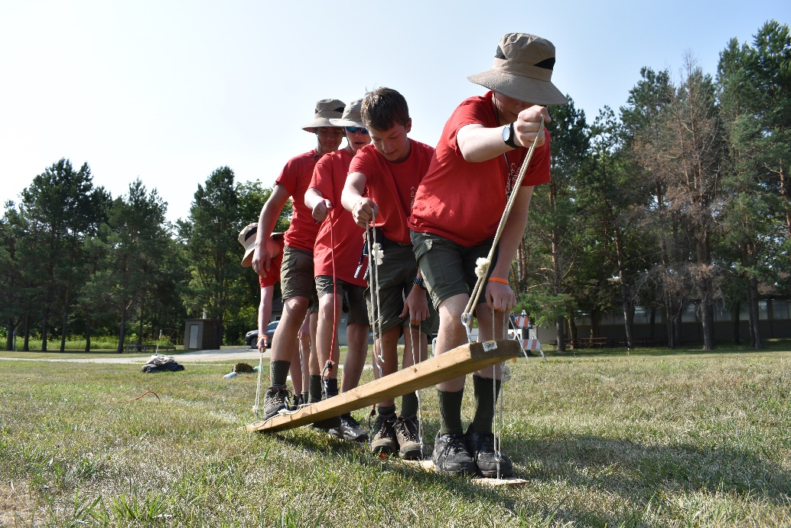  
*A patrol participates in a problem-solving exercise.*

# Course Schedule Overview

More detailed schedules will be provided to participants upon arrival. This schedule exists only for informational purposes leading up to the course. Times and locations for events may change, however the schedule will remain largely in this order.

# Food Service

NYLT participants eat lunches as a large group in a dining-hall style, and breakfast and supper as patrol-style meals which they must cook themselves. Participants are given ingredients for a variety of meals at the beginning of their patrol’s cook time and must go through the patrol process of assigning cooks, cleaners, fire masters, and other roles as needed. NYLT staff review patrol cooking every meal to ensure that meals are cooked thoroughly and well.

Despite this odd food service method, we are more than able to accommodate necessary dietary restrictions given adequate warning (2 weeks minimum). Parents or leaders wishing to learn more about our menu, or cooking methods, may contact us for more details.

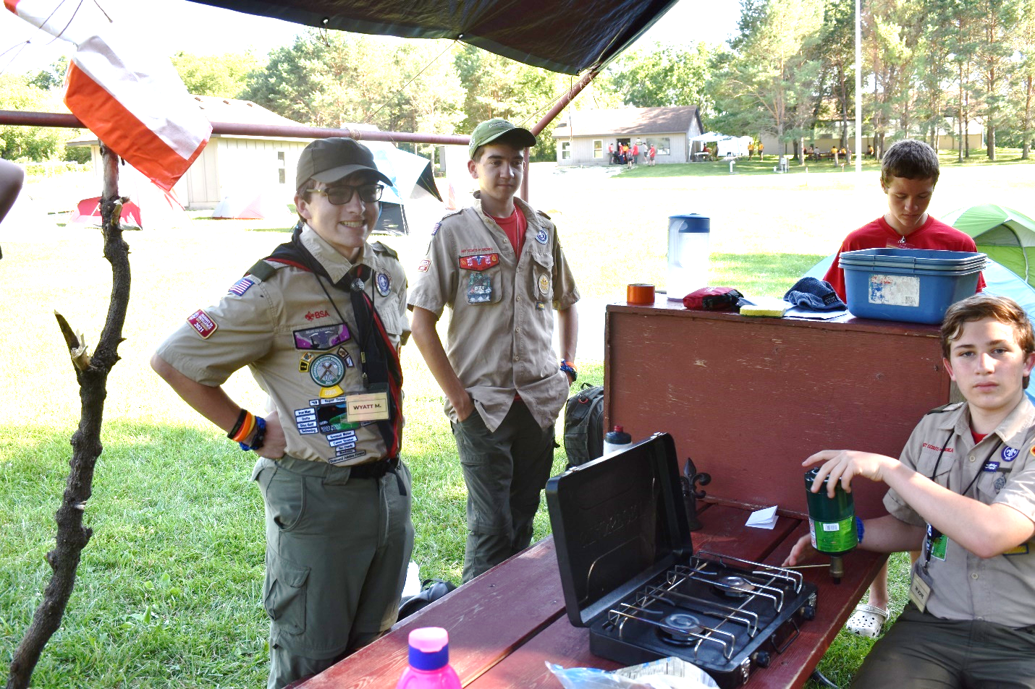  
*Supper is being prepared at a patrol site.*

# NYLT Leadership Team

The NYLT staff and participants model a well-organized and led troop, with all members filling necessary roles for the function of the troop. Youth are primary leaders, while adults help handle logistics and coaching as necessary.



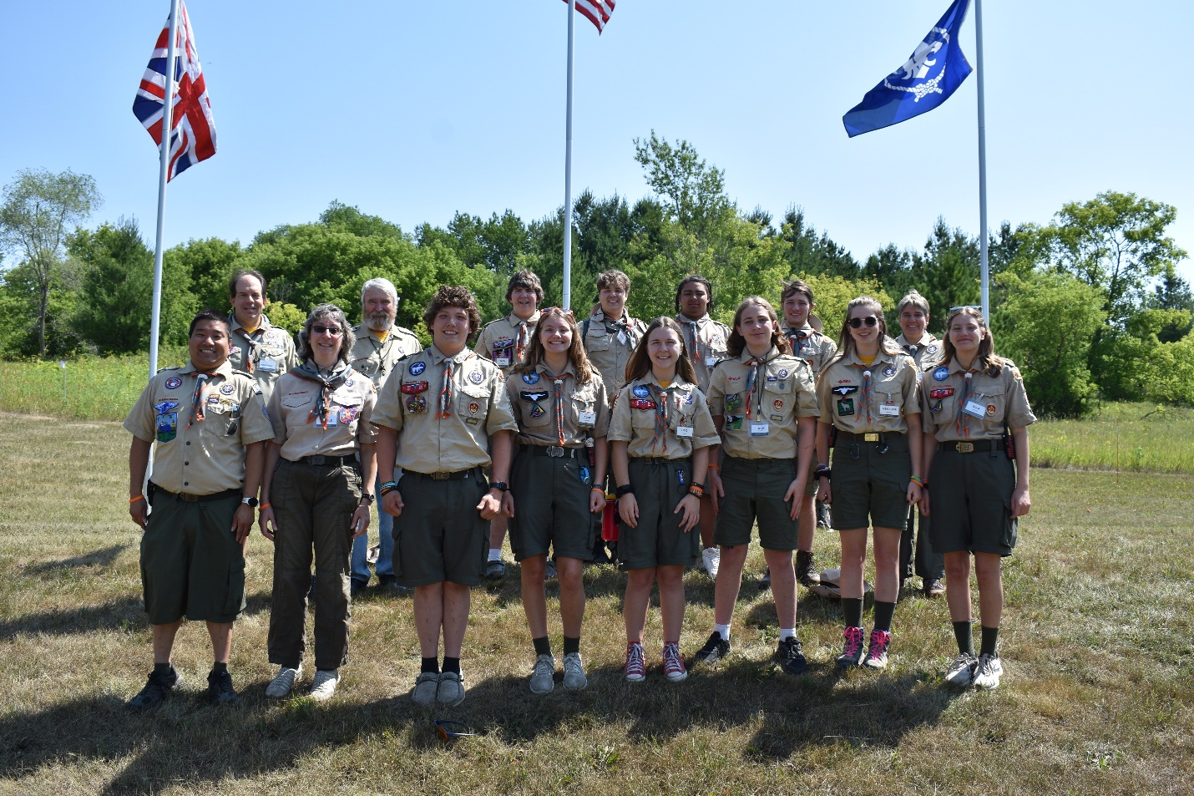  
*NYLT 4-299-2023 Youth and Adult Staff*

# Health and Medical

## Dietary Restrictions

Despite the odd food service method, we are more than able to accommodate necessary dietary restrictions given adequate warning (2 weeks’ minimum). Parents or leaders wishing to learn more about our menu, or cooking methods, may contact us for more details.

## Medicine

Youth may, with their parent’s permission, carry and administer their own medicine. All medicine must be logged on their Annual Health and Medical Record and disclosed to the ASM – Health and Safety. If a youth is unable to administer their own medication for any reason, it may be administered by the ASM – Health and Safety provided this information is communicated clearly before the course.

## Annual Health and Medical Record (AHMR)

The BSA Annual Health and Medical Record MUST be completed in full (parts A, B, and C) before the course. Participants arriving without this form will be turned away and not allowed to participate. This is kept on file with the ASM – Health and Safety through the week and returned to the participants at the end of the week.

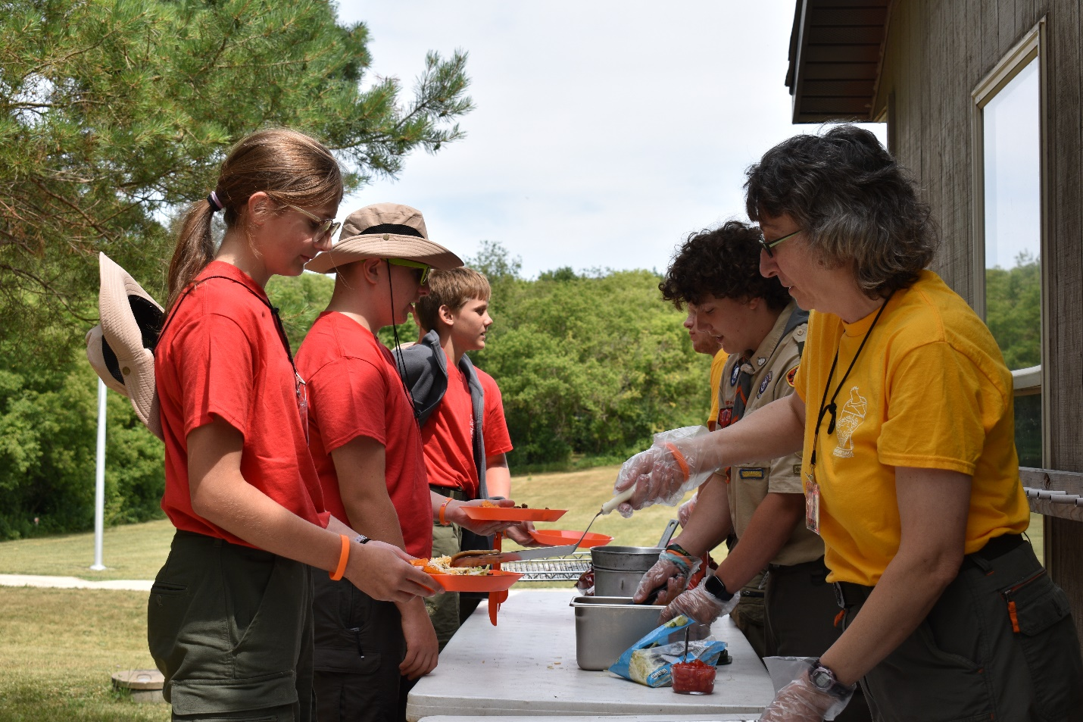  
*The Quartermaster Team serves lunch to some hungry participants*

# Packing List

## Daily Uniform

NYLT is a uniformed event. Participants wear the full Field Uniform (“Class A”) or the provided activity uniform (“Class B”) at alternating points throughout every day, as modelled by the youth staff.

* **FIELD UNIFORM (“Class A”)**
  + Tan Field Uniform Shirt with correct patch placement
  + Nametag (provided)
  + Pencil / Pen
  + Water Bottle
  + NYLT Participant Wristband (provided)
  + NYLT Neckerchief and Woggle Slide (provided)
  + NYLT Hat (provided)
  + Scout Pants, Skirt, Skort, or Shorts
  + Scout Belt
  + Scout Socks
  + Closed-toed shoes
* **ACTIVITY UNIFORM (“Class B”)**
  + Red Activity Uniform T-Shirt (3 provided)
  + Pencil
  + Water Bottle
  + NYLT Participant Wristband (provided)
  + NYLT hat (provided)
  + Scout Pants, Skirt, Skort, or Shorts
  + Scout Belt
  + Scout Socks
  + Closed-toed shoes

In addition to the above uniform pieces, participants should pack:

|  |  |  |
| --- | --- | --- |
| [ ] Sleeping Bag | [ ] Sleeping Pad * | [ ] Small tent |
| [ ] Rain suit or poncho | [ ] Underwear (1/day) | [ ] Insect Repellant † |
| [ ] Sunscreen † | [ ] Watch | [ ] Light jacket or sweatshirt |
| [ ] Sleeping clothes | [ ] Shower Shoes | [ ] Backpack for carrying gear |
| [ ] Extra pencils/pens | [ ] Towel and toiletries † | [ ] Flashlight or lantern ‡ |
| [ ] Small pocketknife (OPT) |  |  |

Scouts should pack a minimum of two pairs of Scout pants/shorts/skorts/skirts and two pairs of Scout Socks. **More Scout Socks are highly recommended for odor control.**

|  |  |
| --- | --- |
| * | As participants must hike 2-3 miles carrying sleeping gear during the “Outpost Camp”, it is highly discouraged to pack only a sleeping cot. Scouts may however choose to pack a cot AND a pad. |
| † | Aerosols are not allowed at camp |
| ‡ | Phones, while allowed for emergency reasons, are to be kept “off” while at NYLT and may be confiscated if being used for lighting or entertainment. There will be no chargers provided, or electricity available. |

# NYLT Code of Conduct

Failure to follow the NYLT Code of Conduct will result in disciplinary action up to and including removal from the course with no option for refund.

## NYLT Is a Special Place

The rules are ones we know well – the Scout Oath and Scout Law. We create a safe haven at NYLT, a place where everyone should feel physically safe and emotionally secure.

We do this in a number of ways:

1. We set the example for ourselves and others by always behaving as Scouts should.
2. We live the Scout Oath and Scout Law each moment of the day.
3. We refuse to tolerate any kind of inappropriate behavior. There is zero tolerance for any putting down, name calling, or physical aggression.
4. We communicate our acceptance of each other through expression of concern and by showing our appreciation whenever possible.
5. We create an environment based on learning and fun. We seek the best from others and ourselves, and we do our best to help everyone achieve their best.
6. The buddy system is always required, except where privacy is expected, such as in bathrooms, showers, and tents.

## Harassment and Discrimination

It is our responsibility to report instances of discrimination or harassment (directed at ourselves or another person) to the NYLT Course Director, or any adult on the NYLT course.

Everyone has the right to live and study in an environment free from discrimination or harassment based on race, color, ethnicity, religion, gender identity, sexual orientation, age, disability, national origin, or citizenship.

Prohibited comments and conduct include the following:

1. Using vulgar language.
2. Threatening another participant or staff member or making derogatory comments.
3. Mocking or telling jokes based on race, color, ethnicity, religion, gender, sexual orientation, age, disability, national origin, or citizenship.
4. Engaging in political comments or conversations.
5. Displaying degrading photographs, posters, or objects.
6. Reading aloud about degrading acts.
7. Touching (e.g., brushing, patting, hugging, rubbing, pinching) participants or staff members.
8. Staring or leering at participants or staff members.