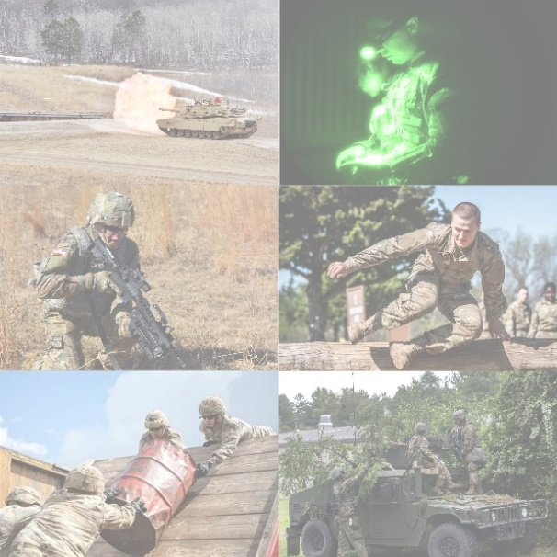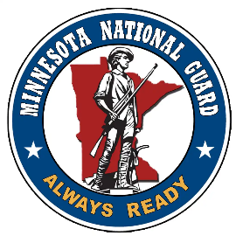­

**Must be 16 – 20 years of age and an Eagle Scout to attend.**

**Cost is $10 for Eagle Scouts and $10 for parents**

For more information and to register go to:

<https://scoutingevent.com/296-EagleCamp>

Contact: Wade Bastian 320-452-0007 or [Wade.Bastian@scouting.org](mailto:Wade.Bastian@scouting.org)

**Vehicle Operations**

**Land Navigation**

**Weapons Management**

**Obstacle Course**

**Team Work / Leader Reactions**

**Vehicle Maintenance**

**Combat Medical Simulations**

**Weapons Deployment**

**Tactical Maneuver**

**Communications**

**Rappelling**

**Calling For Fire Support**

**Welcome young leaders to OPERATION EAGLE CAMP hosted by the Minnesota National Guard on Camp Ripley. This event is meant to strengthen the partnership between the two organizations and demonstrate just some of the team-building and leadership development skills the U.S. Army takes pride in each day. Some of these event include:**

AUGUST 3 - 5, 2022

On Camp Ripley

15000 HWY 115 Little Falls, Mn 56345