Thriving in 2022

Bring your friends and family to
Summerland Family Fun Park
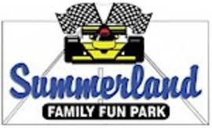
Special Event August 23, 2022 from 6pm to 9pm
Cost is $20.00 per person if paid online
Or $30.00 at the door

Includes:
Bumper Boats, Bear Country Mini Golf, Go-Karts,
Batting Cage, Moon Walk (ages 3-10) and Giant Water Slide.
Plus learn more about Cub Scouts and Scouts BSA.
To pay online go to:
https://scoutingevent.com/296-Summerland2022
Questions contact the CMC Scout Office 320-251-3930

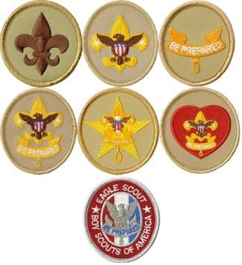
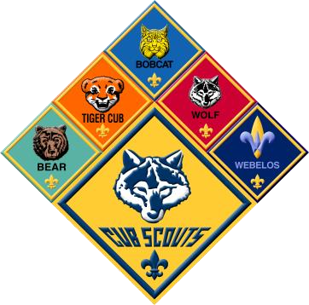
Sponsored by:
Central Minnesota
Cub Scouts
& Scouts BSA

