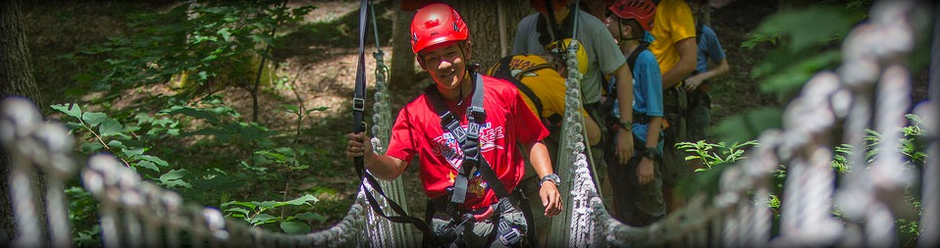
Summit Bechtel Reserve “2020 Vision” contingent
Central Minnesota Council Contingent
High Adventure Awaits in the Mountains of West Virginia

The Central Minnesota Council has a minimum of 8 spots (7/1- youth/adult) available for Scouts, BSA, Venturers and adult leaders for the “2020 Vision” Summit. But these will go fast! This is a once in a lifetime opportunity that can be the pinnacle of a Scouting career.

SUMMIT EXPERIENCE- Experience a half day in every onsite high adventure program area at the Summit Bechtel Reserve. Shooting, Archery, Skateboarding, BMX, Canopy Tours, Rock Climbing, High Ropes Course, Mountain Biking and Lake Activities. A ½ rafting trip can be substituted for our lake activities at an additional cost.

Trek Dates:
Arrive at the Summit: August 2, 2020
Depart the Summitt: August 8, 2020

Cost: $825.00 per person (this does not include transportation, transportation, side trips, and expenses)
Based on previous contingent treks, the trip is estimated at $1,500.00 per person. (may vary)

Additional Requirements:
- All participants must complete a full health form including physical.
- All participants must meet the Height and Weight requirements (found in Part D of the BSA Health Form). Anyone who shows up at the Summit not meeting these requirements may be sent home.
- At least one adult per Crew should have completed Wilderness First Aid training.
- A deposit of $200.00 per person is required by December 1, 2019. Deposits are non-refundable, unless you secure a replacement for your spot.
- All Scouts must be at least 13 years old by September 1, 2020.
- All Scouts must hold the rank of First Class or higher and have Scoutmaster or Crew Advisor approval.
- If female Scout(s) is/are registered, a female leader must also be registered.

Summit Payment Schedule:
- Deposit of $200 Due December 1, 2019
- Payment of $350 Due January 1, 2020
- Payment of $350 Due March 1, 2020
- Payment of $350 Due May 1, 2020
- Payment of $250 Due by July 1, 2020

Questions? Contact Mary Herlick – Summit Contingent Coordinator at (320)251-3930 x103 or email mary.herlick@scouting.org.

The members of the 2020 council contingent will hold meetings leading up to the trip to prepare physically, go through equipment requirements and make plans for transportation to and from Summit.

Fundraising will be determined by family input. Popcorn Sales Commissions can be directed to this event.
Summit Bechtel Reserve
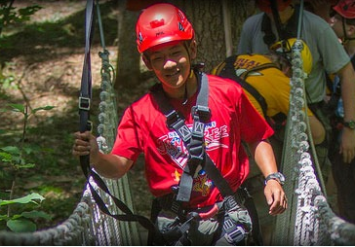
Central Minnesota Council Contingent

Registration Form

Youth Adult

Name _________________________________________________________________________________________________________

Address _______________________________________________________________________________________________________

City _________________________________________________________ State ___________ Zip ________________________

Home Phone _____________________________ Email ______________________________________________________________

Unit Number _________________________________

Height ____________inches Weight ______________lbs. Gender: Male ________ or Female _________

American Red Cross certified: First Aid: _________ CPR _________

Amount Enclosed $_________________ ($200 holds your spot)

For Scouts, BSA/Venturers
Present Rank _____________________________________________________________

Age ______________ Birth date _______________________________

Approval Signatures*
Parent or Guardian ______________________________________________________

Scoutmaster or Crew Advisor ______________________________________________________

*Signature denotes that you have read and understand Part D of the BSA Health Form, which includes the High Adventure guidelines, and the height and weight limits.

Mail with Deposit, sign up will be online September 5:
Summit 20/20 Vision
Central Minnesota Council, BSA
1191 Scout Drive
Sartell, MN 56377

(320)251-3933 Fax

