Climbing Merit Badge Day

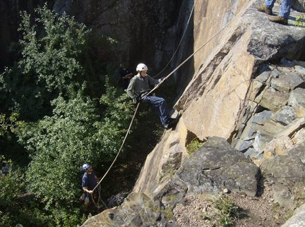
When:
Saturday, September 14, 2019 – Merit Badge Day

Where: QUARRY PARK
1802 County Road 137
Waite Park, MN
Quarry Park charges $4 parking fee
(come in groups if possible).
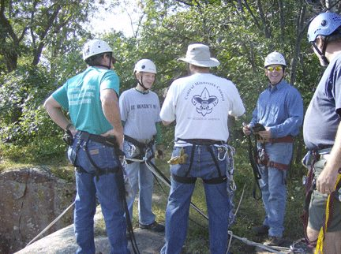
Who:
- Merit Badge
  - Open to youth age 12 and older. No prior experience necessary.

Registration:
- Register online at http://www.bsacmc.org/rock-climbing
- $25/ participant attends Merit Badge Day. All climbing gear is included in the fee.
- MAXIMUM of 20 participants.
- Registration due by September 9, 2019.
- check in at 9:30 am in the parking lot with session from 10 am to 5 pm.
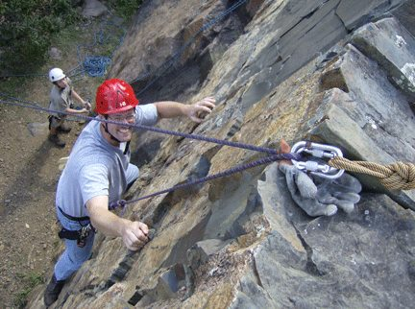
- AT LEAST ONE ADULT IS REQUIRED FROM THE UNIT TO BE WITH THE YOUTH

What to Bring:
- Climbing Merit Badge Pamphlet
- Annual health forms. Include any accessibility needs or special health needs.
- Youth participants must include a parent-signed consent part of the medical form.
- Wear comfortable “moveable” but NOT loose or baggy clothing.
- Rain gear, bug spray, sunscreen, etc.
- A bag lunch.

For more information contact: Chuck Rose, Course Director at 320-293-3332 or clrose@stcloudstate.edu

