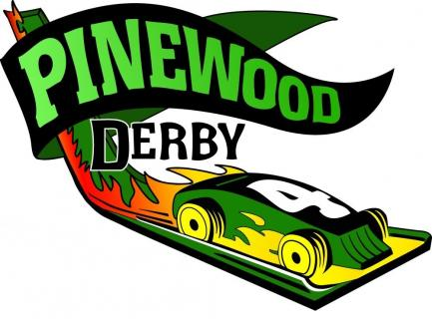
2018 GATEWAY PINEWOOD DERBY RACE
Saturday, March 17, 2018
Registration – 9:00am to 10:00am
Race Time – 10:00am
Princeton, MN

- Are you ready for the big race? We are excited to bring to you the “Gateway District Pinewood Derby Race”.

- Who: The Top 3 Scouts from each age group from every Pack Tigers, Wolves, Bears, and Webelo’s I and II are combined.

- Where: Princeton Primary Elementary School.
1206 7th Ave N, Princeton MN 55371

- REGISTRATION:
- The registration time is from 9:00am to 10:00am. We need to have all Scouts registered on time because everything is done electronically and late entries will not be entered.
- A registration fee of $8.00 per car will be charged which will help cover expenses for trophies, certificates, and over all award.
- Must have Pack registration in by March 10th. Registration after March 10th will not be accepted.
- Registration Link online at www.bsacmc.org
- Print your confirmation from website or mail with check to:
BSA, 1191 Scout Drive, Sartell MN 56377

FINAL NOTES:
- We encourage all Scouts to invite family and friends to come watch the race! We will have concessions available and plan to make the event fun for everyone who attends! If you have any questions regarding this event please contact Adam Willard - adam.willard@scouting.org We look forward to a fun and exciting time at the races!

GATWAY DISTRICT PINEWOOD DERBY RULES
Central Minnesota Council

THE SCOUT OATH AND LAW APPLY HERE, AS THEY DO EVERYWHERE!

- COMPLIANCE WITH THE DERBY RULES IS THE RESPONSIBILITY OF THE CAR BUILDER.
- ANY INFRACTION, WHETHER DISCOVERED AT WEIGH-IN OR ON RACE DAY, MAY LEAD TO DISQUALIFICATION OF PARTIES INVOLVED.
- POOR SPORTSMANSHIP CAN LEAD TO IMMEDIATE DISQUALIFICATION!

- Participation is Voluntary. All decisions final the day of the race.

- (3) Representatives from each rank of each pack are eligible except we are only taking (3) total for Webelos rank.

- New cars only. You may NOT race a car built for any prior derby year. The car from the pack level this year is the car for the district derby.

- Each car must weigh at most 5 ounces or 141.75 grams. ANYTHING added to increase the weight must be FIXED in place - no moving weights or mercury allowed. Overweight cars will not race - space and tools will be available for last minute adjustments.

- The car cannot exceed 7 inches long and 2-3/4 inches wide. The car must have a 3/8-inch clearance height between the bottom of the car body and the bottom of the tires to allow for the track.

- Nothing must project from the underside of the car other than the wheels.

- Official parts only - each car must be built using the wood, wheels, and axles provided in the official Cub Scout kits or parts purchased at the Scout store in Sartell.

- 8. Wheels and axles may be cleaned of flack, but may not be modified from original shape or size. Original axle grooves do not have to be used, and may be moved.

- Only dry, powdered graphite may be used to lubricate axles. No oil or spray or other lubricants allowed.

- Only gravity to propel cars - must be freewheeling, with no starting device.

- The car must be crafted so that the entire car has to start behind the starting peg.

- After registration only the Race Officials are allowed to handle the cars.

- If the car leaves the track, runs out of its lane, interferes with another car, or loses an axle or other part, AND if it can be repaired quickly by the Race Officials, it can then be run again.

- All cars will race on each of the lanes.

- 15. Standings will be determined by the average of all finishing times, not by the actual placements. Times determined by the software.

- 16. The recognition ceremony will be immediately following the race.

- 17. All rulings and judgments by the race officials are final.

- 18. Unsportsmanlike behavior will not be tolerated. Please support this effort.

- 19. Webelos I and II have been combined into a single Webelos registration. This is due to the crossovers that occur before the district derby. It is up to the packs to determine who from the Webelos ranks will attend the district derby.

