Central MN Council Boy Scouts of America

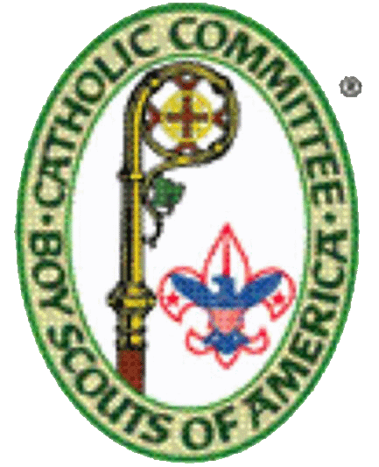
AD ALTARE DEI RETREAT 2018

October 12-14, 2018 with Friday night check in at 6:30 -7:15 pm and completion by 11:30 am Sunday
Whitewater Lodge at Camp Stearns, 3303 County Road 44, South Haven, MN 55382
$40 per Boy Scout (includes food, lodging, and handouts)
Limit of (15) due to facilities, we need a minimum of (10) to hold the course
Open to any registered Boy Scout of the St Cloud Catholic Diocese but recommended for those grades 7 and above
Registration online https://scoutingevent.com/296-2018AdAltareDeiRetreat
Or through: Central MN Council BSA
1191 Scout Drive
Sartell, MN 56377

Questions: Contact Deb or Mike Peters home 320-746-2377 or
Email to mdpeters@albanytel.com

Scouts should bring camping items per the registration website AND:
- BSA health form sections A and B
- Ad Altare Dei youth participant manual #33094
- Food shelf donation from each Scout to Catholic Charities
- Pen or pencil plus notebook
- Class A uniform including neckerchief or bolo, Scout pants if
you have them
- Camping chair

