BLUE WATER NESA Merit Badge DaY WILL BE AT PERCH POINT AGAIN!


Perch Point Conservation Club
7930 Meisner Road, Casco MI.
The date is May 9, 2026.
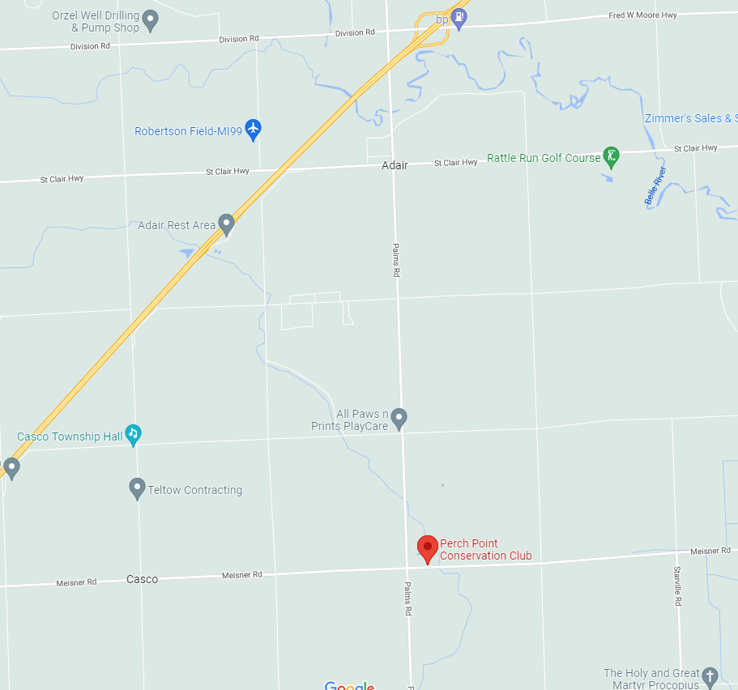
North

