STURGEON FOR TOMORROW
2026 SPRING CAMPOREE
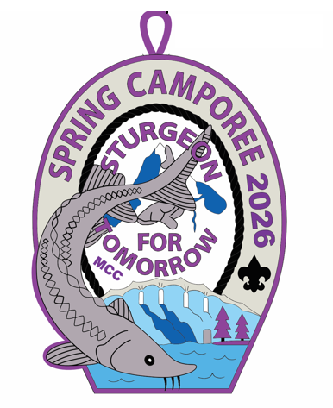
Who: Scouts BSA, Crew Members, and Webelos Scouts may attend for the whole weekend. (Webelos must be registered with a troop.)

When: May 1,2,3 2026

Where: On the Black River in Cheboygan
County (see map for directions).

Camporee will be limited to the first 150 Scouts and
adults to register, as we are limited to camping areas.

Why: To have fun and learn about Sturgeon and
our Natural Resources.

Cost: Will be $20.00 for the weekend.



SPRING CAMPOREE
Sturgeon Guarding Experience
Upper Black River, Cheboygan County, Michigan
May 1-3, 2026
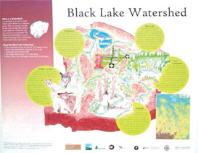
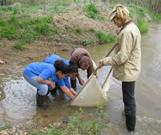
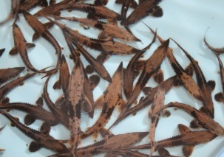
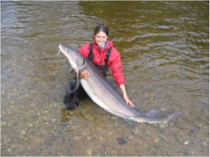
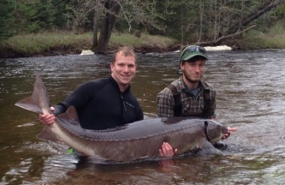

Each spring, several hundred adult lake sturgeon, a threatened species in Michigan, migrate up the Black River to spawn. During this time this iconic fish needs protection because they are vulnerable to poaching. Troops will camp along the river and in the wilderness to stand guard during the spawning migration and will have the unique opportunity to view these iconic fish in the wild. Troops will participate in four programs and gain valuable knowledge and experience as they view biologists netting and tagging large sturgeon, sturgeon hatchery tour, help stabilize the streambank to protect spawning habituate by planting native plants and sample the river for aquatic macroinvertebrates (mayflies, insects...). The lake sturgeon has a long history in the lakes and rivers of Michigan. In fact, sturgeon have been cruising lake waters since the time of the dinosaurs – about 136 million years ago. However, many stresses threaten their survival. Sturgeon can live to be more than 100 years old, grow to 8 feet in length and weigh more than 200 pounds. YOU CAN HELP!

Friday, May 1
Arrival: Set up Camp, 9pm: Cracker Barrel-Orientation

Saturday, May 2
8am: Flag Rising
PROGRAMS
Sturgeon Biology
Base Camp/Site B: Have you ever seen a lake sturgeon in the wild? Well, now you can! Join us and see them up close and maybe even get a chance to touch this majestic animal. Join researchers along the riverbank as they net, tag and collect biological data on the adult spawning lake sturgeon.

Habitat Conservation
Site C: In 2007 in Sturgeon for Tomorrow and Huron Pines began work to prevent erosion near the sturgeon spawning sites. Streambank stabilization methods were deployed including terracing and native plantings. Scouts will assist with planting native plants to revegetate and replace plants that did not survive. We are not certain if the Forester will have time to work with us on this program, but we remain hopeful.

Sturgeon Hatchery Tours
Kleber Dam: During the tours, researchers will be on hand to talk about lake sturgeon biology, and reproductive ecology. Sturgeon for Tomorrow representatives will discuss restoration work to improve sturgeon spawning habitat, sturgeon conservation and outreach programming. The streamside rearing facility is an important component of lake sturgeon rehabilitation efforts in the Cheboygan River watershed. The facility conducts research to determine growth and survival of lake sturgeon.

Aquatic Macroinvertebrate Sampling
Kleber Dam: The aquatic macroinvertebrate community paints a picture of stream ecosystem health. Community diversity and species sensitivity are key factors in determining water quality. A variety of pollution-sensitive stoneflies, mayflies, and caddisflies portrays a healthy ecosystem with good diversity and high water quality. Troops will sample the river and identify species using a dichotomous key.
Continued on next page
This Camporee is being put on by Sturgeon for Tomorrow. Sturgeon for Tomorrow is putting together all program areas and getting volunteers from their organization, along with Foresters, the DNR, Fish Biologist, and help from the Tribes. We will also be guarding the Sturgeon that are in the river spawning, to make sure that no one tries to poach any of the Sturgeon. You will also learn what Sturgeon for Tomorrow is all about. This will be a fun and educational Camporee.

We are asking that each Troop bring in your own water. The closest place to get fresh drinking water is at the State Park, which is five miles away. River water can be used if filtered and boiled.

Each Troop should have a fire barrel for above-ground fires. We will be camping in the woods and there is a lot of Jack Pine around, so we must be prepared for good fire safety. There is a lot of down wood in our camping area that can be collected for fires. We are not sure what kind of weather we will be having, and often in the spring there are fire bans that do not allow for fires above ground. So come prepared ahead of time by bringing a stove to prepare your meals.

We are asking each Troop to invite one volunteer to your campsite for the evening meal. This will also give your Troop someone that can answer any questions the boys might have from the day’s events.

Polarized sun glasses will help by cutting the glare on the water so that the Sturgeon will be seen easier. So, if your boys have any, tell them to bring them along.

Don’t forget to bring your rain coats, as we will be busy all weekend, rain or shine.

Sometimes in the spring along rivers there can be a lot of bugs, so don’t forget the bug spray.

Please bring a journal and pen.

Make sure you bring Health Forms A and B for everyone attending the Camporee and signed Waiver Forms.

It is not allowed that any living trees be cut down or harmed in any way. We are Scouts and all should know this.

Each Scout that participates will get a patch with the Sturgeon Guard logo that will show that they are officially a Sturgeon Guard.

We are trying to get a shuttle to transport people to the Fish Hatchery, but do not know yet if it will work out. Driving time to the hatchery is about 15 minutes. If we are not able to get the shuttle, we will be asking that each Troop provide transportation for this short trip to the hatchery and back.

Sunday, May 3 : Depart

DIRECTIONS
• I-75 to exit 310 in Indian River.
• East on M-68, 18 miles to Black River Rd (F-05).
• North 5 miles to N Allis Hwy (F-05/UAW Corner).
• Turn left/west 1/4 mile. SFT trail marker on your left.
• Turn left follow trail signs to sites B & C.

We will provide a Google map in registration to direct you to Red Bridge Road, off of South Black River Road (F-05). Once at that corner, follow the signage for the Sturgeon Guard. Be advised that this is a 2 mile long two-track. Continue to follow the Sturgeon Guard sign along this two-track, which will bring you into the camping area.

REMINDER: UNITS MUST BRING THEIR OWN WATER AND FIRE BARREL.

Sturgeon for Tomorrow 2026 Spring Camporee

State of Michigan Liability Waiver Form

Each participant must have a waiver completed, signed, and turned in at registration to be able to attend the Sturgeon for Tomorrow 2026 Spring Camporee.

Permittee hereby releases, waives, discharges, and covenants not to sue the State of Michigan, its departments, officers, employees, and agents from any and all liabilities to permittee, its officers, employees, and agents for all losses, injury, death, or damage, and any claims or demands therefore thereto, on account of injury to person or property, or resulting in death of permittee, its officers, employees, or agents, in reference to the activities authorized by the State Land Usage Permit.

Permittee hereby covenants and agrees to indemnify and save harmless, the State of Michigan, its departments, officers, employees, and agents from any and all claims and demands, for all loss, injury, death, or damage that any person or entity may have or make, in a26ny manner, arising out of any occurrence related to (1) issuance of this Permit; (2) the activities authorized by this Permit; and (3) the use or occupancy of the premises which are the subject of this Permit by the Permittee, its employees, contractors, or its authorized representatives.

I agree not to hold the State of Michigan liable for any accident of injury, death, or damage as a result of the Scouts BSA Camporee held on State property.

Name of Youth Participant ___________________________________________________

Parent Signature ___________________________________________________________

Name of Adult Participant ___________________________________________________

Adult Participant Signature __________________________________________________

