

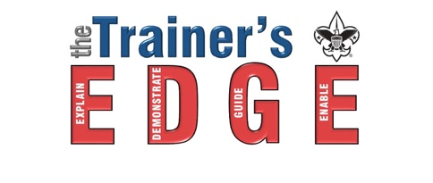
Fundamentals of Training & The Trainer’s EDGE™
November 8, 2025
WMU School of Engineering
4601 Campus Drive
Kalamazoo MI 49008

James E. West, the first Chief Scout Executive, was asked in the early days of Scouting, to identify the three most important needs of the young Scout organization. After careful thought, Mr. West responded, “Training, more training and still more training.” Training continues to be a top priority of the Boy Scouts of America today.
The Trainers EDGE and Fundamentals of Training is for all adult and youth interested in helping with training scout leaders and youth. This course will give you the tools to present an effective and exciting training event. It is also meant to supplement the practice offered through Wood Badge and NYLT staff development. This course is intended to “train the trainer” on behaviors and resources while offering hands-on experience in methods and media. You will learn the “do’s and don’ts” of professional training, all while having fun!!
Who should attend?

Wood Badge Staff (required)
NYLT Staff (required)
Council Training Team
Roundtable Staff
Commissioners
Order of the Arrow Advisors
Troop/Crew/Post Trainers
Pack Trainers
Merit Badge Counselors Youth OA Advisors
Anyone wanting to update training skills

These courses incorporate numerous contemporary training techniques and emphasizes the importance of experiential learning, or “learning by doing.” The training sessions not only demonstrate good training methods but give participants an opportunity to interact and practice what they have learned.

Every boy deserves a well-trained leader, and every leader deserves a well-trained trainer.

How To Register – Register on-line, www.michiganscouting.org calendar by November 1, 2025

Cost: $25 covers handouts, lunch, and a certificate of completion.

Things To Bring:
- Writing materials
- Be Prepared to present a 3 to 5 minute long presentation to your team and staff on a Scouting topic of your choice using a flipchart, a table-top notebook-flipchart, note cards, felt board or similar tools. Whiteboards and markers will be available. Bring any needed materials, equipment or props you will need for the presentation to the course. Presentations must include a visual aid and utilize the EDGE Method. You will receive feedback on your presentation. (Feedback is a Gift…It Truly Is!)

Date, Time and Location:
Saturday, November 8, 2025 4601 Campus Drive
8am check in to 4:30pm Kalamazoo MI 49008

Questions: Contact Laura Lyster at laura.lyster@gmail.com or at 269-598-3383.

